VistA Scheduling Enhancements (VSE)

VS GUI  
User Guide



November 2019

Department of Veterans Affairs

Office of Information and Technology (OI&T)

Version 1.14

Revision History

|  |  |  |  |
| --- | --- | --- | --- |
| Date | Revision | Description | Author |
| 11/14/2019 | 1.14 | Updated Addendum to include site instructions for Patch SD*5.3*731 | M. Clayton  E. Vanderwall  HPS Team  AbleVets |
| 11/5/2019 | 1.13.2 | Updated Addendum for Patch SD*5.3*723 prior to release to include additional known issues and current workflow process. | M. Clayton  AbleVets  F. Jenkins |
| 10/31/2019 | 1.13.1 | Updated Addendum for Patch SD*5.3*723 prior to release to include information related to known issues. | M. Clayton  HPS Team |
| 10/25/2019 | 1.13 | Updated with Addendum for Patch SD*5.3*723 and associated Appendix | M. Clayton  E. Vanderwall |
| 05/01/2018 | 1.12.1 | Updated with edits prior to release of 1.5 | E. Vanderwall  S. Cox  S. Pierce |
| 01/24/18 | 1.12 | Updated for Release 1.5 | F. Johnson |
| 01/05/18 | 1.11.3 | Updated for Release 1.4 | S. Cox  E. Vanderwall |
| 11/07/17 | 1.10.2 | Updated patch description and contacts in Sections 1 and 2 | E. Vanderwall |
| 11/06/17 | 1.9 | Reviewed and incorporated Health Product Support comments | E. Vanderwall |
| 8/31/2017 | 1.8 | Updated per the requirements associated with release 1.3.2 | M. Habic  M. Massiah-King |
| 06/23/2017 | 1.7 | Addressed Business User comments and updated for Build 1.3 Release 1; provided technical edits for format and consistency | M. Habic |
| 01/27/2017 | 1.6 | Addressed VA comments; added Section 5.1.8 Viewing/Editing Patient-Centered Scheduling Request; added alternate text to all figures and tables; added sections for acronyms and hot keys | M. Woehrle  C. Kron  E. Phelps |
| 01/18/2017 | 1.5 | Performed internal peer review; removed *Welcome to VA* references; updated Section 2; added VSE Additional Enhancements description | M. Woehrle  L. Masucci  E. Phelps |
| 01/08/2017 | 1.4 | Incorporated user acceptance testing updates: pages 7, 9, 11, 15, 22, 23, 25, 27, 35-37, 46-48, 50, 52, 55, 57-58,60,63,69,71, 74,76,79,81,84,86,89-91,93,96-109,117-118,120-121, 123, 125, 127-130,132-147,166,181-195; provided technical edits for format and consistency | C. Kron  E. Stuck  C. Zavala E. Phelps |
| 12/21/2016 | 1.3 | Updated table of contents and footers for pages 161-211; provided technical edits – fixed figure captions, added table list, added queries for author | C. Kron E. Phelps |
| 12/7/2016 | 1.2 | Updates to Clinic Grid (pages 31,37-38,72,91) | C. Kron |
| 11/21/2016 | 1.1 | Updates from CIT/ST: pages 6-13,16-21,23-24,27-95,97,99-104,123-124,127,129-131,133,135-137,139-145,157-161,168-171,173-174,176,184 | C. Kron |
| 05/02/2016 | 1.0 | Initial baseline | D. Reed |

Table of Contents

1 Introduction 1

1.1 Purpose 1

1.2 Overview 1

1.3 Project References 1

1.3.1 Information 1

1.3.2 Coordination 2

1.3.3 Help Desk 2

1.3.4 Organization of the User Guide 3

2 System Summary 4

2.1 User Access Levels 5

3 Getting Started 7

3.1 Logging On 7

3.2 Two Factor Authentication Using PIV Cards 7

3.3 New Return to Clinic Orders (RTC Orders) 9

3.4 Logging Off 9

3.5 VS GUI Tabs 9

3.5.1 Tasks Tab 9

3.5.2 System Tab Action Areas 10

3.5.3 Reports Tab Action Areas 11

3.6 Searching 11

3.6.1 Search for Patient 11

3.7 Filtering 12

3.7.1 Filtering Lists 13

3.7.2 Paging Through Records 14

3.7.3 Filtering by Facility or Clinic 15

3.7.4 Filtering by Time Period 15

3.8 Sorting 15

3.8.1 Sorting by Column 16

3.8.2 Sorting Pending Appointments by Column 16

3.8.3 Print Pending Appointment List for a Patient 17

3.9 Printing and Exporting a Request Management Grid 18

3.9.1 Printing a Request Management Grid 18

3.9.2 Exporting a Grid 19

3.10 Viewing 19

3.10.1 View Only Mode 19

3.10.2 Viewing Requests by Request Type 20

3.10.3 Viewing Requests by Patient 21

3.10.4 Schedule View 21

4 Ribbon Bar 22

4.1 Patients Demographics 22

4.1.1 Finding a Patient 22

4.1.2 Viewing Patient Demographics in the Ribbon Bar 23

4.1.3 Patient Eligibility Information 24

4.1.4 Updating Patient Demographics 25

4.1.5 Editing Permanent Address 26

4.1.6 Adding a Temporary Address 27

4.1.7 Bad Address 28

4.2 Actions 31

4.2.1 New Request 31

4.3 Pending Appointment Window 31

4.4 Special Needs/Preferences 34

4.4.1 Adding/Removing Special Needs/Preferences from Requests 34

4.5 Patient Flags 35

4.6 Tools 36

4.6.1 Print 36

4.6.2 Export 36

4.6.3 Refresh 37

4.6.4 Query 37

4.7 Settings – User Preferences 40

5 Request Management 42

5.1 Request Management Procedures 42

5.1.1 Viewing a Patient’s Existing Requests 42

5.1.2 Adding Appointment Request 46

5.1.3 Viewing/Editing Appointment Request 49

5.1.4 Disposition or Removing an Appointment Request 51

5.1.5 Transfer to EWL Request for a Patient 52

5.1.6 Disposition or Removing a Patient from the EWL 54

5.1.7 Adding Patient-Centered Scheduling Request 54

5.1.8 Viewing/Editing Patient-Centered Scheduling Request 56

5.1.9 Disposition or Remove Patient-Centered Scheduling Request 61

5.2 Contacting a Patient 63

5.2.1 New Contact Attempt 63

6 Appointment Management 68

6.1 Adding Appointments 68

6.1.1 Add Appointment for Appointment Request 68

6.1.2 Add Appointment for EWL Request 72

6.1.3 Add Appointment for Patient-Centered Scheduling Request 78

6.1.4 Add Appointment for Consult Request 84

6.1.5 Add Appointment from Return to Clinic request (RTC) 88

6.2 Disposition Appointments 89

6.2.1 Edit Appointment Information 89

6.2.2 View Appointment Information 91

6.2.3 Cancelling an Appointment 93

6.2.3.1 Cancel directly from pending appointment box 96

6.2.4 Mark as No Show Appointment 97

6.2.5 Undo No-Show Appointment 100

6.2.6 Checking In a Patient 102

6.2.7 Undo a Patient Check In 104

6.2.8 Check Out a Patient 106

6.2.9 Undo a Patient Check Out 109

6.2.10 Rescheduling an Appointment 110

6.3 Multiple Appointment Requests and Appointments 111

6.3.1 Multiple Appointment Request 111

6.3.1.1 Note Regarding Parent and Child Appointment Requests 112

6.3.2 Adding Multiple Appointments from Find Appointment Dialog 113

6.4 Overbooking Appointments 118

6.4.1 Overbooking Appointments with SDMOB Security Key 118

6.4.2 Overbooking Appointments with SDOB Security Key 122

6.5 Variable Length (VL) APPT 127

6.5.1 Identifying a VL Clinic: 127

6.5.2 Add a VL APPT 129

6.6 Compensation and Pension (C&P) APPTs 131

6.6.1 Add a C&P APPT Request 131

6.6.2 Add a C&P APPT for Pending 2507 Request NOT Previously Linked to Appointment 132

6.6.3 Add a C&P APPT for Pending 2507 Request Already Linked to APPT NOT Due to Cancellation 133

6.6.4 Add a C&P APPT for Pending 2507 Request due to Clinic Cancellation 135

6.6.5 Add C&P APPT for Pending 2507 Request due to Veteran Cancellation/No Show 138

6.6.6 Disposition APPT Linked to Pending 2507 Request 141

6.7 VA Online Scheduling (formerly VAR) 142

7 Clinics 143

7.1 Tasks Tab 143

7.1.1 Viewing Clinic Schedule Availability 143

7.1.2 Viewing Clinic’s Availability Cancellation 146

7.1.3 Viewing the Clinic’s Length of APPT and Max OB 147

7.1.4 Viewing the Clinic’s VL Indicator 147

7.1.5 Viewing the Clinic’s Special Instructions 147

7.1.6 Viewing Clinic’s Available Slots 148

7.1.7 The Time Slot Viewer 149

7.1.8 Viewing Provider Availability 153

7.1.9 Viewing Clinic Group Availability 155

7.2 System Tab 156

7.2.1 Viewing Clinic Availability Information 156

7.2.2 Adding and Removing Privileged Users 158

7.2.2.1 Add A Privileged User 158

7.2.2.2 Remove Privileged User 159

7.2.3 Creating Clinic Groups 160

7.2.4 Removing a Resource from a Clinic Group 162

8 Reports 163

8.1 The Audit Activity Report 163

8.1.1 Generating an Audit Activity Report for an Individual Scheduler 163

8.1.2 Generating an Audit Activity Report for All Schedulers 164

8.1.3 Working with Audit Activity Report Data 165

8.1.3.1 Sorting by Column Header 165

8.1.3.2 Filtering by Column Data 166

8.1.4 Export an Audit Activity Report for Individual or All Schedulers 167

8.2 Clinics Report 168

8.2.1 Clinic Activity Report – Individual Clinic 168

8.2.2 Working with the Clinic Activity Report 168

8.2.2.1 Sorting by Column Headers 168

8.2.2.2 Filtering Data by Column 170

8.2.3 Exporting a Clinic Report 171

9 Trash Queue Cleanup 173

9.1 Compile List of Re-Opened REQUEST Records that Can Be Closed 173

9.2 Commit Records to Be Closed from Compiled List 175

9.2.1.1 Systems Manager 177

9.3 View Unresolved APPT Requests Reopened by the SDCANCEL Option 179

10 VistA Scheduling 508 Compliance 180

10.1 The Tasks Tab 180

10.1.1 The Ribbon Bar 180

10.1.2 Request Type Dialog 181

10.1.3 Appointment Request 181

10.2 Systems Tab 185

10.2.1 Systems Tab Ribbon Bar 185

10.2.2 Scheduling Management 185

10.2.2.1 Clinics and Users Tab 185

10.2.2.2 Clinic Groups Tab 187

10.2.3 Availability Selection 188

10.3 The Reports Tab 188

10.3.1 Reports Tab Ribbon Bar 188

10.3.2 Audit Activity 189

10.3.3 Clinic Activity 190

11 Troubleshooting 190

11.1 Changing User ID and Password 190

11.2 Special Instructions for Error Correction 191

12 Acronyms and Abbreviations 192

13 Keyboard Shortcuts Quick List 194

A. Addendum for Patch SD*5.3*723 Site Instructions 197

A.1. Information 197

A.2. Known Defects and Anomalies 198

A.2.1. Impact 198

A.2.2. Workaround 198

A.3. Overview 198

A.3.1. Problem 198

A.3.2. Solution 199

A.3.3. Access Requirement 199

A.3.4. Assistance 200

B. Identify Clinic without Matching Resource List 200

C. Reviewing/Analyzing Report Results 201

C.1. Report Results 201

D. Correct Clinic Resource Issues 203

D.1. Edit Resource 203

D.2. Create a Resource 205

D.3. Check Corrections Made to the SDEC RESOURCE File 207

D.4. Check for Inactive Clinics 207

E. Identify and Fix Existing Appointments with Resource Problems 209

E.1. Automatically Fix Appointments with No Resources 210

E.2. Reviewing/Analyzing Appointments without Resources Results 211

F. Ongoing Data Check Expectations 212

G. Addendum for Patch SD*5.3*731 Site Instructions 213

G.1. Known Defect and Work Around 213

G.2. Overview 213

G.3. Site Instructions 213

G.4. Automatically Fix Appointments with Resource Problems 214

G.5. Identify Remaining Appointments with Resource Problems 214

G.5.1. Appointments with Missing Resources Option 214

G.5.2. Appointments with No Resource Report Option 216

G.6. Manually Fix Appointments with Resource Issues 217

G.6.1. Manually Fix Appointments with No Resource 218

G.6.2. Edit Appointment Resource 219

G.7. Check Corrections for Appointments with SDEC Resource Issues 220

A. Appendix A 221

A.1. Send Report Results to Text File 221

List of Figures

Figure 1: User Login 7

Figure 2: Main Screen with Test Environment Displayed 7

Figure 3: Linking PIV to VistA Account 8

Figure 4: User Logoff 9

Figure 5: VS GUI Tabs 9

Figure 6: Tasks Tab Display 10

Figure 7: System Tab 11

Figure 8: Reports Tab 11

Figure 9: Patient Search 12

Figure 10: Filtering Lists 13

Figure 11: Paging Through Records 14

Figure 12: Filtering by Facility/Clinic 15

Figure 13: Filtering by Time Period 15

Figure 14: Sorting by Column 16

Figure 15: Sorting Pending Appointments list by Column 16

Figure 16: Print Pending 17

Figure 17: Select Desired Printer 17

Figure 18: Selecting the Print Option 18

Figure 19: Selecting a Printer 18

Figure 20: Exporting a Grid 19

Figure 21: Request Type Column 20

Figure 22: Select Patient 21

Figure 23: Patient Pending Requests and Booked Appointments 21

Figure 24: Changing View of a Specific Schedule 22

Figure 25: Search Patient 23

Figure 26: Patient Demographics in the Ribbon Bar 23

Figure 27: Patient Inquiry Detail 24

Figure 28: Patient's Eligibility Information 25

Figure 29: Patient Information Dialog 26

Figure 30: Patient is Being Edited Warning Pop-up 26

Figure 31: Patient Info Dialog–Permanent Address 27

Figure 32: Patient Info Dialog – Temporary Address 28

Figure 33: Select Patient 29

Figure 34: Request Type 29

Figure 35: Appointment Request Dialog—Bad Address Selection 29

Figure 36: Actions Pane 31

Figure 37: Request Type – APPT 31

Figure 38: Pending Appointment Window – Past Appointment Date 32

Figure 39: Pending Appointment Window – Current less than Three Days in Future 32

Figure 40: Pending Appointment Window – Future Appointment Dates 33

Figure 41: Patient Info Dialog – Special Needs/Preferences Section 34

Figure 42: Ribbon Bar – Special Needs/Preferences 34

Figure 43: Patient Record Flags Dialog 35

Figure 44: Patient Record Flags 36

Figure 45: Refresh Button in Tools Pane 37

Figure 46: Request Query 38

Figure 47: Query Rule Validation 38

Figure 48: Request Query Rule Confirmation 38

Figure 49: Settings – User Preferences 41

Figure 50: Settings – Save as Default View 42

Figure 51: Request Grid and Pending Appointments 43

Figure 52: Request Grid Displaying Expand Entry Block 44

Figure 53: Appointment Demographics 45

Figure 54: Appointment Event Log 45

Figure 55: Appointment Wait Time 45

Figure 56: Patient Information 46

Figure 57: Encounter Information 46

Figure 58: Request Type - APPT 47

Figure 59: Actions Pane—New Req. Selection 47

Figure 60: Appointment Request Dialog – Request Information Section 48

Figure 61: Special Needs/Preferences Section from Patient Info Dialog 48

Figure 62: Appointment Request Dialog 49

Figure 63: View Request (Read Only) 50

Figure 64: Edit Request (Request Information Only) 51

Figure 65: APPT/Veteran Disposition Options 52

Figure 66: EWL Request Dialog 53

Figure 67: Request Type–PATIENT-CENTERED SCHEDULING 55

Figure 68: Patient-Centered Scheduling APPT Request Dialog 56

Figure 69: Patient-Centered Scheduling Disposition Dialog 57

Figure 70: Patient-Centered Scheduling Appointment View Request Dialog 58

Figure 71: Patient-Centered Scheduling Disposition Dialog 59

Figure 72: Patient-Centered Scheduling Appointment Edit Request Dialog 60

Figure 73: Patient-Centered Scheduling Disposition Options 61

Figure 74: PtCSch Comment Dialog Box 62

Figure 75: Warning Pop-Up If Business Rules Were Not Met 62

Figure 76: Request Type/Dispositions/Contact Message Reference 63

Figure 77: Contact Attempts 64

Figure 78: Patient Contact Dialog 64

Figure 79: New Contact Attempt Submitted and Displayed 65

Figure 80: Displaying Name of Person Entering Contacts 65

Figure 81: Appointment Canceled 66

Figure 82: New Contact Attempt After Cancellation 67

Figure 83: Select APPT Request – Clinic Schedule Grid Display 68

Figure 84: Select Time Slot 69

Figure 85: Right-click Options – Add Appointment 69

Figure 86: New Appointment Dialog 70

Figure 87: Print Letter? Dialog 70

Figure 88: Closing Request Dialog 71

Figure 89: Clinic Schedule Grid – Past Appointment Display 71

Figure 90: Clinic Schedule Grid – Current Appointment Display 72

Figure 91: Clinic Schedule Grid – Future Appointment Display 72

Figure 92: Request Type 73

Figure 93: Select EWL Request 74

Figure 94: Select Time Slot 74

Figure 95: Right-click Options – Add Appointment 75

Figure 96: New Appointment Dialog 75

Figure 97: Print Letter? Dialog 75

Figure 98: Print to VistA Device Printer to place address in correct position 76

Figure 99: Closing Request Dialog 76

Figure 100: EWL Appointment Past Date Display 77

Figure 101: EWL Appointment Current Date 77

Figure 102: EWL Appointment Future Date Display 78

Figure 103: Request Type 78

Figure 104: Select Patient-Centered Scheduling Request 79

Figure 105: Select Time Slot 79

Figure 106: Right-click Options – Add Appointment 79

Figure 107: New Appointment Dialog 80

Figure 108: Print Letter? Dialog 81

Figure 109: Closing Request Dialog 81

Figure 110: Clinic Schedule Display – Past Date Appointment 82

Figure 111: Clinic Schedule Display – Current Date Appointment 82

Figure 112: Clinic Schedule Display – Future Date Appointment 83

Figure 113: Select Consult Request 84

Figure 114: Clinic Schedules 85

Figure 115: Select Time Slot 85

Figure 116: Right-click Options – Add Appointment 85

Figure 117: New Appointment Dialog 86

Figure 118: Print Letter? Dialog 86

Figure 119: Clinic Schedule Display – Consult Past Appointment Date 87

Figure 120: Clinic Schedule Display – Consult with Current Date 87

Figure 121: Clinic Schedule Display – Consult Future Appointment Date 88

Figure 122: Appointment Right-click Options – Edit Appointment 90

Figure 123: Edit Appointment Dialog 90

Figure 124: Hover Box Displaying Appointment Details 91

Figure 125: Appointment Right-click Options – View Appointment 92

Figure 126: View Appointment Dialog 93

Figure 127: Appointment Right-click Options – Cancel Appointment 94

Figure 128: Cancel Appointment Dialog 95

Figure 129: Pending Appointment Window – Appointment Status Cancelled by Clinic 95

Figure 130: Pending Appointment Window – Appointment Status Cancelled by Patient 96

Figure 131: APPT Request – Time Slot Count Increase 96

Figure 132: Select Cancel Appointment 97

Figure 133: Cancelled by Clinic 97

Figure 134: Appointment Right-click Options – Mark as No Show 98

Figure 135: Mark as No Show Dialog 99

Figure 136: Clinic Schedule Display – No-Show Red 99

Figure 137: Pending Appointment Window – Appointment Status No-Show 99

Figure 138: No-Show Warning Message 100

Figure 139: Appointment Right-click Options – Undo No-show 101

Figure 140: Appointment Clinic Schedule Display – Undo No-show as Purple 101

Figure 141: Undo No-show – Appointment Status No Action Taken 102

Figure 142: Appointment Right-click Options – Check In Patient 103

Figure 143: Appointment Check In Dialog 103

Figure 144: Clinic Schedule Display – Check In Yellow 104

Figure 145: Pending Appointment Window – Status ACT REQ/CHECKED IN 104

Figure 146: Appointment Right-click Options – Undo Check In Patient 105

Figure 147: Clinic Schedule Display – Undo Check In Patient Purple 105

Figure 148: Pending Appointment Window – Appointment Status No Action Taken 106

Figure 149: Appointment Right-click Option – Check Out Patient 107

Figure 150: Appointment Check Out Dialog 108

Figure 151: Clinic Schedule Display – Check Out Patient Orange 108

Figure 152: Pending Appointment Window – Status ACT REQ/CHECKED OUT 108

Figure 153: Appointment Right-click Options – Undo Check Out Patient 109

Figure 154: Clinic Schedule Display – Undo Check Out Patient Yellow 109

Figure 155: Pending Appointment Window – Status ACT REQ/CHECKED IN 110

Figure 156: MRTC Interval/Appt. # Dialog 112

Figure 157: MRTC Requests displayed in Request Management Grid 113

Figure 158: Find Appointment Dialog 115

Figure 159: Find Appointment Dialog and MRTC Booking Status Dialog 116

Figure 160: Future Clinic Inactivation Date 117

Figure 161: Request Type 118

Figure 162: Clinic Schedule Display – APPT Request Future CID/Preferred Date 119

Figure 163: Max Overbook Limit 119

Figure 164: Appointment Right-click Options – Add Appointment 120

Figure 165: View Appointment Dialog – Appointments 121

Figure 166: Print Letter? Dialog 121

Figure 167: Closing Request Dialog 122

Figure 168: Clinic Schedule Display – Overbook Appointment 122

Figure 169: Request Type 123

Figure 170: Clinic Schedule Display – APPT Request Future CID/Preferred Date 124

Figure 171: Overbook After Hours Time Slot 124

Figure 172: Appointment Right-click Options – Add Appointment 125

Figure 173: Overbook Confirmation Dialog 125

Figure 174: New Appointment Dialog 126

Figure 175: Print Letter? Dialog 126

Figure 176: Closing Request Dialog 126

Figure 177: Clinic Schedule Display – Overbook Appointment After Hours 127

Figure 178: Clinic Schedules – Clinic Search 128

Figure 179: Clinic Schedule Grid 128

Figure 180: VL Indicator 128

Figure 181: Consecutive Time Slots 129

Figure 182: New Appointment Dialog 130

Figure 183: Clinic Schedule Display – Appointment Length Extended 131

Figure 184: TRACKING Record Updated 132

Figure 185: C&P Appointment for Patient with No Pending 2507 Request 133

Figure 186: C&P Requests Dialog 134

Figure 187: C&P Request Due to Cancellation Dialog 134

Figure 188: AMIE C&P EXAM TRACKING Record Updated 134

Figure 189: C&P Requests Dialog 136

Figure 190: C&P Request Due to Cancellation Dialog 136

Figure 191: C&P Request APPT Links Dialog 137

Figure 192: C&P APPT Links Due to Veteran Cancellation or No Show 137

Figure 193: C&P APPT Links Due to Cancellation Dialog 137

Figure 194: C&P APPT Links Adjustment Dialog 138

Figure 195: C&P Requests Dialog 139

Figure 196: C&P Request Due to Cancellation Dialog 139

Figure 197: C&P Request APPT Links Dialog 140

Figure 198: C&P Canceled APPT Links Dialog Warning 140

Figure 199: C&P APPT Links Due to Veteran Cancellation or No Show 140

Figure 200: AMIE C&P EXAM TRACKING Record Updated 141

Figure 201: C&P Cancel APPT Associated 2507 Request Updated 142

Figure 202: C&P Cancel APPT NOT Linked to Pending 2507 Request 142

Figure 203: Clinic Schedules Search 144

Figure 204: Clinic Schedules Display – Available and Unavailable 144

Figure 205: Clinic Schedules Display – Hours of Operation 145

Figure 206: Clinic Schedules Display – Holiday Bookable 145

Figure 207: Clinic Schedules Display – Holiday Unbookable 146

Figure 208: Clinic Schedule Display – No Availability Defined 146

Figure 209: Clinic Schedule Display – Whole and Partial Day Cancel Availability 146

Figure 210: APPT Length and Max OB Allowed 147

Figure 211: VL Indicator 147

Figure 212: Special Instructions Indicator 148

Figure 213: Time Slot Count 148

Figure 214: Overbook Time Slot Count 149

Figure 215: Minimized Time Slot Viewer 150

Figure 216: Expanded Time Slot Viewer 150

Figure 217: Time Slot Viewer Displays Slot Details 150

Figure 218: Time Slot Viewer Right-click–Edit, View, Cancel 151

Figure 219: Time Slot Viewer – Check In Patient 152

Figure 220: Time Slot Viewer – Check Out Patient 152

Figure 221: Time Slot Viewer – Mark as No Show 153

Figure 222: Provider Schedules 153

Figure 223: Provider Schedules Selection List 154

Figure 224: Provider Schedule Display 154

Figure 225: Provider Schedules Booked APPTs 154

Figure 226: Clinic Groups 155

Figure 227: Clinic Groups Search Result List 155

Figure 228: Clinic Groups Schedule Display 156

Figure 229: Clinic Availability Search 157

Figure 230: Clinic Availability 158

Figure 231: Clinics and Users 158

Figure 232: Add Privileged User 159

Figure 233: Remove Privileged User 160

Figure 234: Create New Clinic Group 160

Figure 235: Find Resource 161

Figure 236: Add Resource to Clinic Group 162

Figure 237: Remove Resource from Clinic Group 162

Figure 238: Reports Tab Selections 163

Figure 239: Audit Activity Report – Individual Scheduler 163

Figure 240: Audit Activity Report – All Schedulers 165

Figure 241: Audit Activity Sort – Ascending 166

Figure 242: Audit Activity Sort – Descending 166

Figure 243: Audit Activity Report – Filtered 167

Figure 244: Audit Activity Report – Multiple Filters 167

Figure 245: Clinic Activity Report Sort – Ascending Order 170

Figure 246: Clinic Activity Report Sort – Descending Order 170

Figure 247: Clinic Activity Report – Filtered 171

Figure 248: Clinic Activity Report – Multiple Filters 171

Figure 249: Clinic Activity 172

Figure 250: Save As 172

Figure 251: Scheduling Manager's Menu [SDMGR] \ Supervisor Menu [SDSUP] 199

Figure 252: CLINICS WITHOUT MATCHING RESOURCE LIST Menu Option 200

Figure 253: CLINICS WITHOUT MATCHING RESOURCE LIST Report Prompts 201

Figure 254: Sample Output with Blank DIFF? Column 202

Figure 255: Sample Output with N/A listed in the DIFF? Column 202

Figure 256: Sample Output with Mismatched Resource with Three (3) Asterisks (***) in the DIFF? Column 202

Figure 257: Sample Output with a Missing Resource with Three (3) Asterisks (***) in the DIFF? Column 202

Figure 258: How to Search Using Find 203

Figure 259: Find Dialog Box 203

Figure 260: EDIT RESOURCE Menu Option and Prompt Responses 205

Figure 261: RESOURCE TYPE Entered Incorrectly 205

Figure 262: CREATE A RESOURCE Menu Option and Prompt Responses 206

Figure 263: Checking SDEC RESOURCE File (#409.831) Corrections 207

Figure 264: Clinic Profile Menu and Prompts 208

Figure 265: Clinic Profile for Inactive Clinic 209

Figure 266: Clinic Profile of Active Clinic 209

Figure 267: Automatically Fix Appointments with No Resources 211

Figure 268: Appointment with SDEC RESOURCE Issue Automatically Corrected 212

Figure 269: Past Patient Appointment - No Correction Required 212

Figure 270: Future Patient Appointment - Must be Corrected 212

Figure 271: Summary of Appointments Checked and Results 212

Figure 272: Appointments with Missing Resources Prompts 215

Figure 273: Appointments with Missing Resources Sample Output 216

Figure 274: Appointments with No Resource Report 217

Figure 275: Appointments with No Resource Report Output 217

Figure 276: Manually Fix Appointments with No Resource Menu Option and Prompts 218

Figure 277: Manually Fix Appointments with No Resource Onscreen Results and Prompts 219

Figure 278: Location of Backtick on QWERTY Keyboard 220

Figure 279: Edit resource for an appointment Prompt Responses 220

Figure 280: Send Report Results to Text File 222

Figure 281: Stop Logging 222

List of Tables

Table 1: Clinic Schedule Availability 143

Table 2: Keyboard Shortcuts for Ribbon Bar Components 181

Table 3: Keyboard Shortcuts for Request Type 181

Table 4: Keyboard shortcuts for the Appointment Request 182

Table 5: Keyboard Shortcuts for the Systems Tab Ribbon Bar 185

Table 6: Keyboard Shortcuts for Scheduling Management 187

Table 7: Keyboard Shortcuts for the Clinic Groups Tab 187

Table 8: Keyboard Shortcuts for the Availability Selection 188

Table 9: Keyboard Shortcuts for the Reports Tab Ribbon Bar 189

Table 10: Keyboard Shortcuts for Audit Activity 189

Table 11 Keyboard Shortcuts for Clinic Activity 190

Table 12: Warning Messages 191

# Introduction

Department of Veterans Affairs (VA) Veterans Health Information Systems and Technology Architecture (VistA) Scheduling (VS) Graphical User Interface (GUI) module is the Windows GUI version of the Patient Information Management System (PIMS) Scheduling module. It provides appointment management functions included in PIMS Scheduling, but with the added convenience and usability of a GUI.

## Purpose

The Veterans Health Administration (VHA) Office of Veterans Access to Care (OVAC) requested an enterprise enhancement for the VS package. The enhancement reduces operating costs for VHA and improves operational efficiencies, resulting in patient-centered access to care, coordinated care, increased customer satisfaction, and the reduction of excessive cycle/wait time for scheduling patients.

## Overview

VS GUI is a software module that allows schedulers to make appointments quickly by viewing multiple appointment request types and multiple clinics in one screen. A scheduler can easily view patient requests for service, find the next available open appointment, view the provider’s availability in multiple clinics, and track a patient’s appointment process. Refer to Section 2 for a more detailed description of VS GUI functionality.

## Project References

### Information

The VS GUI points of contact (POCs) include:

* OVAC VSE Project Manager – Ms. Erin Vanderwall, [Erin.Vanderwall@va.gov](mailto:erin.vanderwall@va.gov)
* OVAC Program Office – [VHAVSEProgramOffice@va.gov](mailto:VHAVSEProgramOffice@va.gov)
* OIT VSE Project Manager – Mr. Shannon Ayers, [Shannon.Ayers@va.gov](mailto:Shannon.Ayers@va.gov)

**Note:** The VSE project SharePoint site can be accessed via the following link: <http://vaww.oed.portal.va.gov/pm/iehr/vista_evolution/enhancements/SitePages/Home.aspx>

VSE Pulse pages:

* Scheduler: <https://www.vapulse.va.gov/community/vista-scheduling-enhancements-vse>
* Super User: <https://www.vapulse.va.gov/groups/vse-superusers>
* National Return to Clinic Order Implementation: <https://www.vapulse.va.gov/groups/return-to-clinic-rtc>
* Frequently Asked Questions/Known Issues document: <https://vaww.vha.vaco.portal.va.gov/sites/DUSHOM/10NA/ACAO/VSE_Adopt_Implementation/Lists/VSEKnownIssues/AllItems.aspx>

### Coordination

Coordination between the project and its specific support functions (e.g., installation coordination, security, etc.) for VS GUI is the same as those for VistA.

### Help Desk

Refer to Section 11 for additional information.

### Organization of the User Guide

This user guide is comprised of 11 sections, as follows:

* **Introduction:** Addresses general project information
* **System Summary:** Contains system configuration, data flows, and user access level information
* **Getting Started:** Contains procedures for logging on and off of the system, instructions on how to print and export schedules, and information on VS GUI tab displays, basic functions for searching, sorting, filtering, and viewing
* **Ribbon Bar:** Contains procedures for using the Schedule Manager Ribbon Bar and details on features, such as patient demographics, new request actions, pending appointments, print, export, refresh, query tool, user preferences, and patient preferences
* **Request Management:** Outlines features and procedures for using the Request Management Grid (where patient’s pending requests are displayed 25 at a time) and the Pending Appointments window (where booked appointments are displayed in the in the Ribbon Bar of the Tasks tab)
* **Appointment Management:** Provides details describing how to manage an appointment – after selecting a patient, the option appears to schedule a new appointment (APPT) or Patient-Centered Scheduling (PtCSch); a list of recent and upcoming appointments is displayed in the Ribbon Bar
* **Clinics:** Provides an overview of clinic and administrator views and actions
* **Reports:** Provides an overview of viewing and printing reports, and procedures for generating audit and clinic reports; a list of warnings is also included
* **Trash Queue Cleanup:** Defines this task and provides instructions for use
* **VistA Scheduling 508 Compliance**: Outlines processes for executing VistA Scheduling application functionality from the keyboard
* **Troubleshooting:** Provides contact information for the Help Desk regarding any problems with the VS GUI module

# System Summary

The VSE project delivers a series of enhancements to legacy VistA Scheduling Version 5.3 via the VS GUI application.

The previously nationally released version 1.4 includes VS GUI 2.0.0.14 and VistA M patch SD*5.3*672. Install compliance date was Feb 8, 2018. This update included the following:

* Provides the capability for VSE users to authenticate via Personal Identity Verification (PIV)
* Clinic Group will display for second patient without searching for a different clinic group first. (Users should put curser in the clinic group field and click Enter to refresh.) Ticket I10959194FY17
* Electronic Wait List (EWL) can now be consistently dispositioned from the Resource Management (RM) Grid. Ticket I11259063FY17
* Scheduling grid no longer allows overbooks in the evenings after a FULL DAY availability cancellation. The visual display does not extend the cancellation hash marks to midnight, but it will not allow the user to book, and presents an appropriate error message to user. Ticket I12362398FY17
* Drag and drop rescheduling within the current calendar view (including clinic groups and provider search calendar views) is now available for most existing appointments. Consult linked appointments and appointments in the past cannot drag and drop as they have other linkages that still require manual cancellation. Ticket I12487403FY17
* Slot tallies no longer move as the calendar view is scrolled down. Ticket I12529073FY17
* Schedulers cannot add new request or appointments in VS GUI after a patient is listed as deceased in VistA. Ticket I12602010FY17
* Cancel by Clinic no longer allows PID to be changed by switching between Cancel by Clinic and Cancel by Patient. Ticket I12748395FY17
* VS GUI Audit Report now reports accurate counts of actions within VS GUI for both individual and all schedulers. Tickets I12871937FY17
* Checking out appointment “Follow-up Needed” now works better than it did in former versions, however we continue to keep it tied to the SD SUPERVISOR key until we can completely separate the administrative check out function in VS GUI from any ties to the encounter files. We do not recommend use of check out at this time. Ticket I13233499FY17
* Appointments scheduled in VS GUI with a past date will now show in CPRS cover sheet and visit location lists. Ticket I13212697FY17
* SDRR CLINIC LETTER REPORT will now run properly (was hanging on bad data in previous versions). Ticket R14380532FY17

The next nationally released version 1.5 includes VS GUI 2.0.0.15 and VistA M patches SD*5.3*679 and GMRC*3.0*98. Install period is projected for May 31 2018 at time of publishing. This update includes the following:

* Pending Appointment Box Improvements:
  + Columns in the Pending Appointment list are now sortable
  + Filters can now be placed on each column in the Pending Appointments list
  + The date range for the Pending Appointments list has changed from (-365 days to +365 days) to (-365 days to + 1000 days)
  + Right-clicks on the Pending Appointments list in the ribbon in VS GUI, a new menu option, Print Pending, is now available. This option will print a list of all of the current patient’s appointments that occur from the install date of SD*5.3*679 into the future. If the list is filtered or date range extended, the Print Pending results should reflect those filters.
* Patient Selection, when a patient is selected, the system no longer immediately jumps to the New Request pop up box to prompt the user for a request type. The user can click the New Request (New Request) button in the ribbon in order to start a new request, as they could previously. This forces the scheduler to view existing requests before making a new one.
* The View Mode selector in the Arrangement pane of the ribbon has been removed, as it was unused.
* The print buttons in the letter printing window previous read Print (Local) and Print (Server). Now they read Print (Windows Printer) and Print (VistA Print Device), respectively.
* In the Select Patient pane located in the ribbon, additional fields have been added to the patient information displayed. These include Primary Care Provider (PCP), Mental Health Provider (MHP), and phone number. This addresses Ticket R16775634FY18.
* The New Appointment dialog will now have the Comments field filled with the comments from the original appointment request, whether it is an Appointment (Appt.) Request, National Return to Clinic (RTC), Patient Centered Scheduling (PtCSch) Electronic Wait List (EWL), or Consult request.
* The New Appointment dialog will now check to make sure that the slot being booked into has not been made unavailable since the user started working on the appointment (such as a clinic that was temporarily opened on a holiday being re-closed). This addresses Ticket I15980703FY17.
* View only users and users without privileges in restricted clinics can now access both the View Appointment and Expand Entry options when right-clicking on an appointment. Neither of these options allows changing of any data. This addresses Ticket R16581333FY17.
* The system will now allow a user to cancel an appointment for a deceased patient. This addresses Ticket I12603678FY17.

## User Access Levels

The VS GUI module uses three access levels:

**Provider and Non-Scheduler (View Only)** can view patient appointments, clinics, and provider’s availability in VS GUI via:

* **View** patient appointments, clinics, and provider’s availability
* **Find Available Appointments** slots in a clinic or group of clinics
* **Appointment Schedule** displayed by clinic, provider or clinic group
* **Request Management Query Tool** to produce a list of patients waiting for an appointment
* **Expand Entry** on existing appointments to view details of when the appointment was created, encounter information (if available), and other appointment audit fields
* **VistA Account Requirements:** VistA option CLINICAL SCHEDULING PROCEDURE CALLS [SDECRPC] and VistA key SDECZVIEW. Please note, SDECZVIEW blocks all other SDEC keys the user may hold

**Scheduler** can make appointments quickly by viewing multiple clinics in one screen. The user can easily find open appointments, view the provider’s availability in multiple clinics, and track a patient’s appointment process in VS GUI via:

* **Find Appointments** to specify the dates to view only available appointments in a clinic or list of clinics
* **Resource Schedules** to display clinic schedules
* **Appointment Schedule** to display appointment schedules for a clinic and be able to view a provider’s schedule for the day, week, or month
* **Request Management Queue** to display a list of patients waiting for an appointment or a consolidated list of a particular patient’s unfulfilled appointment needs
* **Ribbon Bar** for a view that shows individual patient information after a patient is selected (demographics, pending appointments, etc.), as well as system functions like print, export, query tool and user preferences.
* **VistA Account Requirements:** VistA option CLINICAL SCHEDULING PROCEDURE CALLS [SDECRPC] and VistA key SDECZMENU. Please note, SDECZVIEW blocks all other SDEC keys the user may hold.

**Administrator** can performall VS GUI Scheduler functions with the Task tab, with the addition of two additional tabs:

* **System** **Tab** to add/delete privileged users from a prohibited clinic and setup clinic groups.
* **Reports Tab** to view and export reports for clinic profile and user action audit reports
* **VistA Account Requirements:** VistA option CLINICAL SCHEDULING PROCEDURE CALLS [SDECRPC] and VistA keys SDECZMENU and SDECZMGR. Please note, SDECZVIEW blocks all other SDEC keys the user may hold.

# Getting Started

This section provides a general walkthrough of the system from initiation through exit. The logical arrangement of the information shall enable the user to understand the sequence and flow of the system.

## Logging On

VistA User Access and Verify codes are required to log on to the VS GUI. The user must have VistA options and keys according to their role (listed above).

VA Identification Cards (PIV)-enabled log in is introduced in this version. It is now the primary method of log in, but the user must have an active VistA account to access VS GUI, regardless of the method used to log in.

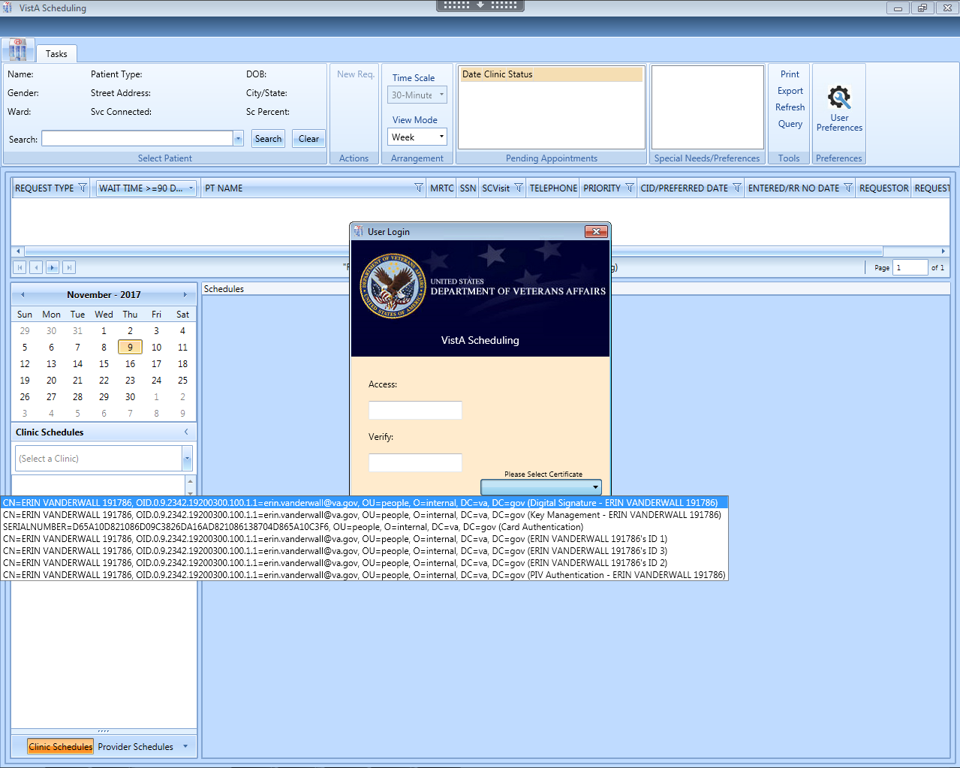

VistA Access Verify Codes are available as a back up log in method

PIV log in is preferred. Highlight the certificate that contains “PIV Authentication” and your name, then click OK.

Figure : User Login

**Note:** The main screen of the application informs users whether they are logged into the test or production environment. The environment to which the user is logged in will be displayed in the top right corner of the main screen page.

Figure : Main Screen with Test Environment Displayed

## Two Factor Authentication Using PIV Cards

You will be prompted to access VS GUI using your PIV card and Personal Identification Number (PIN). In order to do this, you must have taken the one-time action of linking your PIV card to your Vista account. If you have already linked your account when CPRS began PIV log in, you will not need to do it again for VS GUI. However, if you move to a different station/VistA instance, you may need to re-link to add your new VistA account to your PIV card.

If you have not already linked your account, you can do so by following this link <http://go.va.gov/qugx>**.** If you experience any issues or are unable to complete the linking/binding process, please contact the **Enterprise Service Desk at (855) 673-4357, Option 3, or by email to** ESDOtherSupport@va.gov**.**

**Note:** After selecting IAM Provisioning Service Link VistA to User you can tell if you’re already linked or there is no link by looking at the Vista Instances.

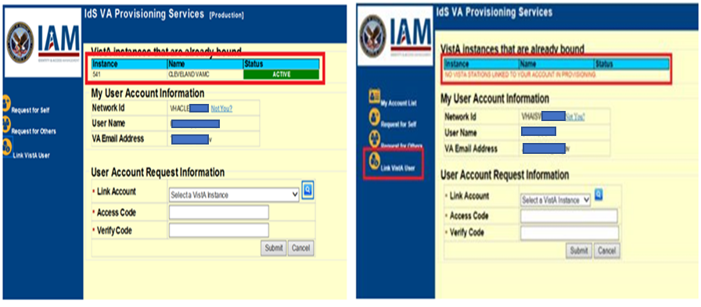

Figure : Linking PIV to VistA Account

If you are not able to log in with your PIV for any reason, you will be able to bypass the PIV logon on the log in pop up by inserting your Access code/Verify Code on the log in pop up box, but it is expected that a security mandate will **require** you to use two factor authentications in the future, so it is highly recommended that you link your account to avoid access problems in the future.

If you have used your PIV card in another capacity (logged into your computer, for instance) in the last few minutes, VS GUI may recognize that PIV activity, and automatically take you into the application without re-entering your PIV PIN.

Note: If the PIV authentication service itself is having problems authenticating, the user may get an error, even if they select the correct certificate. These are usually widespread outages affecting several applications. If the PIV service is going to be down for an extended time, the national PIV will remove PIV completely, and the user will see a message to use VistA login credentials. Either way, VistA credentials are the contingency and can be used whether or not PIV authentication is working.

## New Return to Clinic Orders (RTC Orders)

A nationally developed Return To Clinic (RTC) order dialog is included in CPRS version 31A. This order will allow VistA to transfer the national RTC orders to VS GUI as RTC requests. This will make it easier to transfer a providers RTC order information seamlessly into an appointment with minimal human error in data transfer. All facilities have received upgrades to both CPRS and VS GUI to allow this to happen, however implementation and use of the national RTC order may not be immediate, and in some sites, will take significant planning and coordination. Once clinical staff begin using the national RTC orders in CPRS, the resulting requests should be processed in VS GUI.

## Logging Off

To log off when you are finished scheduling appointments, click the close button (**X**) in the upper right corner of the VS GUI.



Figure : User Logoff

## VS GUI Tabs

The VS GUI provides the following tabs:

* **Tasks:** Allows the scheduler to search for patient requests, view clinic resources, and make appointments.
* **System:** Allows an administrator (with the SDECZMGR security key) to add/delete privileged users from a prohibited clinic and set up clinic groups.
* **Reports:** Allows for various reports to be generated by users holding the SDECZMGR security key.

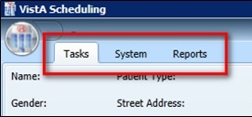

Figure : VS GUI Tabs

### Tasks Tab

The **Tasks** tab Ribbon Bar includes the following sections:

* **Select Patient:** Search for and view information about a selected patient
* **Actions:** Allows the sscheduler to initiate new APPT or Patient-Centered Scheduling requests
* **Arrangement:** Time Scale (slot length) displayed. Note: in this version, View Mode does not change the view of the calendar. Use the Day, Week, Month and Timeline buttons above the calendar itself to change the display.
* **Pending Appointments**: Date, clinic, and status of any pending appointments, past appointments (365 days back), and future appointments (1000 days forward) for the selected patient
* **Special Needs/Preferences:** Identified special needs and/or preferences for the selected patient missing the Patient Record Flags (PRFs)
* **Tools:** Options include print, export, refresh, and queries.
* **Settings:** Access to User Preferences.

The **Tasks** tab Resource area includes the following sections:

* Calendar to choose a desired appointment date and to search for and access **Clinic Schedules**, **Provider Schedules**, and **Clinic Groups**
* **Schedules:** View single or multiple clinic schedules in one screen

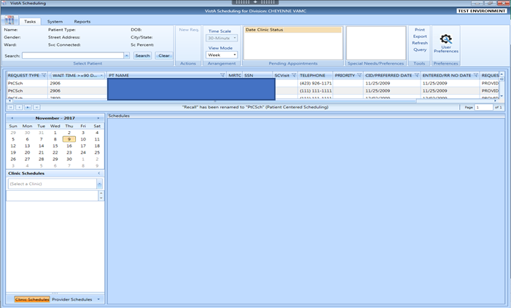

Figure : Tasks Tab Display

### System Tab Action Areas

The System tab includes the following sections:

* **Resource Management:** **Scheduling Management** allows for management of privileged users within Prohibited and Clinic Groups as well as the creation and management of clinic groups.
* **Resource Schedules** **Availability** allows for search of clinic, provider or clinic group by name.
* **Selected Clinic** provides a quick view of the selected clinic’s Primary Provider, Overbook Limit, Inactive Date, and ReactiveDate.

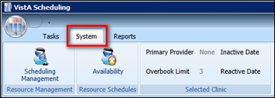

Figure : System Tab

### Reports Tab Action Areas

The **Reports** tab allows for viewing and exporting of **Audit Activity** and **Clinics** setup information. Please note: Audit Activity Report is now working. See details in 8.1

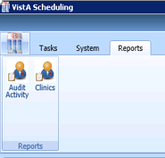

Figure : Reports Tab

## Searching

The search feature enables a scheduler to:

* View and search clinic profiles to view appointments resources by clinic, provider, or by clinic groups
* View and search patient requests by request type
* Sort the request queue by any column in ascending or descending order and filter.
* Sort results and save the search into various outputs, such as Microsoft Excel or Adobe PDF and print to a network printer.

### Search for Patient

1. Log into VS GUI.
2. From the **Tasks** tab, in the **Search** text box, type the search criteria for the patient. Click **Search**, and then select the requested patient’s name. Click **Search/Choose patient from the resulting list**.
3. In the Search field, the following options are available for searching for a patient:

* Last name,First name (no space between comma and first name)
* Full SSN
* First initial of the last name + last four of the SSN (ex. T0170)
* Last four of SSN (0170)
* Last name only (three-character minimum)
* Spacebar + Search will bring the last patient used in VistA, CPRS and VS GUI into the search drop down.

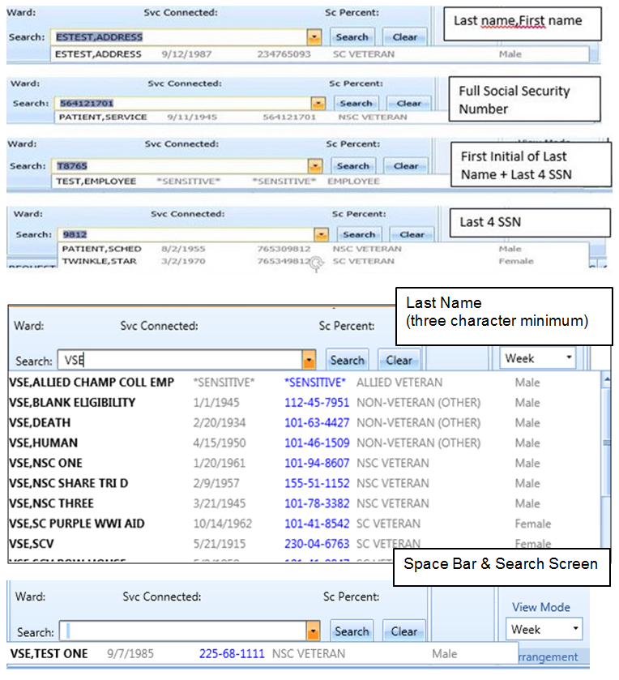

Figure : Patient Search

## Filtering

Filtering can be accomplished in several areas of the VS GUI. Items that can be filtered are:

* Lists
* Time Period
* Facility

The following sections describe basic filtering.

### Filtering Lists

You can filter any column on the request grid to narrow the type of information that you want to view.

1. In the request grid or pending appointments box, click any column that shows a filter icon.
2. Select a filter option.
3. Please note: Return to Clinic (RTC) are a sub-type of APPT Requests, and will be included if you check APPT.

NOTE: Filters often carry forward to other patients or activities. They do not automatically clear as the user moves from patient to patient, since many times the filter function is being used to work a list of open items and those filters should stay in place.

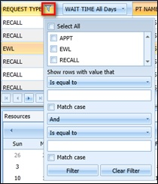

Figure : Filtering Lists

### Paging Through Records

Filtered results are retrieved from the database and displayed in 25 row increments.

To view additional records, use the arrow key located below the list to page through the records.

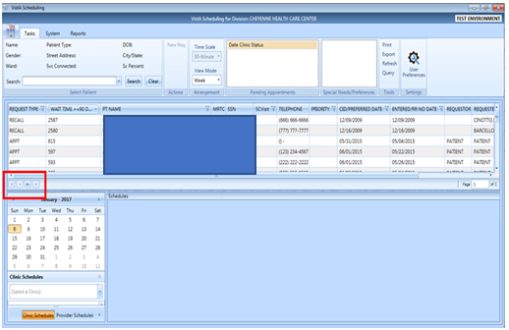

Figure : Paging Through Records

### Filtering by Facility or Clinic

1. To filter by facility or clinic, in the Clinic Schedules pane, type in the name of the desired clinic (six-character minimum when searching by clinic name; four-character minimum when searching by clinic abbreviation),
2. Click the name of the clinic from the list to view the desired clinic.

VS GUI Filtering by Facility or Clinic window

Figure : Filtering by Facility/Clinic

### Filtering by Time Period

1. To filter by time period, in the Resources pane, search for and select a desired clinic.
2. From the calendar, select a month and day for viewing appointments.

Click the back and forward buttons to go to the previous or the next month.

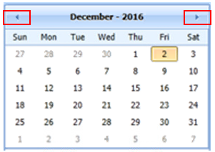

Figure : Filtering by Time Period

## Sorting

You can sort the consolidated list of requests in the request grid in different ways to isolate the information that you need to see.

### Sorting by Column

You can sort the consolidated list of requests in ascending or descending order. The default sort is by Priority Group, Service Connected priority, Preferred Appointment date, and Date entered (Request date).

**To sort by column:**

1. Log on to VS GUI.
2. Click any of the column headers to change the sort order.

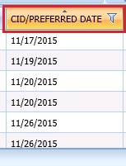

Figure : Sorting by Column

1. Click on the column header again to return to the default sort order.

### Sorting Pending Appointments by Column

You can sort the pending appointments of a patient by Date, Clinic and Status. Date sort is the default and the non-cancelled appointment closest to today’s date is displayed.

**To sort by column:**

1. Log on to VS GUI.
2. Click the Date, Clinic or Status column header to change the sort order.

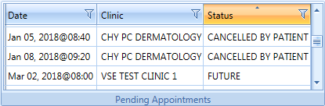

Figure : Sorting Pending Appointments list by Column

### Print Pending Appointment List for a Patient

The VS GUI allows for print of the Pending Appointment List. Use the following procedure to print.

* 1. Log on to VS GUI.
  2. In the “Search” field, search for the name of the patient you wish to print pending appointments for.
  3. Right click in the Pending Appointments section. Select **Print Pending** from the menu. Select desired printer, and then click **Print.**

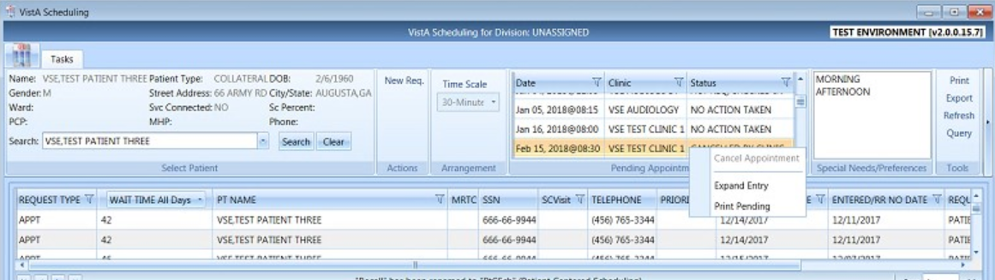

Figure : Print Pending

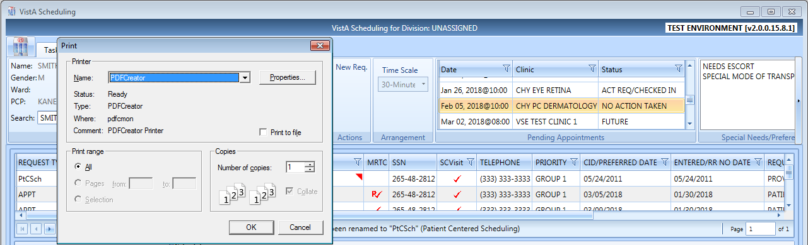

Figure : Select Desired Printer

## Printing and Exporting a Request Management Grid

### Printing a Request Management Grid

The VS GUI also allows for printing of a Request Management Grid. Use the following procedure to print a request grid.

**Note:** Only requests downloaded on the Request Management Grid will print.

1. On the Ribbon Bar, in the Tools section, select the **Print** option.

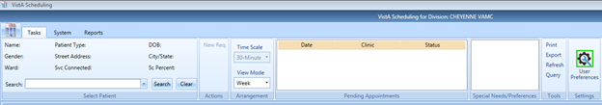

Figure : Selecting the Print Option

1. Select the desired printer, and then click **Print**.

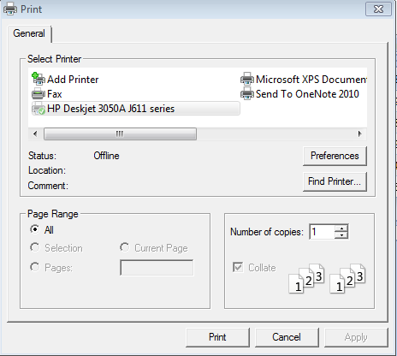

Figure : Selecting a Printer

### Exporting a Grid

The VS GUI also allows for exporting of a Request Management Grid in Microsoft Excel format.

**To export a schedule:**

1. On the Ribbon Bar, in the Tools section, select the **Export** option.

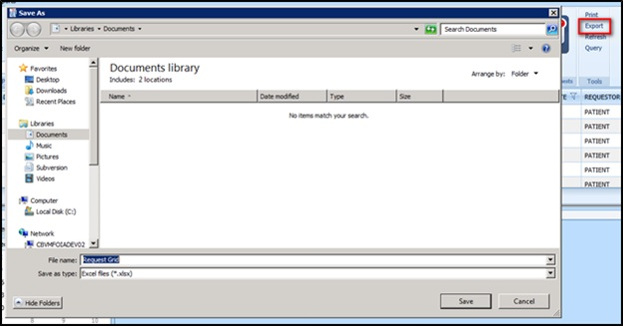

Figure : Exporting a Grid

1. In the **Save As** dialog box, type a file name, select a file type, browse to the location where you want to save the information, and then click **Save**.
2. Open the file and review the contents. All data displayed in the Request Management Grid is saved.

**Note:** Only data that was loaded on screen at the time of export will be exported to the file. Users may need to load more screens to see all the data.

## Viewing

### View Only Mode

A View Only mode is available for non-scheduling personnel. To provide this mode to a user, you will need the option SDECRPC, and the SDECVIEW security key must be assigned to the user. This mode allows users to view data in VS GUI but no changes or edits will be allowed. This key overrides other VS GUI keys and assigns the user to View Only of the Task Tab.

Information available for viewing includes:

* All Pending Requests
* Previously scheduled appointments
* Clinic with appointments scheduled
* Provider with appointments scheduled
* Clinic Group with appointments scheduled
* Patient demographics and special needs/preferences
* Expanded Entry to display appointment audit details such as create date/time
* Query Tool to display a custom list of open requests

### Viewing Requests by Request Type

A Scheduler can view requests for Veteran Appointments (APPT) requests—Consults, Procedure, Veteran, Patient-Centered Scheduling reminders, or EWL reminders. The default view is for requests that are 90 days or older. Users can change the view for a particular session or change the default view by changing their user preferences (refer to Section 4.7).

Requests display 25 records at a time. Additional requests can be viewed by going to the next page.

**To view requests by request type:**

1. Log on to VS GUI.
2. View the request grid. Consult, APPT, EWL, Procedure, and Patient-Centered Scheduling requests that have a wait time of 90 days or more will appear in the grid. The preferred date for the patient request type is shown in the **Clinically Indicated Date (CID)/Preferred Date** column.

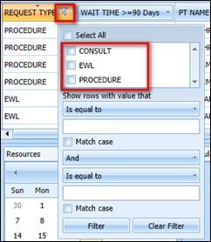

Figure : Request Type Column

1. Click the **Request Type** column to filter specific requests. Only request types that are in the current request grid display in the filter tool.
2. Select **EWL** to view the Electronic Wait List requests.
3. Select **APPT** to view appointment requests (and RTC requests if the category does not appear on its own.)
4. Select **RTC** to view Return to Clinic requests (may be included in APPT for some views including the query tool)
5. Select **Patient-Centered Scheduling** to view Patient-Centered Scheduling requests.
6. Select **Procedure** to view procedure requests.
7. Select **Consult** to view consultation requests.
8. Or you can use any combination of the above.

### Viewing Requests by Patient

**To view requests by patient:**

1. Log on to VS GUI.
2. From the **Tasks** tab, in the **Search** text box, type the patient’s last name or the patient’s first initial of the last name and last four of the SSN (e.g. S1234), Click **Search**, and then select the requested patient’s name.

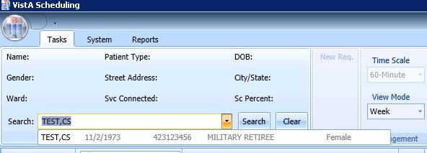

Figure : Select Patient

1. In the **Request Type** dialog box select either **APPT** or **PATIENT-CENTERED SCHEDULING,** and then click **OK** or click **Cancel to see the existing open requests**.

The patient’s pending requests are displayed in the Request Management Grid, 25 records at a time. Booked appointments are displayed in the Pending Appointments window on the Ribbon Bar of the **Tasks** tab.

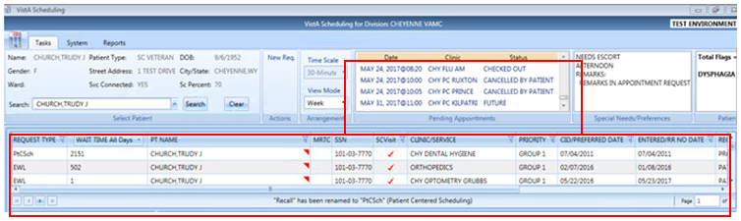

Figure : Patient Pending Requests and Booked Appointments

### Schedule View

The buttons across the top of the calendar are the only working method to change the view the schedule.

The default schedule view displays the clinic schedule by week. but the view can be changed to day or month view for ease of scheduling. To change the schedule view:

1. Log on to VS GUI.
2. Search and select a Clinic to open.
3. To change a view for a specific schedule, at the top of the Schedules section, click the tab of your choice. The available views from the schedule include:

* Day
* Week
* Month
* Timeline

See the week view display below.

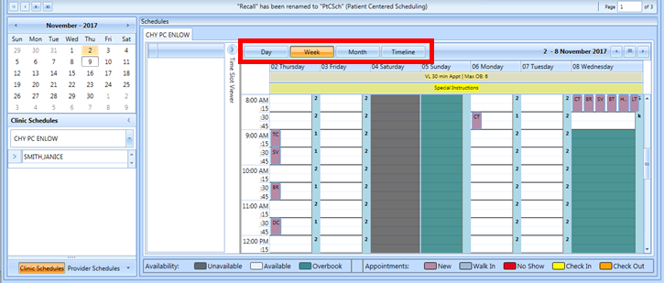

Figure : Changing View of a Specific Schedule

# Ribbon Bar

The following section outlines the features available in the Ribbon Bar of Schedule Manager.

## Patients Demographics

### Finding a Patient

1. Log on to VS GUI.
2. From the **Tasks** tab, in the **Search** text box, type the patient’s last name or the patient’s first initial of the last name and last four of the SSN (e.g. S1234). Click **Search**, and then select the requested patient’s name.
3. Select the requested patient’s name from the list.

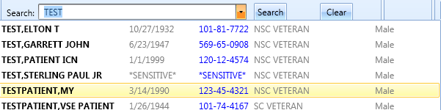

Figure : Search Patient

### Viewing Patient Demographics in the Ribbon Bar

You can view basic patient demographic information in the Ribbon Bar; it provides a limited amount of patient information, but you can choose to display more patient details. To view patient demographics in the Ribbon Bar:

1. Log on to VS GUI.
2. From the **Tasks** tab, in the **Search** text box, type the patient’s last name or the patient’s first initial of the last name and last four of the SSN (e.g. S1234). Click **Search**, and then select the requested patient’s name.

View the patient demographics in the Ribbon Bar. The following patient demographics are available:

* **Name:** Last name, First name
* **Patient Type:** VA patient type
* **DOB:** Date of birth in mm/dd/yyyy format
* **Gender:** Male (M) or female (F)
* **Street Address:** Patient’s street address
* **City/State:** Patient’s address city and state
* **Ward:** For inpatients, current ward location display
* **Svc Connected:** Is the patient service connected (YES or NO)
* **SC Percent:** Percent of service connected disability
* **PCP:** The patients Primary Care Provider
* **MHP:** The patients Mental Health Provider
* **Phone:** List the primary phone number of the patient

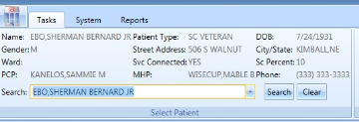

Figure : Patient Demographics in the Ribbon Bar

1. Click anywhere in the Select Patient section of the screen to view the Patient Inquiry Detail screen. This allows for viewing of additional patient information, including the patients Primary Care team and provider, if applicable.

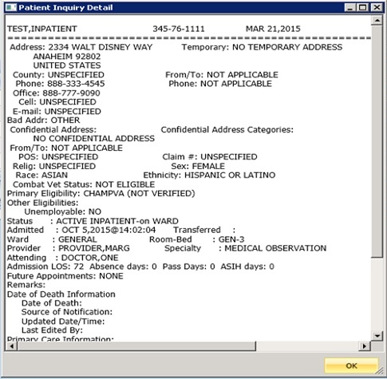

Figure : Patient Inquiry Detail

### Patient Eligibility Information

When adding a new Patient-Centered Scheduling or APPT request, the **Patient’s Eligibility Information** window displays along with the **New Appointment** dialog box. The user can move the **Patient’s Eligibility Information** window around the screen, for convenience. Changes to eligibility may take 5 to 20 minutes to show in VS GUI as there are task jobs running to verify the change before it is fully posted to the patient’s file. Please refresh if you know the patient had a recent change in eligibility.

The window includes:

* SC Percent
* Current Disabilities
* Primary and Secondary Eligibility Codes

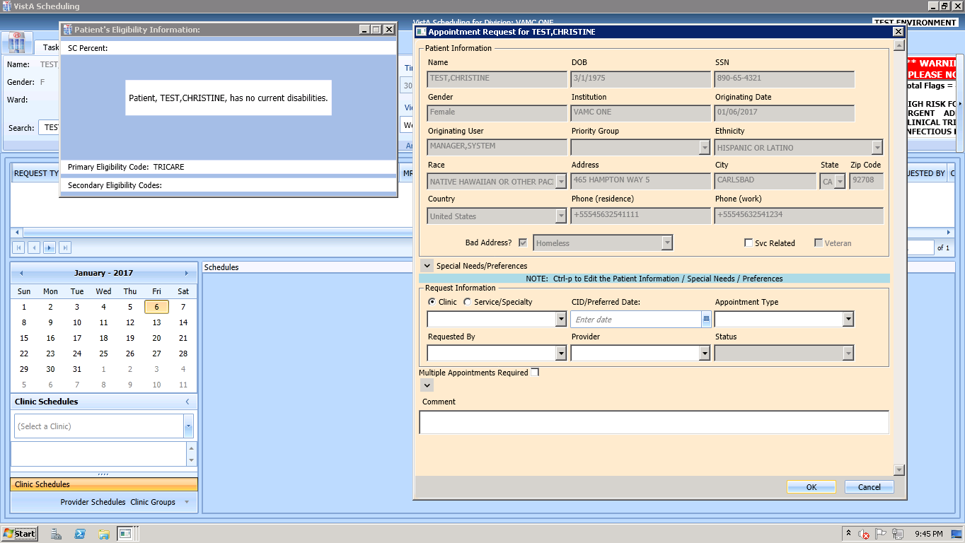

Figure : Patient's Eligibility Information

When the **New Appointment** dialog box is closed, the **Patient Eligibility Information** window closes automatically.

### Updating Patient Demographics

Patient demographic information, such as ethnicity, race, address, state, ZIP code, country, or phone numbers that were not defined during registration, can be updated at any time during the process. Perform the following procedure to update patient demographic data.

1. Log on to VS GUI as a Scheduler.
2. From the **Tasks** tab, in the **Search** text box, type the patient’s last name or the patient’s first initial of the last name and last four of the SSN (e.g. S1234). Click **Search,** and then select the requested patient’s name. Click **Search**.
3. Press CTRL+P to open the Patient Info screen. Alternatively, right click in the patient demographics box or the patient preferences box.

Patient demographic information can now be displayed and edited at any point in the process. Undefined patient demographic information displays in lists and text fields, on the Patient Information window.

**Note:** Information that appears dimmed cannot be edited.

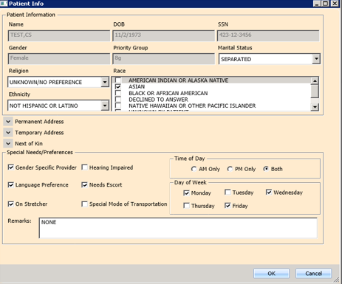

Figure : Patient Information Dialog

1. Click **OK** to update patient demographics. At this point, the updated information displays in the Ribbon Bar.
2. Click **Cancel** to go back to the all patients view.

**Note**: If the patient is being edited in VistA Register a Patient or Load/Edit Patient Data and the user attempts to save edits made to the Patient Info data, a “Patient is being edited” warning message will appear and the user must click OK and Cancel to get out of the Patient Info screen until the VistA Register a Patient or Load/Edit Patient Data option is exited.

Patient is Being Edited Warning Pop-up

Figure : Patient is Being Edited Warning Pop-up

### Editing Permanent Address

The Permanent address for a patient can be edited.

1. Point to the **Patient Info** screen, which is available at any point via the RM Grid.
2. Press **CTRL + P** to view the patient’s information.

A user can update the patient’s address Line 1 and 2, Zip Code, and Phone Numbers.

* Zip Code – five or nine digits (when entered, the system provides choices for Cities that match that zip code and based on that, automatically completes the State and County fields).
* For Phone numbers, VS GUI automatically formats the Patient Work Phone to (xxx) xxx-xxxx if 10 digits are entered. If more than 10 digits are entered, it auto formats to x-xxx-xxx-xxxx x….

Only characters (,), +, -, and X (Except Cell and Pager) are allowed in the Phone Numbers.

1. Click **OK** when complete to save the information.

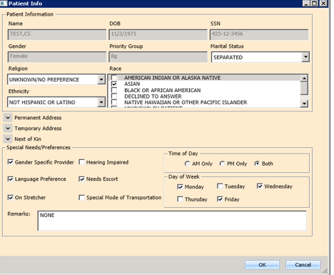

Figure : Patient Info Dialog–Permanent Address

**Note:** Areas highlighted in gray cannot be edited.

### Adding a Temporary Address

A temporary address can be entered for a patient.

1. Point to the **Patient Info** screen.
2. Press **CTRL + P**, which is available at any point in the RM Grid.

**Note:** The Address Active Box should be checked with a Start Date and End Date

A user can update the patient’s address Lines 1 – 2 and Zip Code. Zip Code can be five or nine digits (when entered, the system provides choices for Cities that match that zip code and based on that, automatically completes the State and County fields).

1. Click **OK** when complete to save the information.

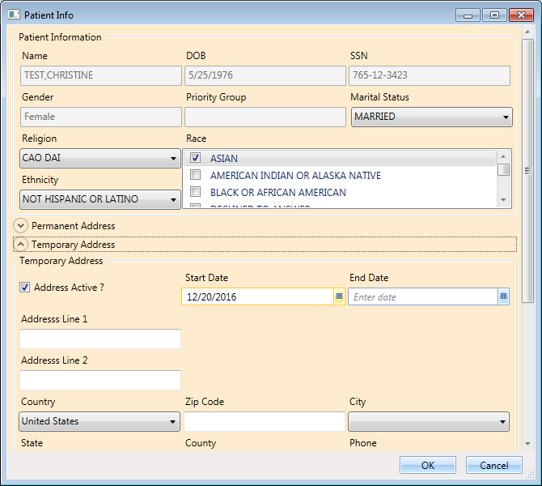

Figure : Patient Info Dialog – Temporary Address

**Note:** Areas highlighted in gray cannot be edited.

### Bad Address

A patient’s address may be incorrect (e.g., mail has been returned as undeliverable, or if the patient is homeless). If you learn that a patient’s address is incorrect, you must indicate that information on the patient’s record so notices are no longer sent. The incorrect address can be indicated while updating the patient’s address information in the Patient Info dialog.

1. Log on to VS GUI as a Scheduler.
2. From the Tasks tab, in the **Search** text box, type the patient’s last name or the patient’s first initial of the last name and last four of the SSN (e.g. S1234). Click **Search**, and then select the requested patient’s name.

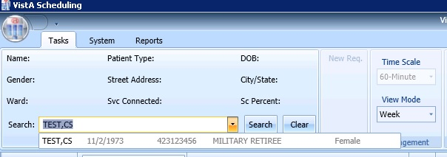

Figure : Select Patient

1. In the **Request Type** dialog box, click **Cancel**.

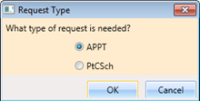

Figure : Request Type

1. Press **CTRL + P** to open the Patient Information dialog screen. Confirm that the patient’s address information is incorrect or missing, and then click to check the Bad Address check box.

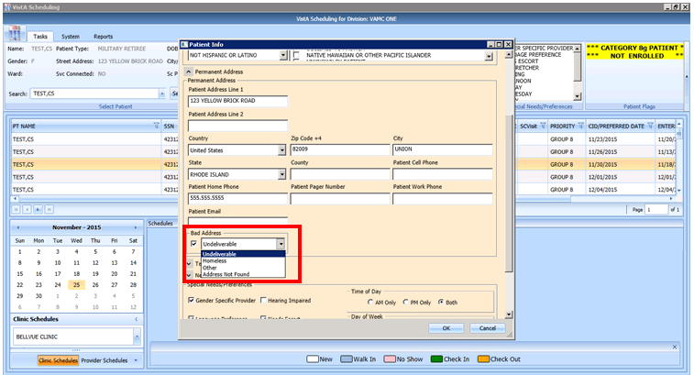

Figure : Appointment Request Dialog—Bad Address Selection

1. Choose the reason for the bad address:
2. Undeliverable
3. Homeless
4. Other
5. Address Not Found
6. Click **OK**.

Note: If a scheduler later obtains a correct address and updates the patient’s record, the scheduler must ensure that the bad address flag is REMOVED manually. If the bad address remains, mail will not resume being sent to the patient.

## Actions

### New Request

After searching for and accessing a specified patient’s demographics and associated pending appointments, the Actions pane allows you to create a new request for the patient. For example, creating a Patient-Centered Scheduling request as a follow-up to an appointment request or creating a new appointment request after looking at only patient information.

**To start a new request for an already selected patient:**

1. Patient demographics and pending appointments appear in the Ribbon Bar. In the Actions pane, select **New Request**.

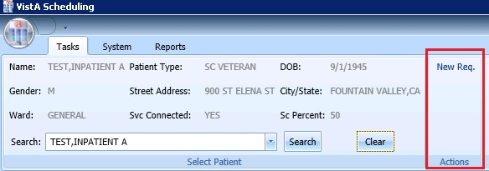

Figure : Actions Pane

The Request Type dialog box opens.



Figure : Request Type – APPT

1. Click the Request Type, and then click OK.

## Pending Appointment Window

The Pending Appointment Window displays a patient’s existing appointments. The appointment view defaults to the current date. The Scheduler can utilize the scroll bar to the right to scroll up to view appointments 365 days in the past. Or, the Scheduler can utilize the scroll bar to scroll down to view appointments 1000 days in the future.

Selecting an appointment from the Pending Appointment window in the Ribbon Bar opens the Clinic Schedule Grid. When you select a past appointment, the clinic schedule defaults to the appointment’s date.

Right click on an existing appointment in either the Pending Appointments box or in the calendar to select Expanded Entry. This will show the audit history of that appointment’s creation, check in, etc.

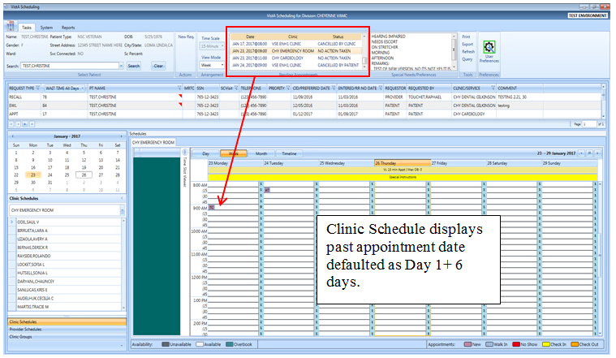

Figure : Pending Appointment Window – Past Appointment Date

The clinic schedule defaults to the current date (today’s date) when you select an appointment dated “today” or less than three days in the future.

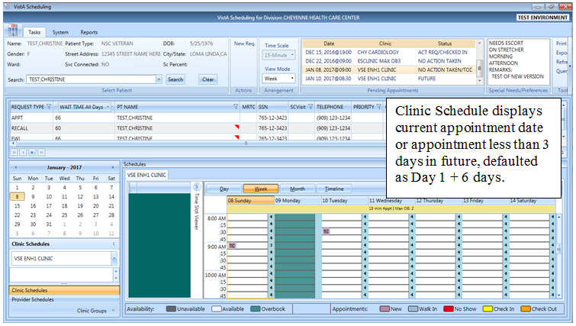

Figure : Pending Appointment Window – Current less than Three Days in Future

The clinic schedule defaults to -/+ three days of the appointment date for future dates.

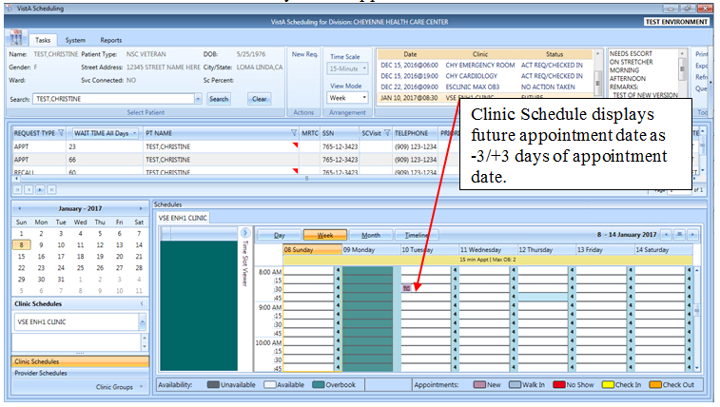

Figure : Pending Appointment Window – Future Appointment Dates

## Special Needs/Preferences

### Adding/Removing Special Needs/Preferences from Requests

Patients visiting the VA may require additional assistance when they arrive for their visit. Some of these special needs/preferences may include issues with hearing, how they are arriving at the VA, Day of the Week or Time of the Day, etc.

**To add Special Needs/Preferences to an appointment request:**

1. Log on to VS GUI
2. From the **Tasks** tab, in the **Search** text box, type the patient’s last name or the patient’s first initial of the last name and last four of the SSN (e.g. S1234). Click **Search**, and then select the requested patient’s name. Click **Search**.
3. Press **CTRL + P** to open the Patient Info dialog box.
4. Select the patient’s special needs from the Special Needs/Preferences section of the Patient Info dialog box.
5. Add additional information regarding patient’s Special Needs/Preferences selections in the Remarks field.

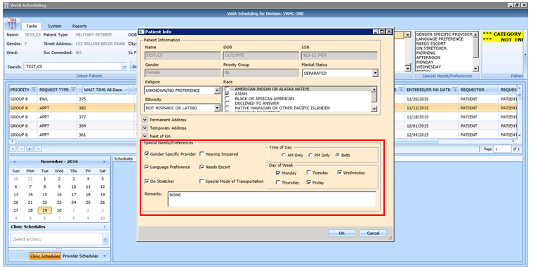

Figure : Patient Info Dialog – Special Needs/Preferences Section

1. Click **OK**. The Special Needs/Preferences entered display in the Ribbon Bar.

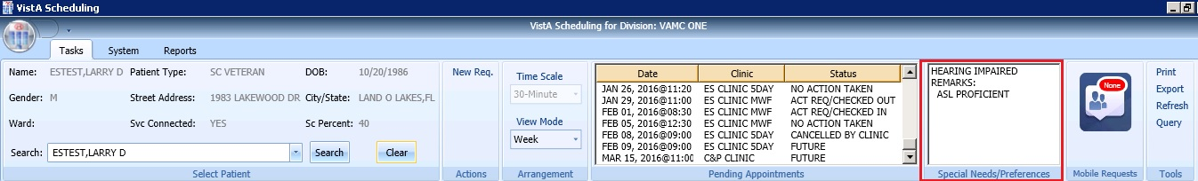

Figure : Ribbon Bar – Special Needs/Preferences

## Patient Flags

PRFs are used to alert VHA medical staff and employees of patients whose behavior and characteristics may pose a threat either to their safety, the safety of other patients, or compromise the delivery of quality health care. PRF assignments are displayed during the patient look-up process. Each PRF includes a narrative that describes the reason for the flag and may include some suggested actions for users to take when they encounter the patient.

When a patient’s record is flagged, a message window opens with an appropriate action recommended.

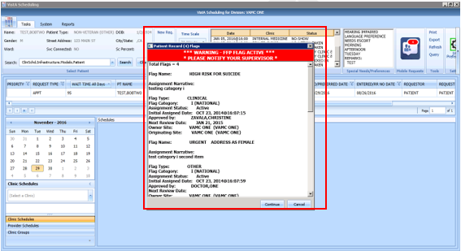

Figure : Patient Record Flags Dialog

1. Select an appropriate action.
2. To continue processing the appointment, click **Continue**; otherwise, click **Cancel**.

Once processing has continued, the PRF continues to show on the Ribbon Bar. If the user clicks on PRF in the flag box in the ribbon bar, the pop up box containing flag details will return.

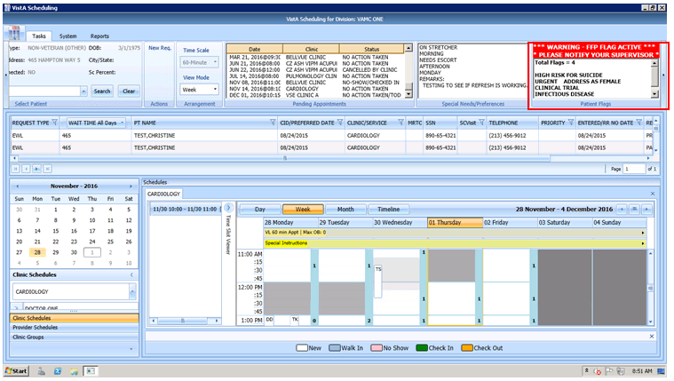

Figure : Patient Record Flags

## Tools

### Print

**Note:** The print buttons in the letter printing window previous read Print (Local) and Print (Server). Now they read Print (Windows Printer) and Print (VistA Print Device), respectively.

Refer to Section 3.8.3 for details on printing the pending appointments list for a patient.

Refer to Section 3.9.1for details on using the Print functionality in the Tools Pane via a network printer. If you are printing a patient letter using this method, the address will print too high on the page to fit into a windowed envelope.

Refer to Section 6.1.1  for details on printing using an active VistA print device. This method is vastly preferred as it places the address into the correct spot for windowed envelopes and allows schedulers to print to their office printer, centralized printers or other bulk mail devices that are used in VistA for processing outgoing mail.

### Export

Refer to Section 3.9.2for details on exporting the request grid.

### Refresh

After checking a patient’s pending appointments or checking availability for a clinic, you may want to reset the GUI back to the default view from when you first logon to the GUI, clearing all text entered in any fields.

1. To refresh the GUI, go to the Tools pane.
2. Click **Refresh**. The GUI resets to its default logon view.

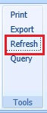

Figure : Refresh Button in Tools Pane

### Query

In order to sift through patient data and only view data of a specific type, the Query tool can be utilized to show only data matching specific criteria. Once the query has been performed, only records matching the query criteria appear in the request grid.

* Patients are in **Group A** and can be used independently or in conjunction with other search criteria.
* Request Type + Clinic/Services are in **Group B**. This group can be used independently or in conjunction with other search criteria.
* Priority, Wait Time, SC Visit, Service Connected, Origination Date, CID/Preferred Date and Urgency are in **Group C**. This group must be combined with other search criteria from either Group A, Group B, or Group A and B to satisfy the Query Tool business rules.

**To perform a query:**

1. Log on to VS GUI.
2. Select **Query** from the **Tools** pane. The **Request Query** window displays.

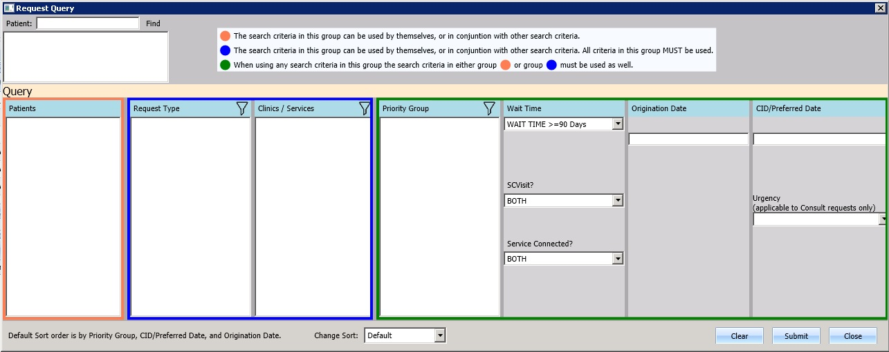

Figure : Request Query

1. Click **Submit**. If the search criteria rules are not satisfied, a **Query Rule Validation** dialog box displays.

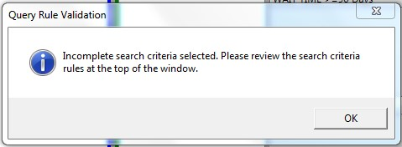

Figure : Query Rule Validation

Once all search criteria has been selected and the results have been returned, a **Request Query Confirmation** dialog box displays the number of records found that satisfied the search criteria.

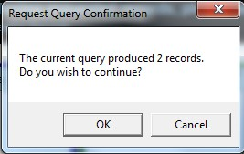

Figure : Request Query Rule Confirmation

1. Click **OK** to display the Query results in the Request Management Grid.
2. Click **Cancel** to remove search criteria and start a new search.

Note: RTC requests are a subtype of Appointment Requests. In version 2.0.0.14, chose Appointment to see both APPT and RTC requests. In addition, the query tool will only return the first 200 entries found in the search. The user will be asked if they want to continue and view the first 200 or go back to limit the search. Once the list displays, page forward until the user reaches the end of the list to sort/filter on the entire list. The query tool will retain the search criteria of the last search in a user’s session to aid the user while they work a list of open requests.

## Settings – User Preferences

Users may now set their own column preferences within a session or as their default view.

From the far right of the Ribbon Bar, select the User Preferences setting icon.

The current column order is:

Request Type;

Wait Time; (Wait time calculated from Create date to today)

Patient (PT) Name;

Multiple Return To Clinic (MRTC);

SSN;

SC Visit;

Telephone;

Priority;

CID/PreferredDate;

Entered/RR No Date;

Requestor;

Requested By;

Clinic/Service; and

Comment

**Note**: Users can drag and drop columns to reorder them. Save as default and accept to save the order from session to session. Reordered columns do NOT have any effect on log in times and are highly encouraged as Clinic/Service and CID/Preferred Date are far to the right in the default order.

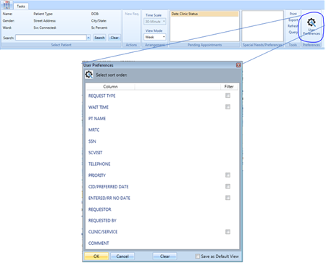

Figure : Settings – User Preferences

Filters on the following fields are also available:

* Request Time
* Wait Time
* CID/Preferred Date
* Clinic/Service
* SC Visit
* Priority
* Entered/RR (Recall Reminder) No Date

**NOTE**: **Adding filters to user preferences is highly discouraged at this time**. If the user restricts their log in with filters, and the system cannot find any open requests, the log in will take an excessive amount of time. If a user experiences long log in times, clear all preferences.

**To save your user preferences:**

1. Select the sort order or filters to display.

To save the selections as your default view, select “Save as Default View” on the bottom right. If you do not select “Save as Default View,” your selections will only be applicable to your current session.

1. Click OK to save.

**Note:** If you filter the requests to view only Consult requests you will not see the PtCSch requests unless you unfilter the preferences.

The User Preferences Settings icon is highlighted in green indicates the user preferences are stored.

**To remove any existing user preferences for the user’s default view:**

1. Click the User Preferences icon.
2. In the User Preferences window, click **Clear, Save as Default View,** then click **OK** to save.

The User Preferences Settings icon will now display without the green highlight when no user preferences have been stored.

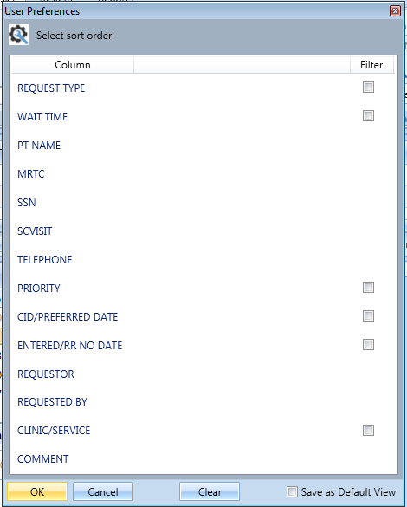

Figure : Settings – Save as Default View

# Request Management

## Request Management Procedures

### Viewing a Patient’s Existing Requests

1. Log on to VS GUI.
2. From the **Tasks** tab, in the **Search** text box, type the patient’s last name or the patient’s first initial of the last name and last four of the SSN (e.g. S1234). Click **Search**, and then select the requested patient’s name.
3. Click Search.
4. Select the requested patient’s name from the list.

In the Request Management grid, view the existing requests for the selected patient.

**Note:** The patient’s booked appointments display in the Pending Appointment Window in the Ribbon Bar. The default is the current date. Schedulers can scroll up or down to view appointments dated -365 days to +1000 days of the current date.

1. Click a Request Type entry and the Prerequisites screen opens. **Prerequisites are for RTCs only and the Prerequisite box will open if there is a Prerequisite note. #NLT# will display in the comments if the provider selected “NO LATER THAN” for a priority request.**

* The Prerequisite screen will remain open while the user is on the Request Management Grid.
* If switching to a Request Type with no Prerequisites, then the Prerequisite screen will go away.

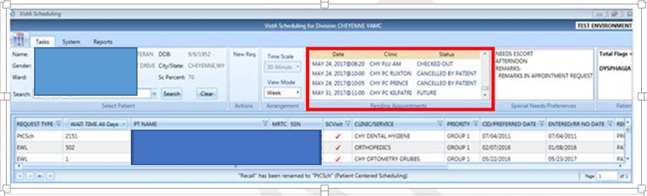

Figure : Request Grid and Pending Appointments

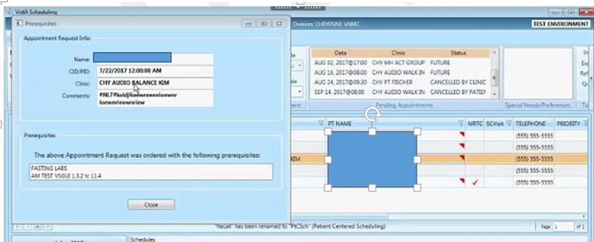

Figure 54: Prerequisite Screen

1. Right-click on an appointment in the Pending Appointments block and the EXPAND ENTRY block opens.

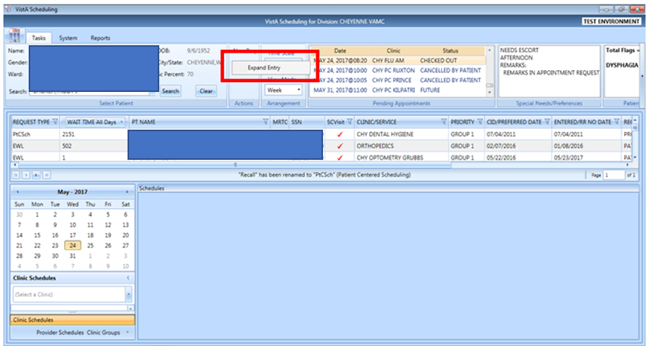

Figure : Request Grid Displaying Expand Entry Block

1. Click the Expand Entry block to see the expanded appointment information.

* Appointment Demographics
* Appointment Event Log
* Appointment Wait Time
* Patient Information
* Encounter Information (this information will only display if the encounter information has been entered for this patient)

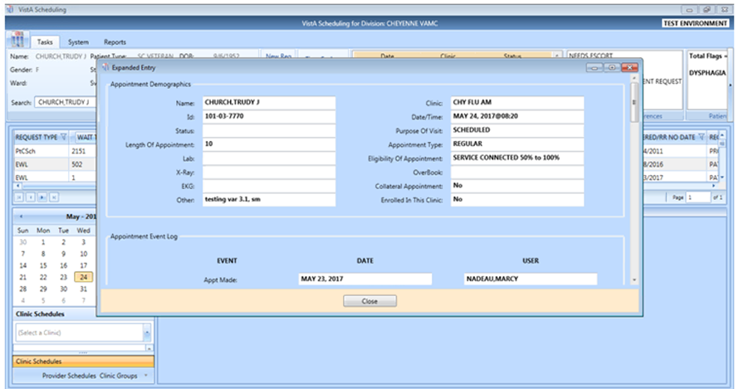

Figure : Appointment Demographics

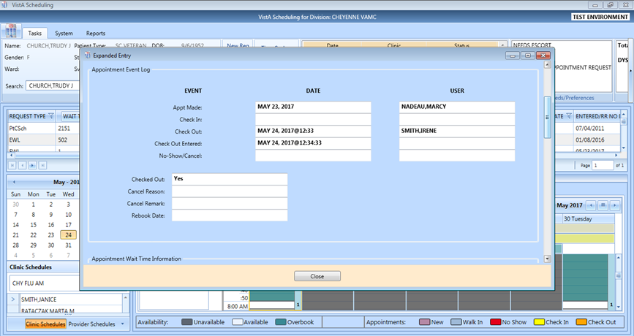

Figure : Appointment Event Log

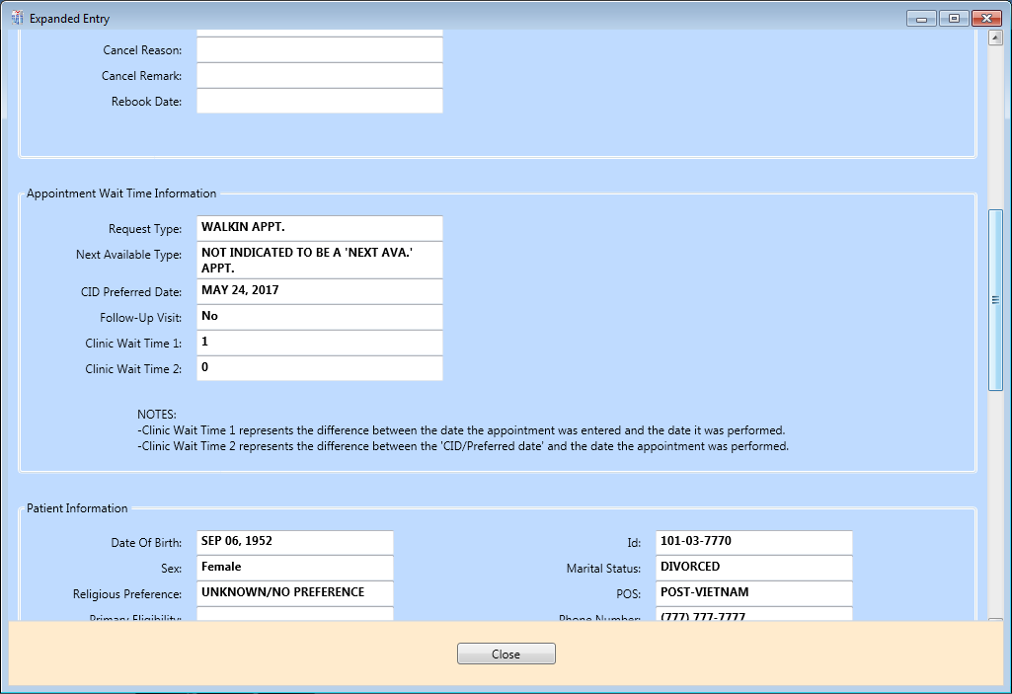

Figure : Appointment Wait Time

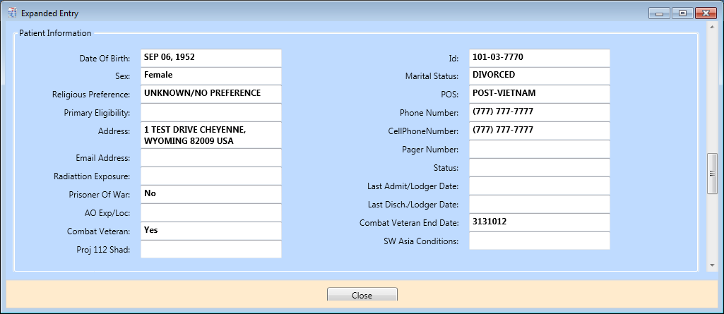

Figure : Patient Information

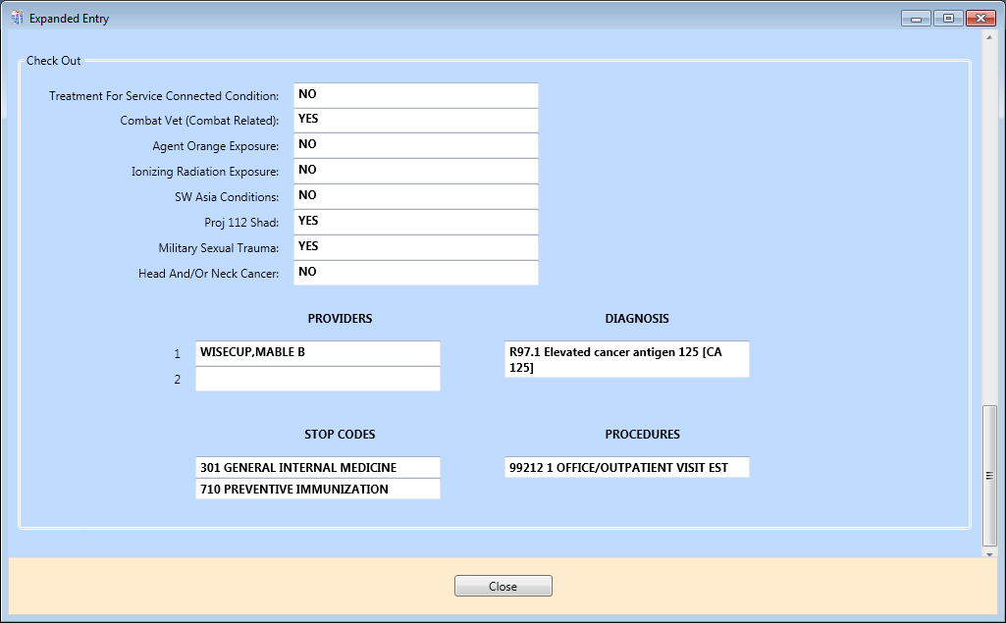

Figure : Encounter Information

**Note:** This information will only display if the encounter information has been entered for this patient.

### Adding Appointment Request

1. To submit an appointment request, from the **Tasks** tab search for the patient using the Search field.
2. Select **APPT** in the **Request Type** dialog box.



Figure : Request Type - APPT

**Note:** If the patient has already been selected, the **Request Type** dialog box can be accessed via **New Req.** in the Actions Pane of the Ribbon Bar.

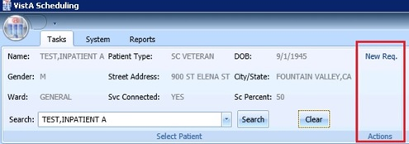

Figure : Actions Pane—New Req. Selection

1. In the **Appointment Request** dialog box, confirm Patient Information details.
2. In the **Appointment Request** dialog box, complete the **Request Information** section.
3. Click the **Clinic** or **Service/Specialty** button. For Clinic, enter clinic name (minimum of six characters) or Clinic abbreviation. For Service/Specialty enter service or specialty (minimum of six characters required).
4. Enter **CID/Preferred Date** for the preferred appointment/Patient-Centered Scheduling date. Enter date directly or select date from Calendar control option. CID/Preferred Date can be past, current, or future.
5. Select **Appointment Type** if not defaulted by patient eligibility and clinic selection then choose from the list.
6. In **Requested By**, select either Provider or Patient.

If **Provider** is selected, then enter the provider name (three-character minimum for the list to populate) and select from the list.   
**Note:** If the Patient was selected from Requested By, then the Provider field appears dimmed and cannot be edited.

* **Status** is automatically populated.

1. Established – The patient has been seen at that clinic in the past 24 months.
2. New – The patient has not been seen at that clinic in the past 24 months.

Refer to Section 6.3.2 for additional instructions regarding Multiple Appointments Requiredcheck box options.

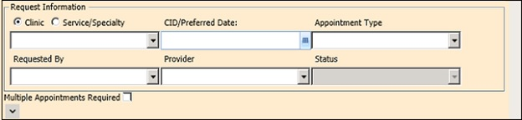

Figure : Appointment Request Dialog – Request Information Section

If needed, users can view existing special needs and preferences in the middle section drop down box. If changes are needed, the user can call the edit special needs and preferences box by **CTRL + P**, complete the **Special Needs/ Preference** section. The **Remark**s field is available to add clarifying information regarding selections made. **Selected Special Needs/Preferences** and **Remarks** display in the Ribbon Bar.

**Note:** Text can be added in the **Remarks** field up to 80 characters to add information regarding the Appointment Request. Text displays in the Request Management Grid under the Comment column.

1. Click **OK**.

Updated demographics display in ribbon bar. The APPT Request appears on the Request Management grid. The Clinic Schedule Grid opens for the clinic specified in the request.

**Note:** APPT Requests with Comments are flagged with a red arrow in the Request Management Grid.

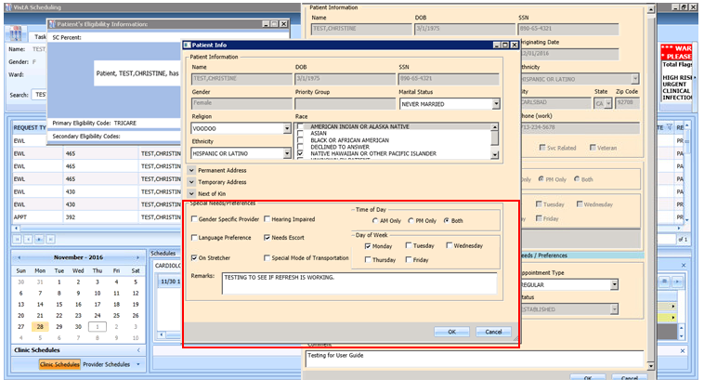

Figure : Special Needs/Preferences Section from Patient Info Dialog

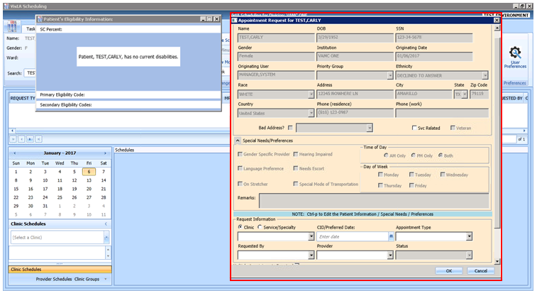

Figure : Appointment Request Dialog

### Viewing/Editing Appointment Request

If a request (APPT, EWL, Veteran) needs to be reviewed or modified before being booked, you can View/Edit the request in the Request Grid:

1. Log on to VS GUI as a Scheduler.
2. From the **Tasks** tab, in the **Search** text box, type the patient’s last name or the patient’s first initial of the last name and the last four of the SSN (e.g. S1234). Click **Search**, and then select the requested patient’s name. Click **Search**.
3. Select the requested patient’s name from the list.

**Note:** When the **Spacebar + Search** is used, the Ribbon Bar and Request Management Grid adjust to that selected patient.

1. In the **Request Management** grid, right-click the applicable **APPT** request.
2. Select APPT/VETERAN Disposition option.

The following options appear for selection:

* View Request
* Edit Request
* Transfer to EWL – refer to Section 5.1.5 for instructions
* Death
* Removed/Non-VA Care
* Removed/Scheduled-Assigned
* Removed/VA Contract Care
* Removed/No longer Necessary
* Entered in Error

1. Select **View Request**. The **Appointment Request** dialog box opens with everything dimmed as the dialog box is Read-Only.

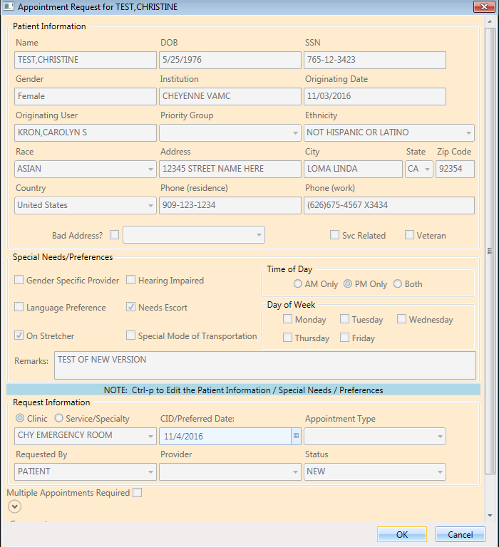

Figure : View Request (Read Only)

1. Click **OK**.

You return to the Request Management Grid.

1. Right-click the applicable **APPT** request.
2. Select the APPT/VETERAN Disposition option.

The following options appear for selection:

* View Request
* Edit Request
* Transfer to EWL. Refer to Section 5.1.5 for instructions
* Death
* Removed/Non-VA Care
* Removed/Scheduled-Assigned
* Removed/VA Contract Care
* Removed/No longer Necessary
* Entered in Error

1. Select Edit Request.

The Appointment Request and Patient’s Eligibility Information dialog display.

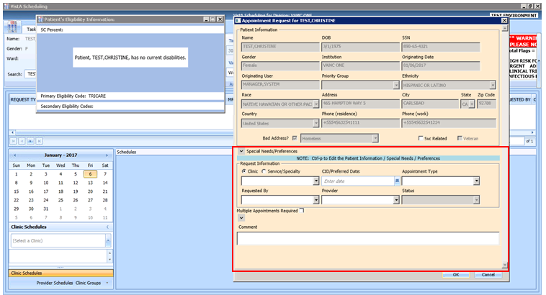

Figure : Edit Request (Request Information Only)

The editable fields are Clinic/Service Specialty; Appointment Type; Requested By; Provider, and Comments. The CID/Preferred Date CANNOT be edited.

1. Click **OK**.

The request returns to the Request Management Grid with the updated information listed.

**Note:** If you change the request for a Clinic to a Service/Specialty request, the **Appointment Type** field can then be edited. Also, changes to the **APPT Request** are tracked by the system in the SDEC APPT REQUEST file.

### Disposition or Removing an Appointment Request

If an APPT request is no longer needed, the Scheduler can remove it from the Request Grid following the steps below.

1. Log on to VS GUI as a Scheduler.
2. From the **Tasks** tab, in the **Search** text box, type the patient’s last name or the patient’s first initial of the last name and last four of the SSN (e.g. S1234). Click **Search**, and then select the requested patient’s name.
3. Click **Search**.
4. Select the requested patient’s name from the list.
5. In the **Request Management** grid, right-click the applicable **APPT** request.
6. Select APPT/VETERAN Disposition option.

The following options appear for selection:

* Transfer to EWL. Refer to Section 5.1.5 for instructions
* Death
* Removed/Non-VA Care
* Removed/Scheduled-Assigned
* Removed/VA Contract Care
* Removed/No longer Necessary
* Entered in Error

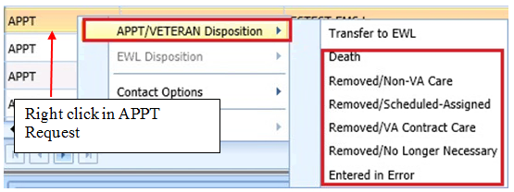

Figure : APPT/Veteran Disposition Options

1. Select the applicable APPT Disposition option. APPT Request is removed from Request Management Grid.

### Transfer to EWL Request for a Patient

If an appointment cannot be scheduled because of limitations, the patient is put on an EWL for future scheduling. Use the following procedures to transfer an APPT Request to an EWL Request.

1. Log on to VS GUI as a Scheduler.
2. From the **Tasks** tab, in the **Search** text box, type the patient’s last name or the patient’s first initial of the last name and last four of the SSN (e.g. S1234). Click **Search**, and then select the requested patient’s name.
3. In the **Request Type** dialog box, click **Cancel**.
4. In the **Request Management** grid, view the open APPT Requests for the patient.
5. Select the **APPT** request that needs transferred to **EWL**.
6. Right-click the APPT request and select **APPT/VETERAN Disposition**.
7. In the APPT/VETERAN Disposition options, select **TRANSFER TO EWL**. The **EWL Request** dialog box displays.  
   **Note:** The Transfer to EWL option is not available for MRTC appointments nor is it available for users who do not have the SDWL MENU Security Key.

Confirm **Clinic** is the default in the dialog box. If not, search for and select the appropriate Wait List Clinic by name. Searching by clinic abbreviation is not supported in the EWL Request dialog.

**Note:** Clinic or Service (stop code) does not default if it is not activated as Wait List Clinics in SD Wait List Parameter (File #409.32).

**CID/Preferred** date and Status are not editable.

**Appointment Type** is the default from APPT Request Clinic. If a patient is a Veteran and the Service Related box is checked, the Appointment type defaults to Service Connected. Also, if the Service Connected disability is greater than or equal to 50%, the Appointment type defaults to Service Connected. This puts the EWL request in a higher priority than other EWL requests.

**Requested By** and **Provider** are populated from the original APPT request but are editable.

Enter **Comments** as appropriate.

1. Click **OK**.

The request grid shows requests of the selected patient. The newly added request is selected. The calendar defaults to the desired date and shows the clinic schedules.

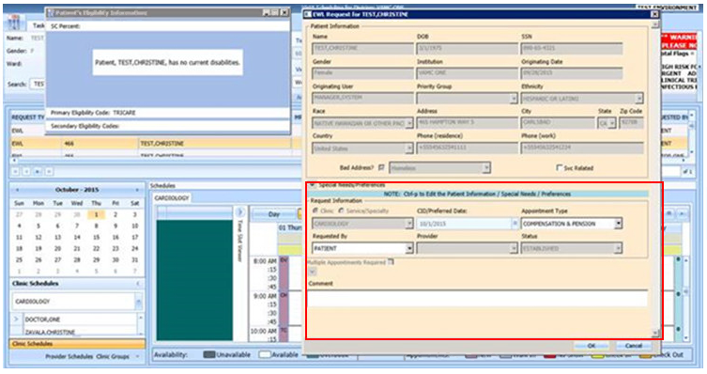

Figure : EWL Request Dialog

### Disposition or Removing a Patient from the EWL

If a patient is on the EWL for an appointment or a consult, and information is received that the patient no longer needs the appointment, the EWL request can be removed and will no longer appear in the Request Management Grid.

**To disposition or remove the EWL Request:**

1. Log on to VS GUI as a Scheduler.
2. From the **Tasks** tab, in the **Search** text box, type the patient’s last name or the patient’s first initial of the last name and last four of the SSN (e.g. S1234). Click **Search**, and then select the requested patient’s name. The patient must have an existing EWL request.
3. In the request grid, right-click the desired EWL request and select the EWL Disposition.

The following EWL Disposition options are available for selection:

* Death
* Removed/Non-VA Care
* Removed/Scheduled-Assigned
* Removed/VA Contract Care
* Removed/No longer Necessary
* Entered in Error
* Transferred

The EWL Request is removed from the Request Management Grid and the next APPT Request is moved up and highlighted.

### Adding Patient-Centered Scheduling Request

**To add a new Patient-Centered Scheduling request for a patient:**

1. Log on to VS GUI as a Scheduler.
2. From the **Tasks** tab, in the **Search** text box, type the patient’s last name or patient’s first initial of the last name and last four of the SSN (e.g. S1234). Click **Search**, and then select the requested patient’s name.
3. Click the **New Req** button in the Actions pane.
4. In the Request Type dialog box, select PATIENT-CENTERED SCHEDULING **(PtSch)** and click OK.

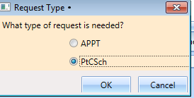

Figure : Request Type–PATIENT-CENTERED SCHEDULING

1. Enter a **Patient-Centered Scheduling Date**. Enter the date the provider requested.
2. Enter a **Patient-Centered Scheduling Date** (per patient). Enter the date the patient prefers.
3. Enter a Patient-Centered Scheduling Appt Type.

* Follow up
* Consultation
* Routine
* Evaluation

Check the box for **Fasting** if the patient needs to fast for the appointment.

1. Enter the Length of the Appointment.
2. Select **Clinic** (the Clinic can be searched by Clinic Name with 6-character minimum or by the Clinic’s abbreviation with a 4-character minimum).

**Note:** The Clinic does not appear for selection if the Patient-Centered Scheduling Reminders Letter is not defined for the clinic.

1. Select Patient-Centered Scheduling Provider (3-character minimum).
2. Enter a **Comment**.
3. Press **Ctrl + P** to view the **Special Needs/Preferences** window for the Patient Info dialog box and add or edit preferences as appropriate.
4. Click **OK**.

The request grid shows requests of the selected patient. The newly added request is selected. The calendar defaults to the desired date and the selected clinic and defaults, and shows the clinic schedules.

View the **Special Needs/Preferences** window in the ribbon bar to confirm it is updated.

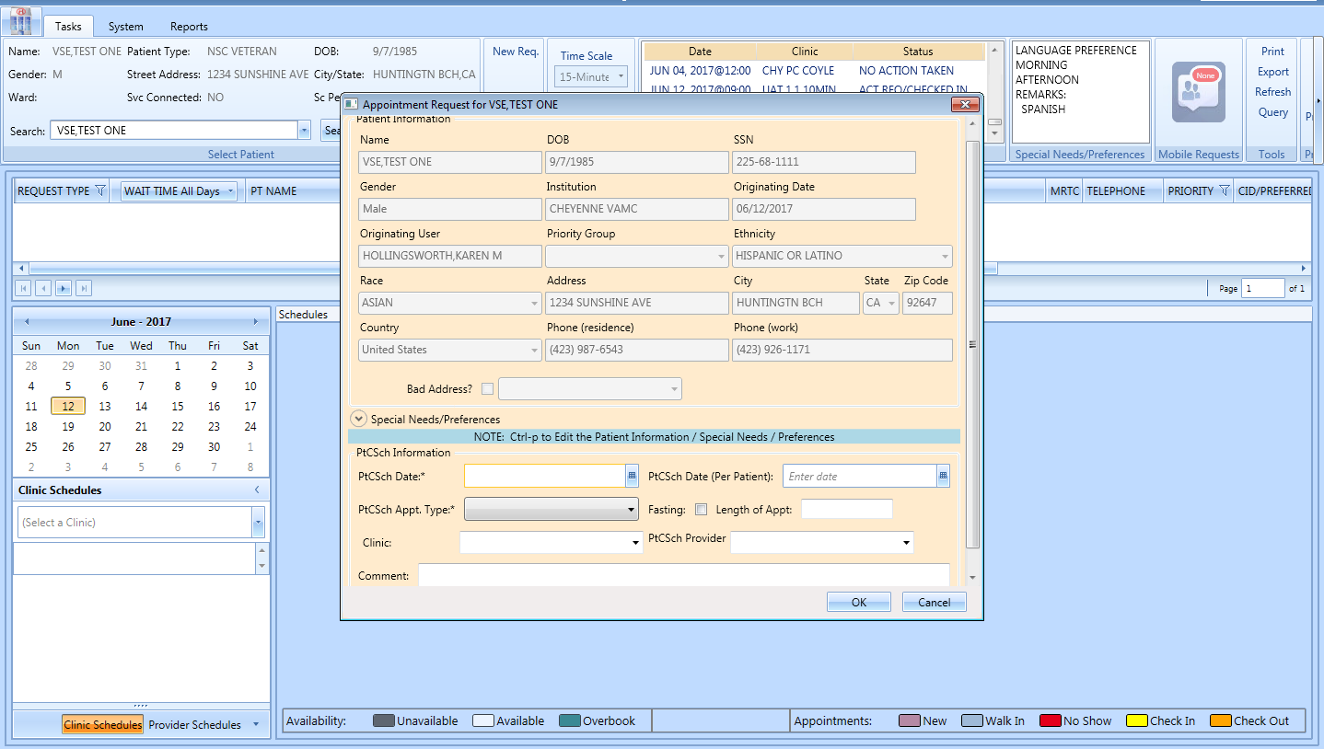

Figure : Patient-Centered Scheduling APPT Request Dialog

### Viewing/Editing Patient-Centered Scheduling Request

If a Patient-Centered Scheduling request needs to be reviewed or modified before being booked, you can View/Edit the request in the Request Grid using the following steps:

1. Log on to VS GUI as a Scheduler.
2. From the **Tasks** tab, in the **Search** text box, type the patient’s last name or the patient’s first initial of the last name and last four of the SSN (e.g. S1234). Click **Search**, and then select the requested patient’s name.

**Note:** When **Spacebar + Search** are used, the Ribbon Bar and Request Management grid adjust to that selected patient.

1. In the **Request Management** grid, right-click the applicable **Patient-Centered Scheduling** request.
2. Select the Patient-Centered Scheduling Disposition option.

The following options appear for selection:

* View Request
* Edit Request
* Failure to respond
* Moved
* Deceased
* Doesn’t want VA services
* Received care at another VA
* Other

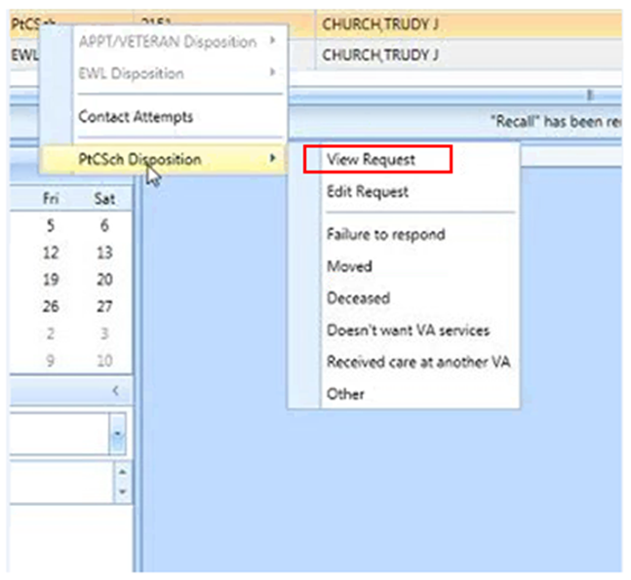

Figure : Patient-Centered Scheduling Disposition Dialog

1. Select **View Request**. The **Patient-Centered Scheduling Request** dialog box appears with the contents dimmed as the dialog box is Read-Only. 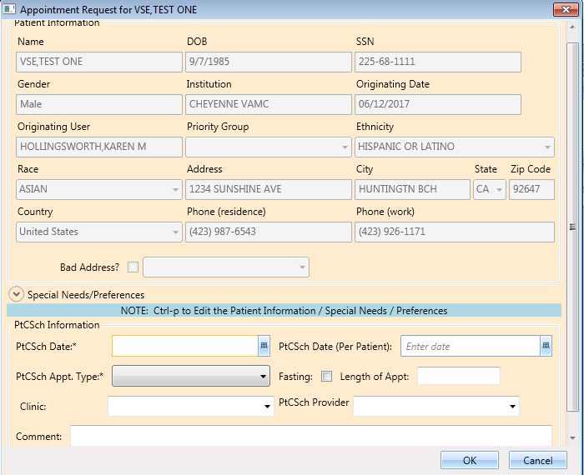

Figure : Patient-Centered Scheduling Appointment View Request Dialog

1. Click **OK**. You return to the Request Management Grid.
2. Right-click the applicable **Patient-Centered Scheduling** request.
3. Select Patient-Centered Scheduling Disposition.

The following options appear for selection:

* View Request
* Edit Request
* Failure to respond
* Moved
* Deceased
* Doesn’t want VA services
* Received care at another VA
* Other

1. Select **Edit Request.** The Patient-Centered Scheduling Request dialog displays.

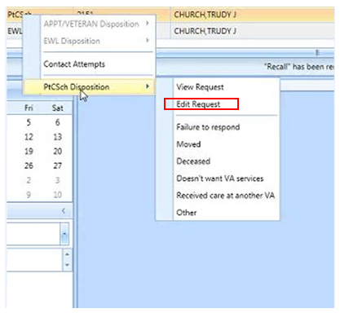

Figure : Patient-Centered Scheduling Disposition Dialog

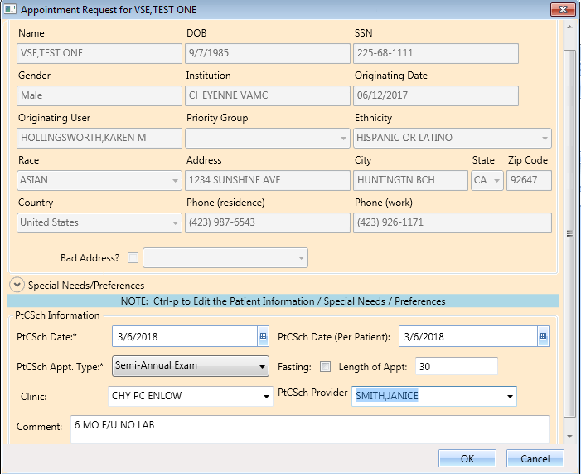

Figure : Patient-Centered Scheduling Appointment Edit Request Dialog

**Note:** The editable fields are PtCSch Appt. Type, Fasting, Length of Appt., Clinic, PtCSch Provider, and Comment. Note the PtCSch Date and PtCSch Date (Per Patient) are not editable.

1. Click **OK**. The request returns to the **Request Grid** with the altered information listed.

### Disposition or Remove Patient-Centered Scheduling Request

To cancel or delete a Patient-Centered Scheduling request:

1. Log on to VS GUI as a Scheduler.
2. From the **Tasks** tab, in the **Search** text box, type the patient’s last name or the patient’s first initial of the last name and last four of the SSN (e.g. S1234). Click **Search**, and then select the requested patient’s name.
3. In the RM Grid, right-click the **Patient-Centered Scheduling** request and select **PtCSch Disposition**. The following dispositions are available for selection:

* Failure to respond
* Moved
* Deceased
* Doesn’t want VA services
* Received care at another VA
* Other

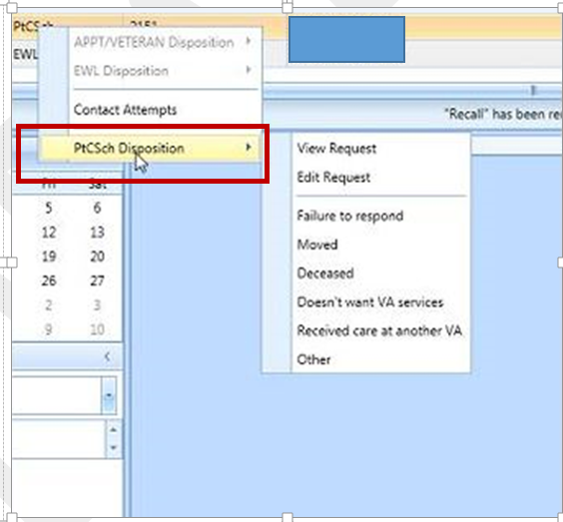

Figure : Patient-Centered Scheduling Disposition Options

1. From the **PtCSch Comment** dialog box, enter comments as necessary. Only the current comment entered is displayed although there is an Audit Log of Uses that created previous comments.

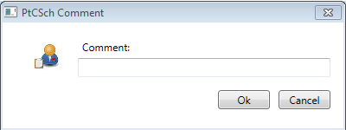

Figure : PtCSch Comment Dialog Box

1. Click **OK**. The patient is removed from the request grid.

Certain dispositions will present a **Patient Contacts** message pop-up if the business rules were not met. To disposition the request, click **Yes** to acknowledge the warning.

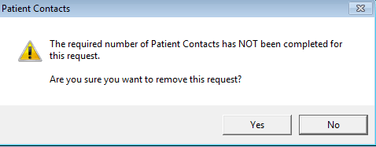

Figure : Warning Pop-Up If Business Rules Were Not Met

**Note** here the Request Type, Dispositions, and Contact Message information.

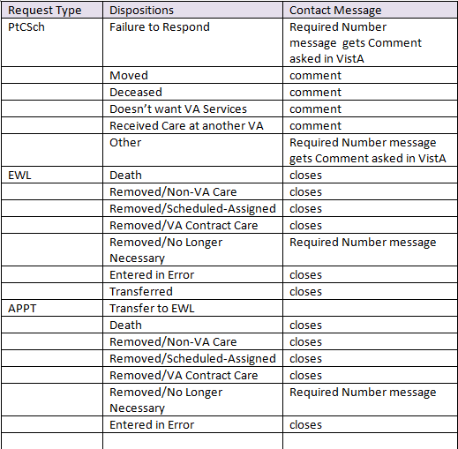

Figure : Request Type/Dispositions/Contact Message Reference

## Contacting a Patient

A patient may need to be contacted by phone or letter to schedule an appointment. Contact efforts can be added to the patient record for APPT and EWL requests. They are viewable in the GUI and are storedin the **SDEC APPT REQUEST file.**

### New Contact Attempt

To document **New Contact Attempt** information:

1. Log on to VS GUI as a Scheduler.
2. From the **Tasks** tab, in the **Search** text box, type the patient’s last name (or the patient’s first initial of the last name) and last four of the SSN (e.g. S1234).
3. Click **Search**.
4. Select the requested patient’s name from the list.
5. In the request grid, right-click APPT, PtCSch, or EWL request type, and then select **Contact Attempts**. The following Contact Types are available for selection:

* Call
* Letter

1. Select Call or Letter

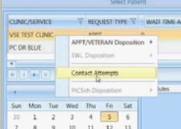

Figure : Contact Attempts

The **New Contact Attempt** dialog box displays showing, Patient Name, Clinic Name, Desired Appt. Date, Request Type, and Patient phone numbers. Select Call or Letter and accept the default contact date/time (which is the time the New Contact Attempt dialog was opened) or change as appropriate. You can change the Date/Time to a past Date/Time to document when the contact attempt was created. Backdating an attempt will still reflect the entry date and time in the far-right column.

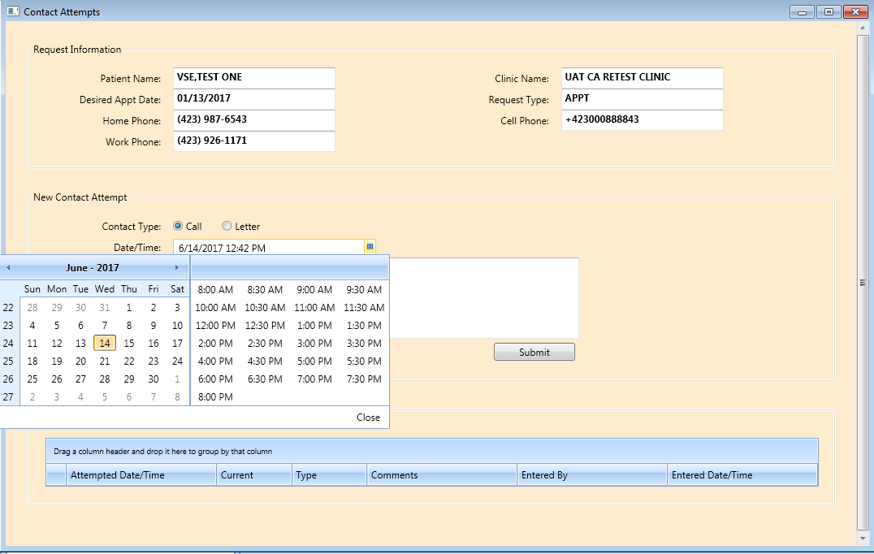

Figure : Patient Contact Dialog

1. Enter the phone number that was contacted, if desired, and provide any appropriate information in the Comments section.
2. Click Submit to enter the Call Attempt details, which will be displayed at the bottom of the New Contact Attempt screen and highlighted in Green.

The above procedures can be repeated as many times as needed to attempt to contact the patient. There is no limit to the number of attempts that can be created.

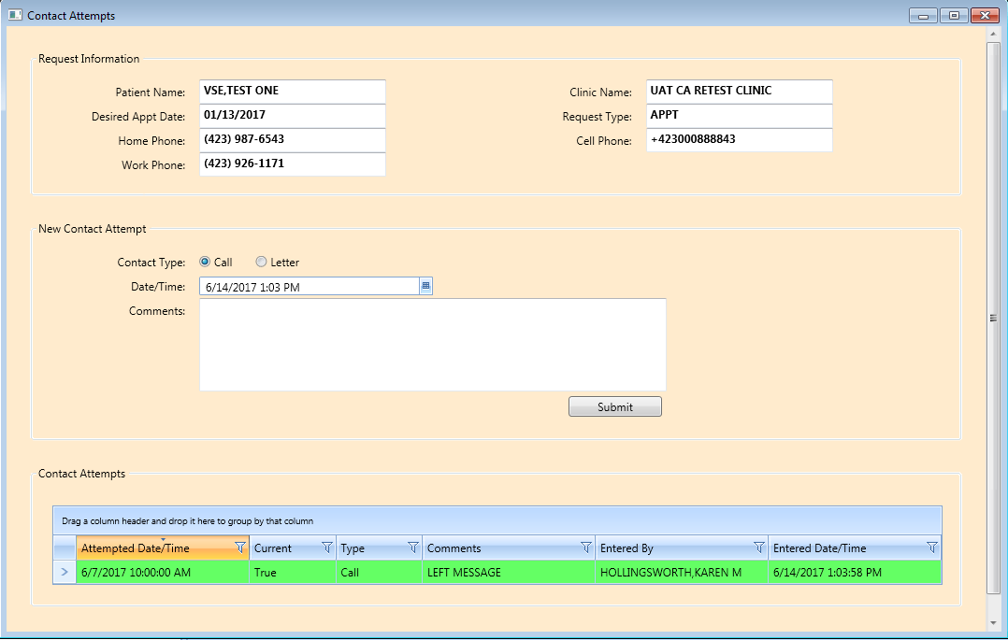

Figure : New Contact Attempt Submitted and Displayed

**Note:** The name of the person entering the contacts, the date the contact was entered, and the attempt date/time are shown.

* For Non-Mental Health appointment contacts, a call and a letter (letter must be at least 14 days old) are required prior to system dispositioning without an appointment.
* Mental Health appointment contacts require 3 calls on different calendar days (ex. Monday, Tuesday, Wednesday). At least one letter is required (letter must be at least 14 days old) and can be on same day as a call attempt.
* Attempting to disposition prior to the above rules being met will result in a warning message of the business rules not being met (See Figure 77). Click Yes to acknowledge the warning and disposition the request or Click No to return to Request Management Grid.

Figure : Displaying Name of Person Entering Contacts

After making an appointment the request is dispositioned and removed from Request Management. If the appointment is cancelled, the request returns to the grid and the current field in **Contact Attempts** changes to false and is a tan color.

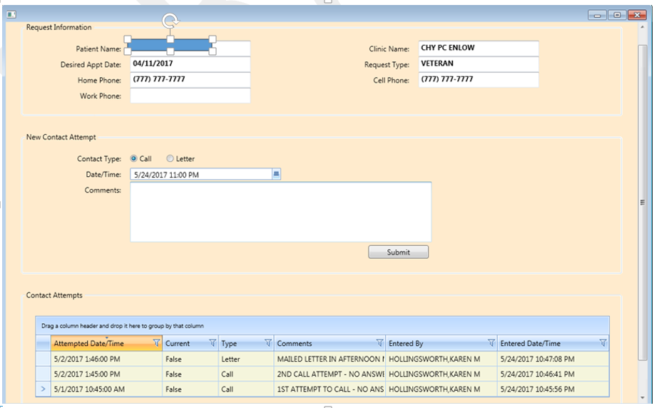

Figure : Appointment Canceled

After making a New Contact Attempt after the cancellation, the new attempt will be green and the **Current** field will be “True”.

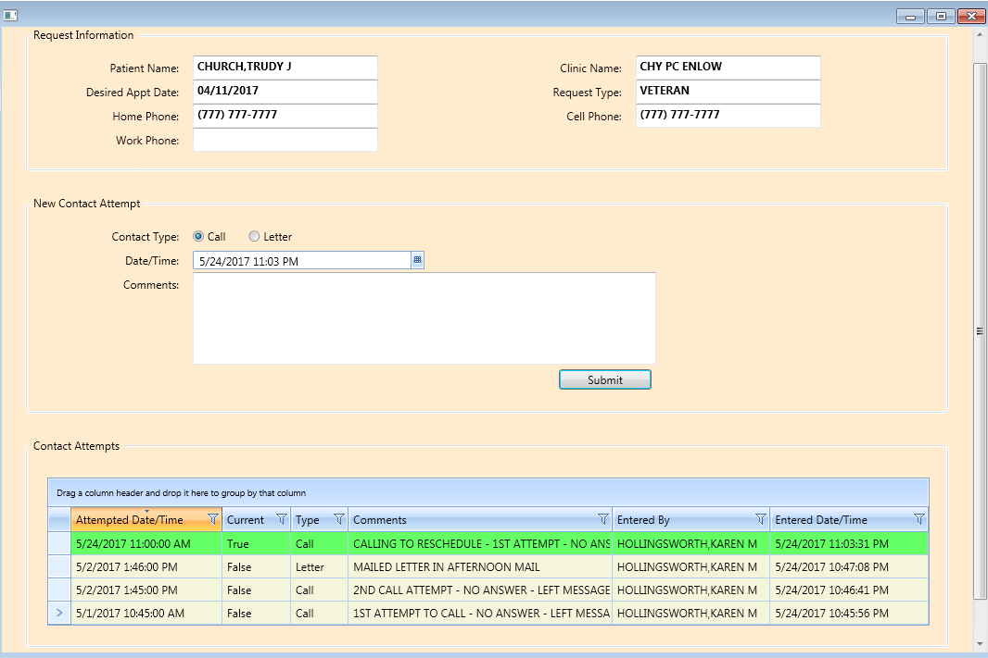

Figure : New Contact Attempt After Cancellation

# Appointment Management

## Adding Appointments

### Add Appointment for Appointment Request

1. Log into VS GUI as a Scheduler.
2. From the Tasks tab, type the patient’s last name and first name in the Search text box. Click Search, and then select the requested patient’s name from the list.
3. In the Request Management Grid, select **APPT** request. The Clinic Schedule Grid displays the clinic schedule based upon CID/Preferred date of request. For past dates, the clinic schedule opens defaulted to current date. For current date (or CID/Preferred date less than three days in future), the clinic schedule displays defaulted to current date. For future dates, the clinic schedule displays -/+ three days of CID/Preferred date.

**Note:** For newly created APPT requests, the system automatically highlights the APPT request and the Clinic Schedule displays.

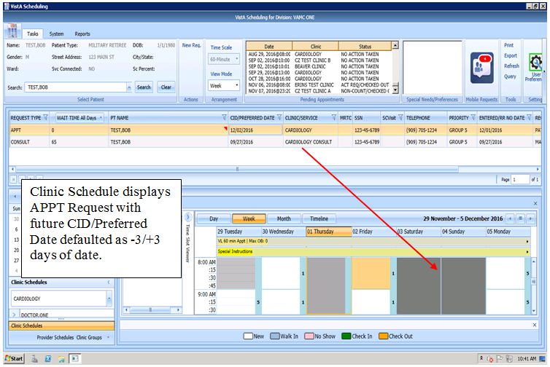

Figure : Select APPT Request – Clinic Schedule Grid Display

1. In the Clinic Schedule Grid, select the available time slot. Uneven start times are available. Time Slot details display in the Time Slot Viewer.

**Note:** Refer to Section 7.1.7 for detailed information on Time Slot Viewer functionality.

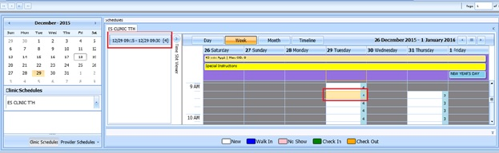

Figure : Select Time Slot

1. Right-click in the time slot. Add **Appointment** option displays. The Create Walk In Appointment option is only available for selection on the current date. It is not available for past or future CID/Preferred dates.

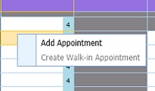

Figure : Right-click Options – Add Appointment

1. Select Add Appointment.

The New Appointment dialog displays as well as the Patient Eligibility dialog box.

* Appointments Tab:
* The **Patient Information** Section displays Name, DOB, SSN, Svc Connected, SC Percent, Global Assessment of Function (score) (GAF) (read only), and the Svc Related check box.
* The **Appointment** information section displays Benefit/Eligibility (provides drop down for patients with multiple eligibility), Start Time, Appt Type, Duration, Clinic and Notes (Appointment Start Time; Duration on for appointments to VL Clinics; and Notes are editable fields). Information can be added pertinent to appointment.
* The comments from the original request will populate the **Notes** field in the New Appointment dialog. This text is editable before the new appointment is created.
* The **Appointment Conflicts** section displays any appointments already scheduled that potentially conflict with the appointment being added.

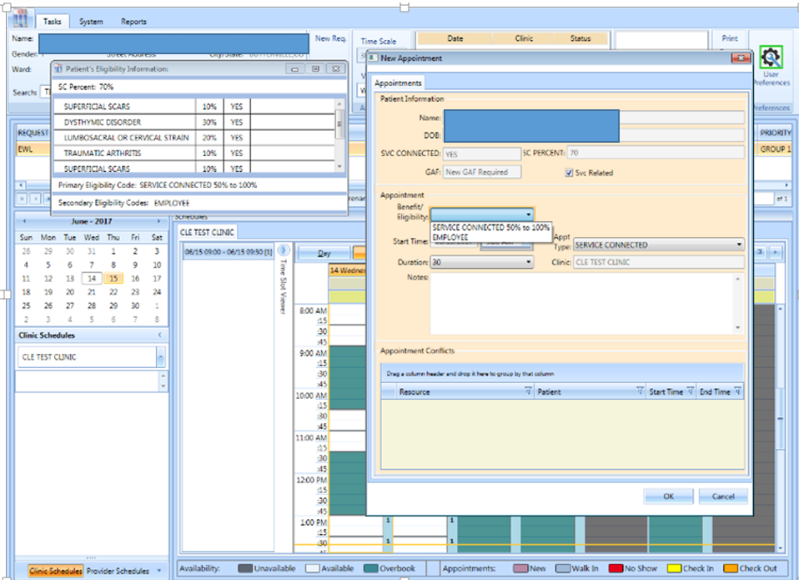

Figure : New Appointment Dialog

1. Add any applicable notes to the appointment. Click **OK**.

The Print Letter? Dialog box displays.

1. Click **OK** to print the Letter to the patient.

Click **Cancel** if you do not want to print the letter.

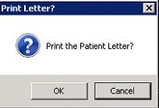

Figure : Print Letter? Dialog

1. To close the Request dialog box, click **OK**.

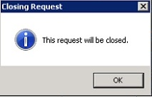

Figure : Closing Request Dialog

The APPT Request is removed from the Patient Request Management Grid. The Next request for patient is moved up and highlighted.

The Clinic Schedule closes and the next appointment clinic schedule opens.

The New appointment displays in the Pending Appointment Window on the Ribbon Bar.

1. Select appointment from the Pending Appointment window to view the appointment in the Clinic Schedule Grid. The clinic schedule opens. For past dates, the clinic schedule opens defaulted to the appointment date. For the current date (or appointment date less than three days in future), the clinic schedule displays defaulted to current date. For future dates, the clinic schedule displays -/+ three days of appointment date.

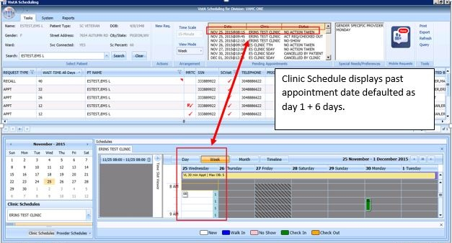

Figure : Clinic Schedule Grid – Past Appointment Display

For current date (or appointment date less than three days in future), the clinic schedule displays defaulted to current date. See below.

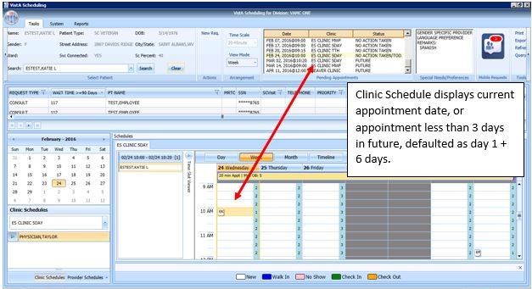

Figure : Clinic Schedule Grid – Current Appointment Display

For future dates, the clinic schedule displays -/+ three days of the appointment date. See below.

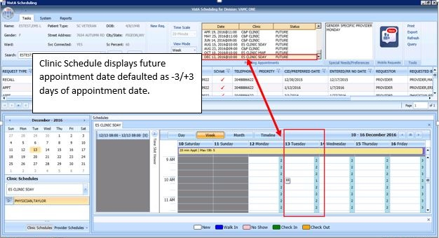

Figure : Clinic Schedule Grid – Future Appointment Display

### Add Appointment for EWL Request

1. Log into VS GUI as a Scheduler.
2. From the Tasks tab, type the patient’s last name and first name in the Search text box. Click **Search**, and then select the requested patient’s name from the list.
3. Click the **New Req** button in the Actions pane.

**Note:** Refer to Section 5.1.5 for steps on transferring the APPT request to the new EWL Request.



Figure : Request Type

1. In the Request **Management** Grid select the **EWL** request.

The Clinic Schedule Grid displays the clinic schedule based upon the CID/Preferred date of the request. For past dates, the clinic schedule opens defaulted to CID/Preferred date. For the current date (or the CID/Preferred date less than three days in future), the clinic schedule displays defaulted to the current date. For future dates, the clinic schedule displays -/+ three days of the CID/Preferred date.

**Note:** For the newly created Patient-Centered Scheduling request the system automatically highlights the APPT request and the Clinic Schedule displays. If the EWL is for a service/specialty, no grid is displayed, and the clinic must be searched and selected.

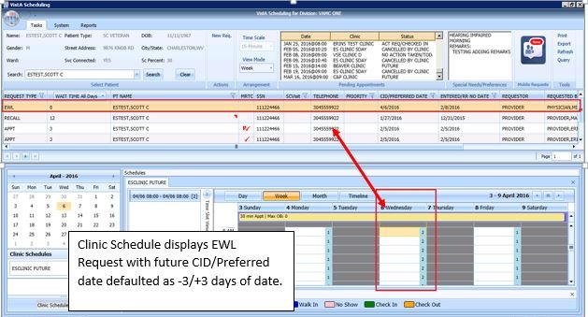

Figure : Select EWL Request

1. In the Clinic Schedule Grid, select the available time slot. Time Slot details display in the Time Slot Viewer.

**Note:** See Section 7.1.7 for detailed information on the Time Slot Viewer functionality.

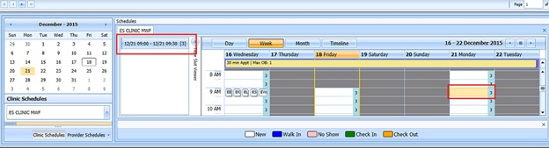

Figure : Select Time Slot

1. Right-click in the time slot. The **Add Appointment** option displays.

**Note: The** Create Walk In Appointment option is only available for selection on the current date. It is not available for past or future CID/Preferred dates.

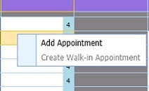

Figure : Right-click Options – Add Appointment

1. Select Add Appointment.

The New Appointment dialog box contains the following sections:

* **Appointments Tab:**
* The **Patient Information** section displays Name, DOB, SSN, Svc Connected, SC Percent, GAF (read only), and Svc Related check box.
* The **Appointment** information section displays Start Time, Appt Type, Duration, Clinic and Notes (Appointment Start Time; Duration on for appointments to VL Clinics; and Notes are editable fields).
* The **Appointment Conflicts** section displays any appointments already scheduled that conflict with appointment being added.

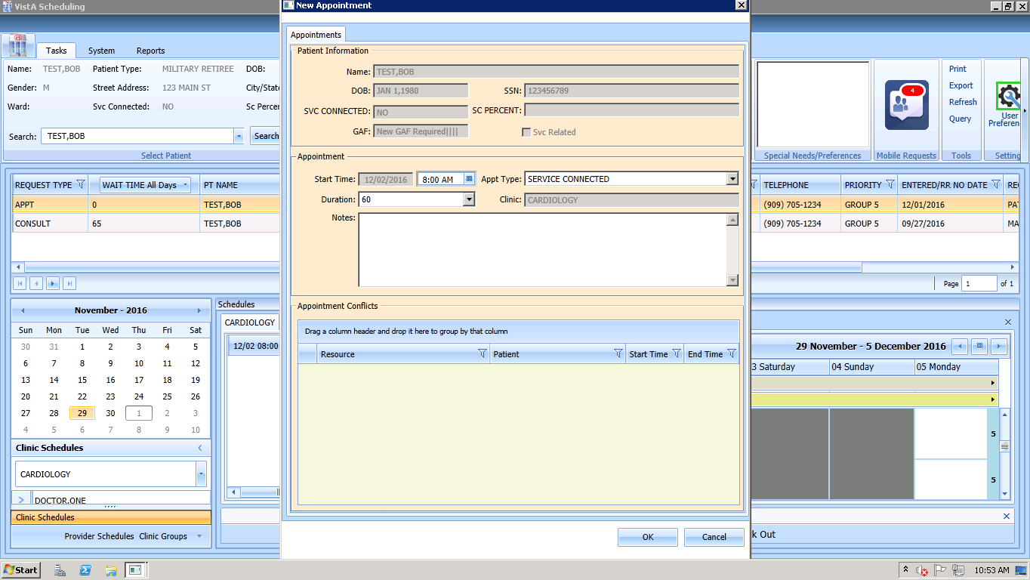

Figure : New Appointment Dialog

1. Add any applicable Notes to the appointment. The comments from the original request will populate the Notes field in the New Appointment dialog. Click **OK**.

The Print Letter? Dialog box displays.

1. Click **OK** to print the Letter to the patient. Click **Cancel** if you do not want to print the letter.

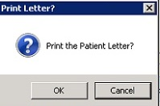

Figure : Print Letter? Dialog

1. If you do want to print the letter, click OK, and the print dialog box will pop up. If there is no letter in the box, contact your local clinic set up team to place that type of letter into the clinic’s set up. If there is a letter, decide whether to print to a network printer via Print (Windows Printer) or a VistA print device via the search box and Print (VistA Print Device). It is highly recommended to use the VistA method, as that will place the address in the correct position for a windowed envelope.



Figure : Print to VistA Device Printer to place address in correct position

1. To close the Request dialog box, click **OK**.

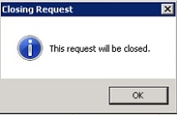

Figure : Closing Request Dialog

* The EWL Request is removed from the Patient Request Management Grid. The EWL request is dispositioned as scheduled.
* The Next request for the patient is moved up and highlighted.
* The Clinic Schedule closes and the clinic for the next request displays.
* The New appointment displays in the Pending Appointment Window on the Ribbon Bar.

1. Select appointment from the Pending Appointment window to view the appointment in the Clinic Schedule Grid. The clinic schedule opens. For past dates, the clinic schedule opens defaulted to appointment date.

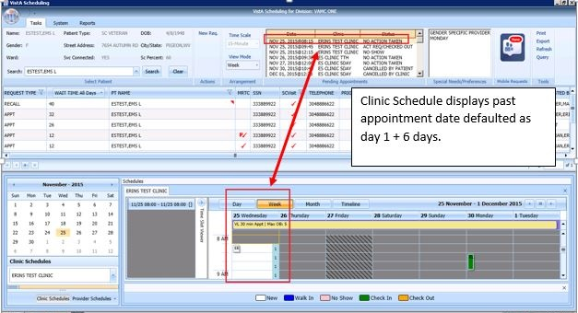

Figure : EWL Appointment Past Date Display

For the current date (or the appointment date less than three days in the future), the clinic schedule displays the default, the current date. See below.

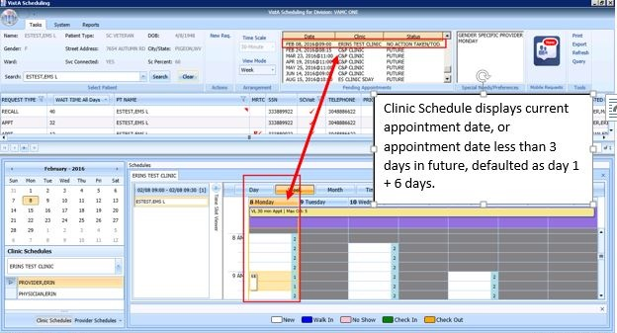

Figure : EWL Appointment Current Date

For future dates, the clinic schedule displays -/+ three days of the appointment date. See below.

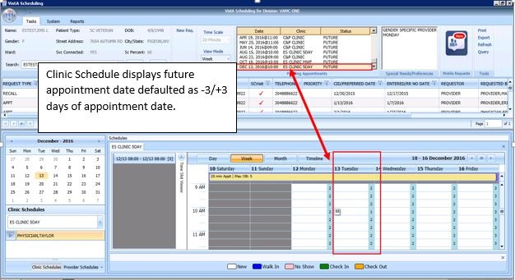

Figure : EWL Appointment Future Date Display

### Add Appointment for Patient-Centered Scheduling Request

1. Log into VS GUI as a Scheduler.
2. From the **Tasks** tab, in the **Search** text box, type the patient’s last name or the patient’s first initial of the last name and last four of the SSN (e.g. S1234). Click **Search**, and then select the requested patient’s name.
3. Click the **New Req** button in the Actions pane.
4. In the Request Type dialog box, select **Patient-Centered Scheduling** (PtSch) and then click **OK** to create a new request or click **Cancel** for the existing request.
5. When a **New Patient** is searched, please select **CANCEL** when the **Request Type** box pops up. This will allow searching for existing requests before creating anything new.

**Note:** Refer to Section 5.1.7 for steps on adding a new Patient-Centered Scheduling Request.



Figure : Request Type

1. In the Request Management Grid select Patient-Centered Scheduling request.

The Clinic Schedule Grid displays the clinic schedule based upon the CID/Preferred date of request. For past dates, the clinic schedule opens defaulted to the CID/Preferred date. For current date (or the CID/Preferred date less than 3 days in future), the clinic schedule displays defaulted to current date. For future dates, the clinic schedule displays -/+3 days of the CID/Preferred date.

**Note:** For a newly created Patient-Centered Scheduling request the system automatically highlights the PATIENT-CENTERED SCHEDULING request in the Request Management Grid and Clinic Schedule.

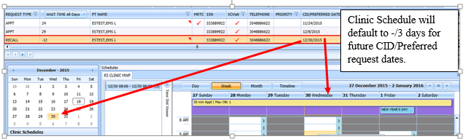

Figure : Select Patient-Centered Scheduling Request

1. In the Clinic Schedule Grid, select the available time slot.

Time Slot details display in the Time Slot Viewer.

**Note:** See Section 7.1.7 for detailed information on Time Slot Viewer functionality.

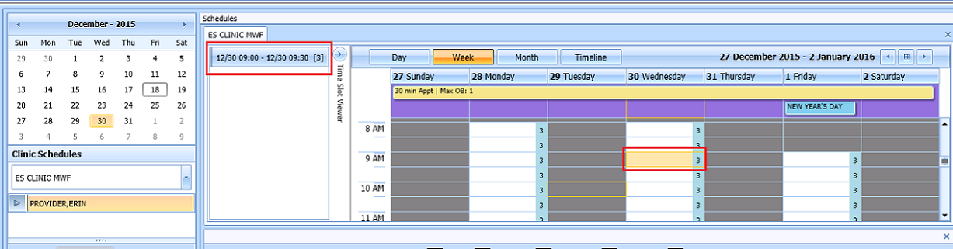

Figure : Select Time Slot

1. Right-click in the time slot.

**Add Appointment** option displays.

**Note:** The **Create Walk In Appointment** option is only available for selection on the current date. It is not available for past or future CID/Preferred dates.

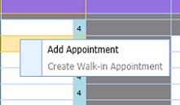

Figure : Right-click Options – Add Appointment

1. Select Add Appointment.

The New Appointment dialog box contains the following sections:

* **Appointments Tab:**
* The **Patient Information Section displays** Name, DOB, SSN, SVC Connected, SC Percent, GAF (read only), and Svc Related check box**.**
* The **Appointment** information section displays Start Time, Appt Type, Duration, Clinic and Notes (Appointment Start Time; Duration on for appointments to VL Clinics; and Notes are editable fields).
* The comments from the original request will populate the Notes field in the New Appointment dialog.
* The **Appointment Conflicts** section displays any appointments already scheduled that conflict with the appointment being added.



Figure : New Appointment Dialog

1. Add any applicable Notes to the appointment. The comments from the original request will populate the **Notes** field in the New Appointment dialog. Click **OK**.

The Print Letter? Dialog box displays.

1. Click **OK** to print the Letter to patient.

Click **Cancel** if you do not want to print the letter.

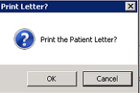

Figure : Print Letter? Dialog

The Closing Request dialog box displays.

1. Click **OK**.

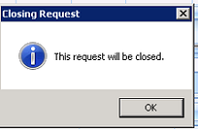

Figure : Closing Request Dialog

**Note:** The Patient-Centered Scheduling request is not immediately removed from the request grid. The request is removed when the task “CLEAN UP CLINIC PATIENT-CENTERED SCHEDULING ENTRIES” has been run and when the appointment is made within the CLEAN UP DAY SETTING in ENTER/EDIT CLINIC PATIENT-CENTERED SCHEDULING SITE PARAMS menu option.

The Clinic Schedule closes and the clinic for the next request displays.

The New appointment displays in Pending Appointment Window on the Ribbon Bar.

1. Select an appointment from the Pending Appointment window to view it in the Clinic Schedule Grid. The clinic schedule opens. For past dates, the clinic schedule displays defaulted to appointment date.



Figure : Clinic Schedule Display – Past Date Appointment

For the current date (or if the appointment date is less than three days in the future), the clinic schedule displays the appointment date as Day 1 + six days to current date.



Figure : Clinic Schedule Display – Current Date Appointment

For future dates, the clinic schedule displays -/+ three days of the appointment date. See below.



Figure : Clinic Schedule Display – Future Date Appointment

### Add Appointment for Consult Request

1. Log into VS GUI as a Scheduler.
2. From the **Tasks** tab, in the **Search** text box, type the patient’s last name or the patient’s first initial of the last name and last four of the SSN (e.g. S1234). Click **Search**, and then select the requested patient’s name.

**Note:** Consult requests are added from CPRS.

1. In the Request Management Grid select ConsultRequest.

**Note:** The Clinic Schedule does NOT display when selecting Consult request, as a consult is directed to an entire service, not a specific clinic. The scheduler should read the consult body in CPRS to determine which specific clinic or clinic group should be used, and then search for that clinic or group in the clinic schedules search box. Consult scheduling can benefit greatly from clinic groups when the specialty has more than one consult clinic that can be grouped and viewed side by side.

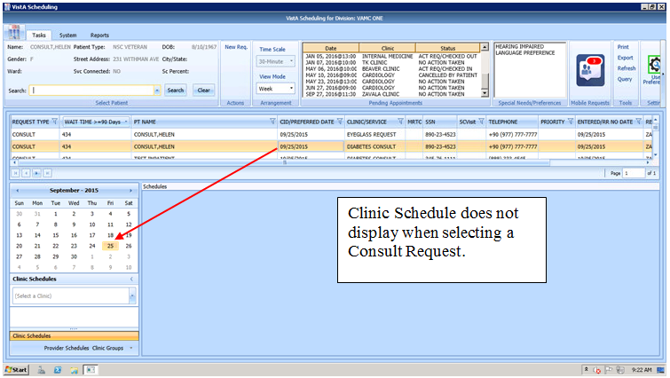

Figure : Select Consult Request

From the Clinic Schedules, enter the clinic name (six-character minimum).

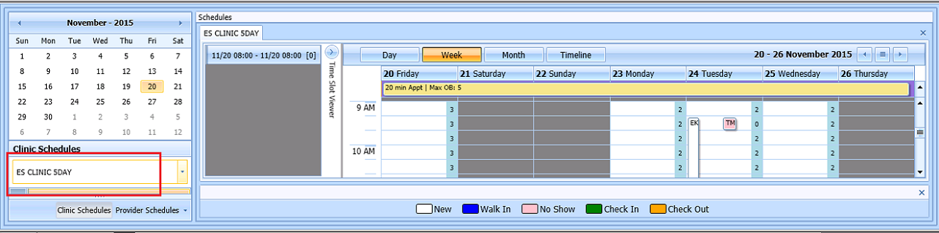

Figure : Clinic Schedules

1. In Clinic Schedule, click the available time slot. Time Slot details display in the Time Slot Viewer.

**Note:** See Section 7.1.7 for detailed information on Time Slot Viewer functionality.

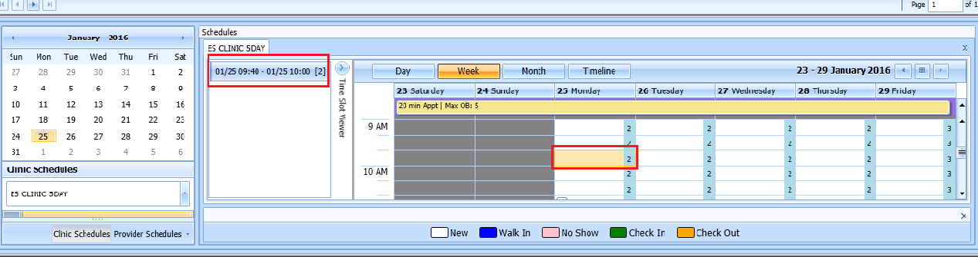

Figure : Select Time Slot

1. Right-click in the time slot.

**Add Appointment** option displays.

**Note:** The **Create Walk-In Appointment** option is only available for selection on current date. It is not available for past or future CID/Preferred dates.



Figure : Right-click Options – Add Appointment

1. Select Add Appointment.

The New Appointment dialog box displays as well as the Patient Eligibility dialog box.

* Appointments Tab:
* The **Patient Information Section displays** Name, DOB, SSN, SVC Connected, SC Percent, GAF (read only), and Svc Related check box**.**
* The **Appointment** information section displays Start Time, Appt Type, Duration, Clinic and Notes (Appointment Start Time; Duration on for appointments to VL Clinics; and Notes are editable fields).
* The **Appointment Conflicts** section displays any appointments already scheduled that conflict with appointment being added.



Figure : New Appointment Dialog

1. Add any applicable Notes to the appointment. The comments from the original request will populate the **Notes** field in the New Appointment dialog. Click **OK**.

The Print Letter? dialog box displays.

1. Click **OK** to print the Letter to the patient.

Click **Cancel** if you do not want to print the letter.

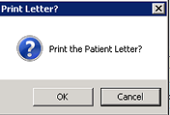

Figure : Print Letter? Dialog

* The Consult Request is removed from the Patient Request Management Grid.
* The next request for the patient is moved up and highlighted.
* The Clinic Schedule closes and the clinic for the next request displays, if applicable.
* The New appointment displays in the Pending Appointment Window on the Ribbon Bar.

1. Select the appointment from the Pending Appointment window to view it in the Clinic Schedule Grid.

The clinic schedule opens. For past dates, the clinic schedule opens to the default appointment date.

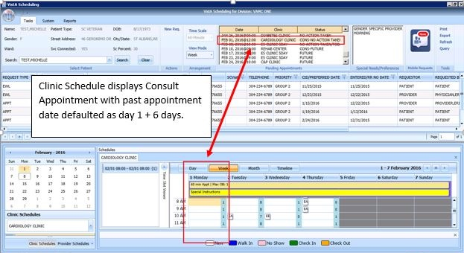

Figure : Clinic Schedule Display – Consult Past Appointment Date

For the current date (or appointment date less than three days in future), the clinic schedule displays the current date as the default. See below.

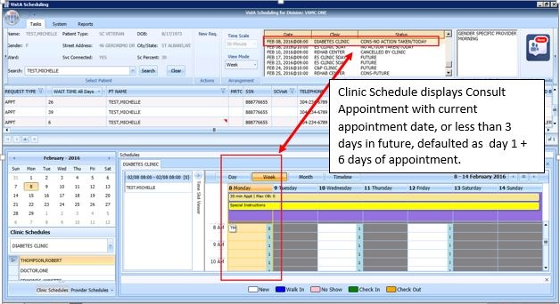

Figure : Clinic Schedule Display – Consult with Current Date

For future dates, the clinic schedule displays -/+ three days of the appointment date. See below.

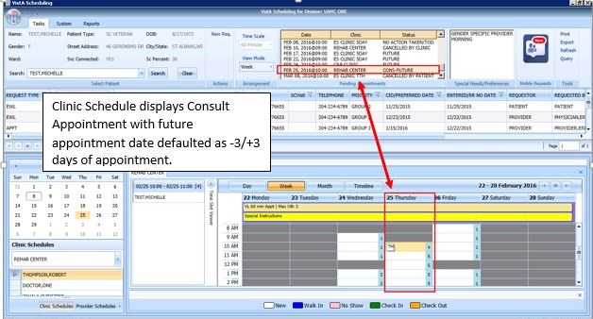

Figure : Clinic Schedule Display – Consult Future Appointment Date

### Add Appointment from Return to Clinic request (RTC)

1. Log into VS GUI as a Scheduler.
2. From the **Tasks** tab, in the **Search** text box, type the patient’s last name or the patient’s first initial of the last name and last four of the SSN (e.g. S1234). Click **Search**, and then select the requested patient’s name.

**Note:** RTC requests are added from CPRS when the clinical staff use the National Return to Clinic Order and sign it.

1. In the Request Management Grid select the RTCRequest and schedule the appointment. Scheduling the appointment while the RTC request is selected (orange) will automatically complete the corresponding order in CPRS.

**Note:** If the RTC is for a single follow up appointment, it will follow the same steps as a Patient Centered Scheduling Request (PtCSch) in Section 6.1.3. If the RTC is for a series of follow up appointments, it will follow the same steps as in the MRTC requests in Section 6.3.1. Contact attempts can be added as appropriate.

1. If a RTC request has prerequisites from the RTC Order in CPRS, it will pop up an extra box with that information. If the prerequisite pop up box is accidently closed, it can be reopened, by clicking on the RTC order in the RM grid again.
2. If a RTC request must be dispositioned without making an appointment, right click on the RTC and select from the disposition drop down. The corresponding National Return to Clinic Order will respond accordingly.

|  |  |
| --- | --- |
| **APPT Request Dispositions** | **RTC Order Disposition** |
| 'D' FOR DEATH | Discontinued – alert to Provider |
| 'NC' FOR REMOVED/NON-VA CARE | Discontinued – alert to Provider |
| 'SA' FOR REMOVED/SCHEDULED-ASSIGNED | Completed |
| 'CC' FOR REMOVED/VA CONTRACT CARE | Discontinued – alert to Provider |
| 'NN' FOR REMOVED/NO LONGER NECESSARY | Discontinued – alert to Provider |
| 'ER' FOR ENTERED IN ERROR | Discontinued – alert to Provider |

## Disposition Appointments

### Edit Appointment Information

Editing appointment information can be done within the VS GUI.

To edit appointment information:

1. Log on to VS GUI as a Scheduler.
2. From the Tasks tab, type the patient’s last name and first name in the Search text box. Click **Search**, and then select the requested patient’s name from the list.
3. Point to the appointment to be edited in the Pending Appointments Window on the Ribbon Bar.

The clinic schedule displays. For past appointment dates, the clinic schedule opens the default appointment date. For the current date (or appointment date less than three days in future), the clinic schedule displays the current date as the default. For future dates, the clinic schedule displays -/+ three days of the appointment date.

1. In the Clinic Schedule Grid, point to the appointment, right-click on the appointment, and then select **Edit Appointment**.

The Edit Appointment dialog box displays.

**Note:** See Section 7.1.7 for detailed information on Time Slot Viewer functionality.

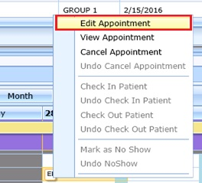

Figure : Appointment Right-click Options – Edit Appointment

The only field that is editable is Notes.

1. Make any necessary edits to the appointment information, and then click OK.

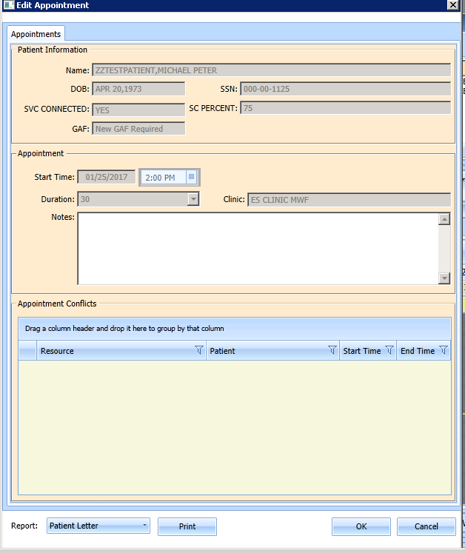

Figure : Edit Appointment Dialog

### View Appointment Information

Viewing appointment information can be done in the Clinic Schedule Grid in the VS GUI.

To view appointment information:

1. Log on to VS GUI.
2. From the **Tasks** tab, in the **Search** text box, type the patient’s last name or the patient’s first initial of the last name and last four of the SSN (e.g. S1234). Click **Search**, and then select the requested patient’s name.
3. Point to the appointment to be viewed in the Pending Appointments Window on the Ribbon Bar.

The clinic schedule displays. For past appointment dates, the clinic schedule defaults to the appointment date as Day 1 + six days. For the current date (or appointment date less than three days in future), the clinic schedule displays the default, the current date as Day 1 + six days. For future dates, the clinic schedule displays -/+ three days of the appointment date.

1. In the Clinic Schedule Grid, point to the appointment, move the pointer over the appointment, and the appointment details display.

**VS GUI Hover Box Displaying Appointment Details window**

Figure : Hover Box Displaying Appointment Details

1. Right-click the appointment.
2. Select View Appointment.

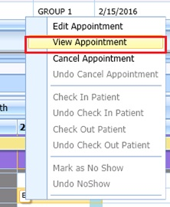

Figure : Appointment Right-click Options – View Appointment

The **View** Appointment dialog box displays. It is in read-only mode. No fields are editable.

1. Click **OK** to close the View Appointment dialog box.

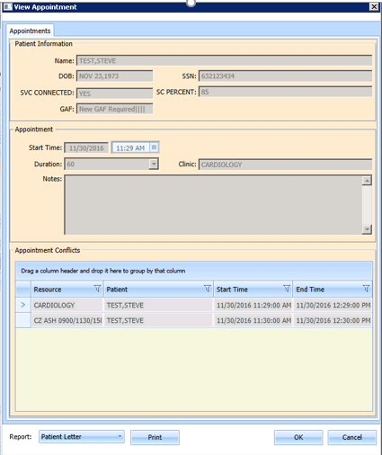

Figure : View Appointment Dialog

### Cancelling an Appointment

You can cancel an appointment without rebooking it.

1. Log on to VS GUI as a Scheduler.
2. From the **Tasks** tab, in the **Search** text box, type the patient’s last name or the patient’s first initial of the last name and last four of the SSN (e.g. S1234). Click **Search**, and then select the requested patient’s name.
3. Select a scheduled appointment from the Pending Appointment Window on the Ribbon Bar.

The clinic schedule displays. For past appointment dates, the clinic schedule opens the default, the appointment date. For the current date (or appointment date less than three days in future), the clinic schedule displays the default, the current date. For future dates, the clinic schedule displays -/+ three days of the appointment date.

1. Select an appointment from the Clinic Schedule Grid.
2. Right-click and select **Cancel**.

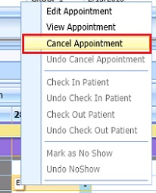

Figure : Appointment Right-click Options – Cancel Appointment

1. In the **Cancel Appointment** dialog box, select a cancellation option:

* **Cancelled by Clinic:** The original CID/Preferred appointment date defaults to the patient desired date. The date cannot be edited.
* **Cancelled by Patient**: The patient CID/Preferred date is available and defaults to original CID/Preferred date request. You can edit the date to change it.

1. Select the **Reason for Cancellation** from the list.

Edit the CID/Preferred dates if applicable.

Add Remarks as needed.

1. Click **OK**.

The appointment is canceled and not rebooked. If the appointment is linked to a consult, the consult status changes to Active.

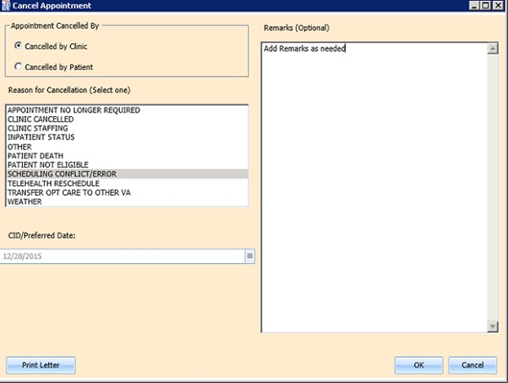

Figure : Cancel Appointment Dialog

The Appointment displays in Pending Appointments with a status of Cancelled by Clinic or Cancelled by Patient (whichever is applicable).

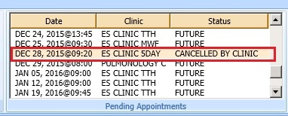

Figure : Pending Appointment Window – Appointment Status Cancelled by Clinic

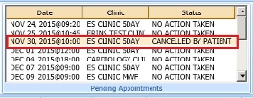

Figure : Pending Appointment Window – Appointment Status Cancelled by Patient

* The Clinic Schedule closes.
* The patient’s appointment request reappears on the APPT Request grid for future rescheduling.

1. Select the **APPT Request** and the Clinic Schedule displays again.

**Note:** The Time Slot count increases when an appointment is canceled.

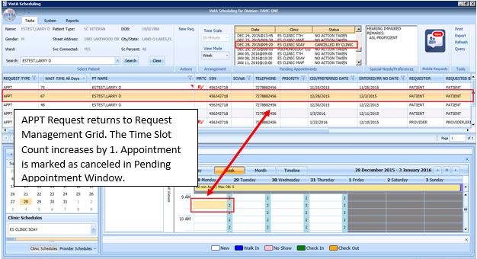

Figure : APPT Request – Time Slot Count Increase

#### Cancel directly from pending appointment box

1. Log on to VS GUI as a Scheduler.
2. From the Tasks tab, in the Search text box, type the patient’s last name or the patient’s first initial of the last name and last four of the SSN. Click **Search**, and then select the requested patient’s name. Right click on a scheduled appointment from the **Pending Appointment** window in Ribbon bar.

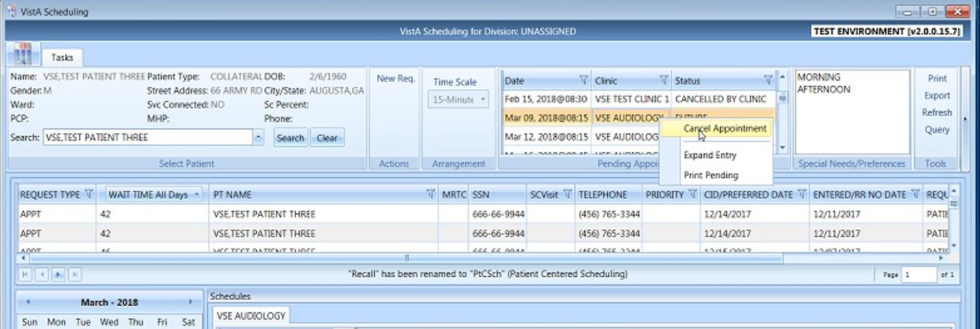

Figure : Select Cancel Appointment

1. In the Cancel Appointment dialog box, select cancellation the appropriate cancellation option **Cancelled by Clinic** or **Cancelled by Patient.** Select a Reason for cancellation from the list. Click OK.

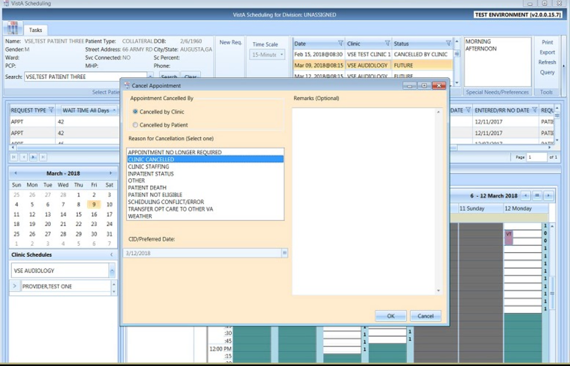

Figure : Cancelled by Clinic

### Mark as No Show Appointment

To record a no show appointment.

1. Log on to VS GUI as a Scheduler.
2. From the Tasks tab, type the patient’s last name and first name in the Search text box. Click **Search**, and then select the requested patient’s name from the list.
3. From the **Pending Appointment** Window select appointment to mark as no show.

The clinic schedule displays.

For past appointment dates, the Clinic Schedule displays the default, the appointment date. For the current date (or appointment date less than 3 days in future), the clinic schedule displays the current default date.

1. Select the appointment from the Clinic Schedule Grid.
2. Right-click the Appointment.
3. Select **Mark as No Show**. The appointment MUST be a past date/time from the current date/time.

**Note: “**Mark as No Show” is not available for future appointments.

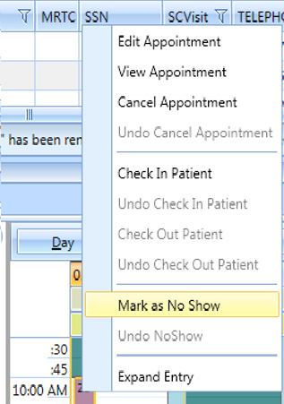

Figure : Appointment Right-click Options – Mark as No Show

The Mark **as No Show** dialog box displays.

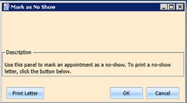

Figure : Mark as No Show Dialog

1. Click **OK**.

The Appointment displays in red in the Clinic Schedule Grid and the Time Slot Viewer.

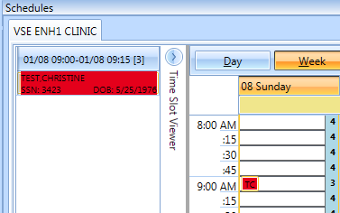

Figure : Clinic Schedule Display – No-Show Red

The Status in the Pending Appointment Window on the Ribbon Bar changes to No-Show.

The Request returns to the Request Management Grid for the patient.

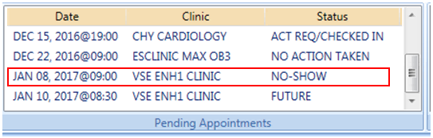

Figure : Pending Appointment Window – Appointment Status No-Show

Inpatient appointments **CANNOT** be dispositioned as a No-Show.

A Not Allowed warning message will display if the user attempts to flag an Inpatient as a No Show.

1. Click OK to close the message and the appointment should not show as a No-Show.

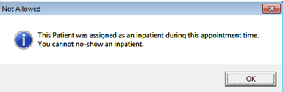

Figure : No-Show Warning Message

### Undo No-Show Appointment

If a patient was previously recorded as a no-show but arrives in time for the current appointment, the previously recorded no show can be undone.

**To undo a no-show appointment:**

1. Log on to VS GUI as a Scheduler.
2. From the **Tasks** tab, in the **Search** text box, type the patient’s last name or the patient’s first initial of the last name and last four of the SSN (e.g. S1234). Click **Search**, and then select the requested patient’s name. Click **Search**.
3. In the Pending Appointments Window on the Ribbon Bar, point to the No Show appointment to be undone.

The clinic schedule displays.

For past appointment dates, the clinic schedule displays the default appointment date.

For the current date (or appointment date less than 3 days in future), the clinic schedule displays the current default date.

1. Right-click Appointment.
2. Select Undo No-show.

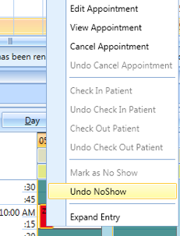

Figure : Appointment Right-click Options – Undo No-show

In the Clinic Schedule Grid, the appointment changes from red to purple.

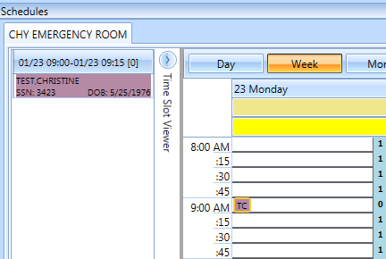

Figure : Appointment Clinic Schedule Display – Undo No-show as Purple

The appointment status in the Pending Appointments Window changes to No Action Taken.

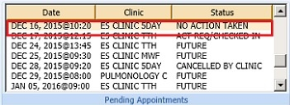

Figure : Undo No-show – Appointment Status No Action Taken

The Request closes and is relinked to the appointment.

### Checking In a Patient

If a clinic location uses VPS Vetlink and/or patient kiosks to check in patients, continue to use VPS Vetlink and kiosks to check in patients. VS GUI is an overlay to VistA, and like a VistA check in, a check in VS GUI will not reflect in Vetlink for patient tracking.

To check in a patient for an appointment:

1. Log on to VS GUI as a Scheduler.
2. From the **Tasks** tab, in the **Search** text box, type the patient’s last name or the patient’s first initial of the last name and last four of the SSN (e.g. S1234). Click **Search**, and then select the requested patient’s name.
3. In the Pending Appointments Window on the Ribbon Bar, point to the appointment to be checked in.

The clinic schedule displays. For past appointment dates, the clinic schedule Clinic Schedule opens defaulted to appointment date. For the current date (or appointment date less than three days in future), the clinic schedule displays the current default date.

1. Right-click Appointment**.**
2. Select Check In Patient.

**Note:** Check In is not available for appointments with future dates.

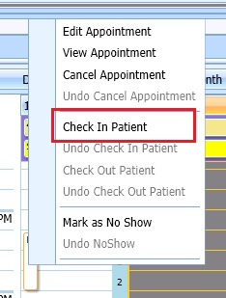

Figure : Appointment Right-click Options – Check In Patient

The Appointment **Check In** dialog box opens. You can change the check in date and time as needed.

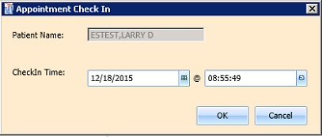

Figure : Appointment Check In Dialog

1. Click **OK**.

The appointment color changes to yellow, which indicates the patient has checked in for the appointment.

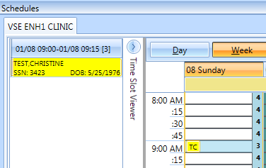

Figure : Clinic Schedule Display – Check In Yellow

In the **Pending Appointment Window** on the Ribbon Bar, the appointment status changes to ACT REQ/CHECKED IN.

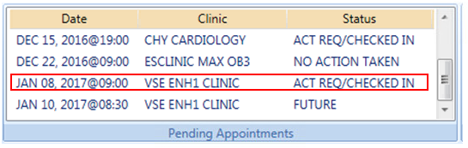

Figure : Pending Appointment Window – Status ACT REQ/CHECKED IN

### Undo a Patient Check In

If a patient is checked in by mistake, the check in can be undone.

To undo a patient check in:

1. Log on to VS GUI as a Scheduler.
2. On the Clinic Schedule Grid, select the patient check in that needs to be undone.
3. Right-click and then select Undo **Check In Patient**.

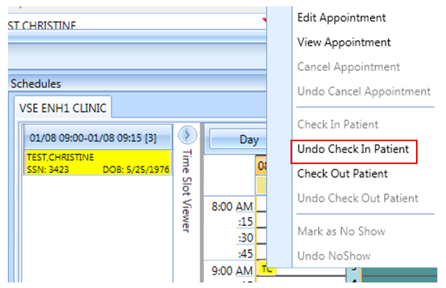

Figure : Appointment Right-click Options – Undo Check In Patient

The Appointment changes color from yellow to purple.

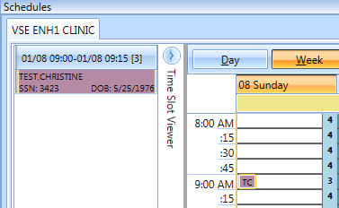

Figure : Clinic Schedule Display – Undo Check In Patient Purple

On the Pending Appointment Window, appointment status changes to No Action Taken.

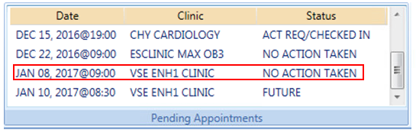

Figure : Pending Appointment Window – Appointment Status No Action Taken

### Check Out a Patient

To check out a patient:

1. Requires the SD SUPERVISOR key in VistA. Please note: The check out follow-up function is now working in version 2.0.0.14, but is still tied to the encounter. Until we can make the VS GUI’s Check Out purely administrative, **we highly discourage the use of Check Out in VS GUI**.
2. Log on to VS GUI as a Scheduler.
3. From the **Tasks** tab, in the **Search** text box, type the patient’s last name or the patient’s first initial of the last name and last four of the SSN (e.g. S1234). Click **Search**, and then select the requested patient’s name.
4. In the Pending Appointments Window on the Ribbon Bar, point to the appointment to be checked out.

The Clinic Schedule displays.

* For a past appointment date, the Clinic Schedule opens on the default appointment date.
* For the current date (or appointment date less than three days in future), the schedule displays the current default date.
* For future dates, the schedule displays -/+ three days of the appointment date.

1. Right-click and select Check **Out Patient**.

**Note:** Check Out is not available to select if Check In has not been performed.

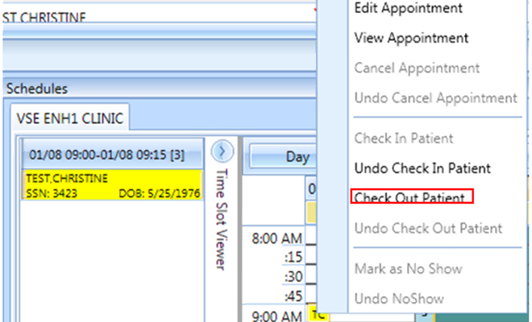

Figure : Appointment Right-click Option – Check Out Patient

1. Update the **Appointment Check Out** dialog box.
2. Confirm the date and time. Edit as needed.

**Note:** Check Out must be at least one minute after Check In.

1. Click **OK**.

The appointment status is changed to ACT REQ/**Checked Out** in the Pending Appointment Window and the color changes to orange in Clinic Schedule.

**Note:** When the Scheduler clicks OK, if Follow-up Needed was checked, then the new APPT Request dialog box opens. This APPT Request dialog box needs to be completed before Patient Check Out is complete.

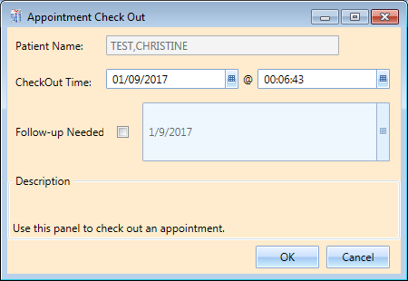

Figure : Appointment Check Out Dialog

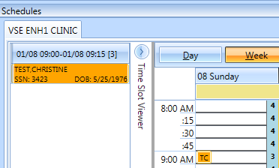

Figure : Clinic Schedule Display – Check Out Patient Orange

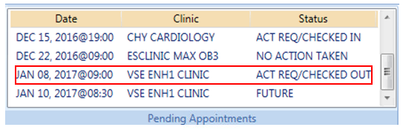

Figure : Pending Appointment Window – Status ACT REQ/CHECKED OUT

### Undo a Patient Check Out

If a patient is checked out by mistake, the checkout can be undone.

To check out a patient:

1. Requires the SD SUPERVISOR key in VistA. **Please note: The Undo Check Out function is not working as designed and should not be used in this version.** It will remove any encounter information associated with this visit.
2. Log on to VS GUI as a Scheduler.
3. On the Clinic Schedule Grid, select the patient check in that needs to be undone.
4. Right-click and select **Undo Check Out Patient**.

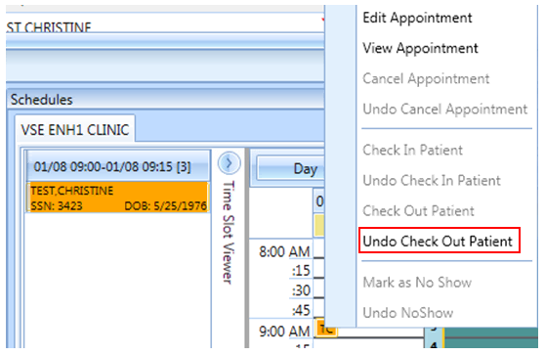

Figure : Appointment Right-click Options – Undo Check Out Patient

The Appointment changes color from orange to yellow.

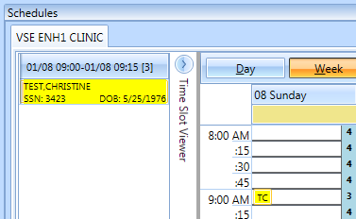

Figure : Clinic Schedule Display – Undo Check Out Patient Yellow

From the Pending Appointment Window, the appointment status changes to ACT REQ/CHECKED IN.

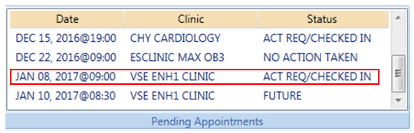

Figure : Pending Appointment Window – Status ACT REQ/CHECKED IN

**Note:** Undoing the checkout will also delete all the unnecessary information that has been entered up to this point.

### Rescheduling an Appointment

You can cancel an appointment and reschedule it for another time.

1. Log on to VS GUI as a Scheduler.
2. From the Tasks tab, in the **Search** text box, type the patient’s last name or the patient’s first initial of the last name and last four of the SSN (e.g. S1234). Click **Search**, and then select the requested patient’s name.
3. In the **Pending Appointments** Window on the Ribbon Bar, point to and select the appointment to be rescheduled.

The Clinic Schedule displays.

For a past appointment date, the Clinic Schedule opens to the default appointment date.

For the current date (or appointment date less than three days in the future), the schedule displays the current default date.

For future dates, the schedule displays -/+ three days of an appointment date.

1. On the Clinic Schedule Grid, select the scheduled appointment, and cancel per section 6.2.3 Cancelling An Appointment.
2. Add the new appointment per section 6.1 Adding Appointments.

The box opens.

1. Click OK to move the appointment or click cancel if you do not want to move the appointment.

## Multiple Appointment Requests and Appointments

Multiple Appointment Requests allow the scheduler to create requests and book a series of appointments at one time for a patient.

### Multiple Appointment Request

1. Log into VS GUI as a Scheduler.
2. From the Tasks tab, in the **Search** text box, type the patient’s last name or the patient’s first initial of the last name and last four of the SSN (e.g. S1234). Click **Search**, and then select the requested patient’s name. Click **Search**.
3. In the Request Type dialog box, select APPT to create a new request.

The Patient’s Eligibility Information dialog box opens.

1. In the **Appointment Request** dialog box confirm Patient Information details and complete the Request Information section.

* Select the **Clinic** or **Service/Specialty** button. For Clinic, enter the name of the clinic (minimum of six characters required). For Service/Specialty, enter the service or specialty (minimum of six characters required).
* Enter the **CID/Preferred Date** for the preferred appointment date. The scheduler can enter the date directly or select the date from the Calendar control option.
* Select the **Appointment Type** (if not defaulted by patient eligibility and clinic selection) then choose from the list.
* In **Request By**, select either Provider or Patient.
* For you select **Provider,** enter the provider’s name (three character minimum) and select from list. If you select Patient , then the Provider field is dimmed and you cannot be edit that field.
* The **Status** is automatically populated.

1. Established – This indicates that the patient has been seen at that clinic in the past 24 months
2. New – This indicates that the patient has not been seen at that clinic in the past 24 months

The Multiple **Appointments Required** check box is enabled.

1. Click the box to enter a check mark.

* The **Number of Appointments Required** list is visible. Up to 60 appointments can be requested at one time.
* The **Interval Between Appointments** (In days) list is visible. Up to 30 days between appointments can be requested at one time.

**Note:** The combination of Number of Appointments Required and Interval Between Appointments cannot exceed 24 months. If the selected combination exceeds 24 months to complete, when the scheduler selects OK to complete the Appointment Request, the MRTC Interval/Appt.# Dialog displays the message: “The combination of requested appointments and the interval between appointments exceeds 24 months. Adjust the number of requested appointments and/or the interval between appointments so that the combined duration is less than 24 months.” The adjustment must be made before the Multiple Appointment Request can be completed.

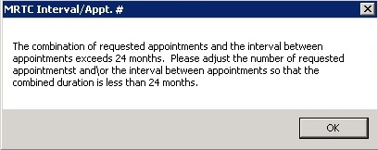

Figure : MRTC Interval/Appt. # Dialog

* Text can be added in the **Comment** field up to 80 characters to add information regarding the Appointment Request. For MRTC Requests, the text displays in the Request Management Grid under the Comment column after the {Day, Interval} information.
* Only the current comment entered is displayed although there is an Audit Log of Uses that created previous comments.

1. Click **OK.**

The **Find Appointment** dialog box opens to allow the scheduler to book Multiple Appointments at one time. See Section 0 for booking appointments from the Find Appointment Dialog.

#### Note Regarding Parent and Child Appointment Requests

When booking Multiple Appointment Requests, the scheduler can click **Close** in the Find Appointment dialog. If this is done prior to the first appointment in the series being booked the Parent MRTC Request is placed in the Request Grid with a “P” and a check mark in MRTC Column. The {Day, Interval} requested in the Appointment Request displays in the Comment column. Any text entered into the Comment field of the Appointment Request dialog displays in the Comment column after the {Day, Interval} information. The MRTC APPT Requests with Comments are flagged with a red arrow in the Request Management Grid.

If the scheduler books the first appointment in the series and then clicks CLOSE in the Find Appointment Dialog box, the Parent Request displays in the Request Grid. Additionally, the remaining unbooked appointments display as individual Child MRTC Requests in the Request Grid with a check mark, not a “P” in the MRTC Column. The appointment placement in the series as well as the number of total appointments requested display in the Comments column. Any comments entered in the original MRTC Appointment Request dialog box display in each individual Child Request after the {Day, Interval} information.

Selecting the Parent MRTC Request launches the **Find Appointment** dialog box and the scheduler can continue booking all remaining appointments for the series from Find Appointment. However, selecting a Child MRTC Request opens the Clinic Schedule and the scheduler can only book the individual appointment following the same steps as adding an appointment for an APPT Request (refer to Section 6.1.1). The Parent MRTC Request is not removed from the Request Grid until all appointments in the series have been booked. A Child MRTC Request is removed from the Request Grid at the time the appointment is booked.

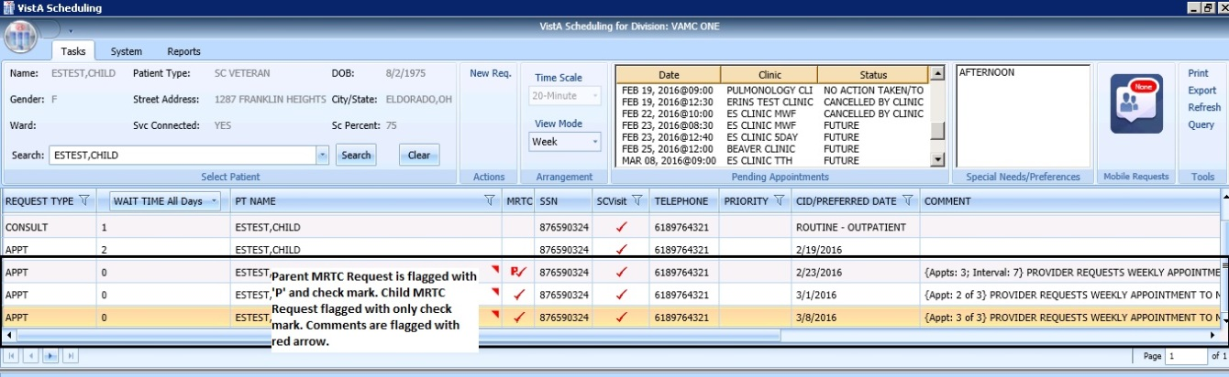

Figure : MRTC Requests displayed in Request Management Grid

### Adding Multiple Appointments from Find Appointment Dialog

When the scheduler clicks **OK** in the **Appointment Request Dialog** with **Multiple Appointments Required** checked**,** the **Find Appointment** dialog box displays to allow the scheduler to book Multiple Appointments at one time.

In the Find Appointment dialog box, the following information is displayed:

* **Calendar** in upper left corner. The CID/Preferred date entered in Appointment Request is highlighted.
* The **Clinic** is the default on the list from the Appointment Request in the Resources Section in the upper middle pane of the Find Appointment dialog box. This field is editable and Clinics can be switched between appointments as needed.
* Patient’s **Time of Day** and **Day of Week** preferences are the default in the upper right pane of the Find Appointment dialog box. These can be edited/adjusted as needed.
* The CID/Preferred date entered in Appointment Request is displayed under the Time of Day and Day of Week preferences in the Find Appointment dialog box with the label **Original CID:**. This data is not editable.
* **Search** is available if the availability needs to be recalculated due to date or clinic changes.
* The Multiple **Appointments Required** information is the default from the Appointment Request in the middle of the Find Appointment dialog box. This information is not editable.
* **CID** displays a list of unbooked appointment dates. These dates are calculated based upon the original CID/Preferred Date + the Number of Appointments + the Interval Between Appointments.
* For clinics with special instructions defined, **Special Instructions**  displays in the Search Results section of the Find Appointment dialog box. When clicked, a Special Instructions dialog box displays with the defined information available to review.
* The clinic’s **appointment length, variable length, and Max Overbook** settings display in the label in the Search Results section.

In the **Search Results** section, availability results display -/+ three Days of the CID date for future dates. For current CID dates availability display Day 1 + six days in Search Results field.

**Note:** Time of Day and Day of Week preferences limit availability results.

* Book Column allows the scheduler to select the time slot for booking an appointment.
* Start Time Column displays the start time of time slot.
* End Time Column displays the end time of time slot.
* Resource Column displays the name of the Clinic currently selected.
* Slots Column displays available time slot count. Slots available for overbooking display based upon the Scheduler’s security key allowances.

**Note:** Time Slots do not display if no availability is defined for that time period for the clinic or overbooking has been reached beyond the scheduler’s security key allowances.

* **Number of Available Slots**: The count displays at the bottom of the Find Appointment dialog box notifying the scheduler how many slots are available for the selected CID date.
* **Next** and **Book** buttons are disabled until first Time Slot(s) is selected for booking.

1. Select a time slot in the Booking Column. If the clinic is Variable Length, schedulers can select multiple appointment slots in the view to lengthen the appointment time. The additional slots must all be adjacent to each other (stop time of first = start time of second).

**Note:** If Clinic DISPLAY INCREMENTS PER HOUR is defined for a count less than the defined LENGTH OF APP'T, then multiple Time Slots may need to be selected to satisfy the Appointment Booking Requirements and enable the Book Button.

1. Click **Book**.

**Note:** If the selected time slot has reached its defined slot count and the scheduler has the appropriate security keys to overbook, then a dialog box displays a message alerting the scheduler that continuing with scheduling the appointment will result in overbooking the selected time slot. The Scheduler can click **OK** to confirm overbooking and continue to the New Appointment dialog box.

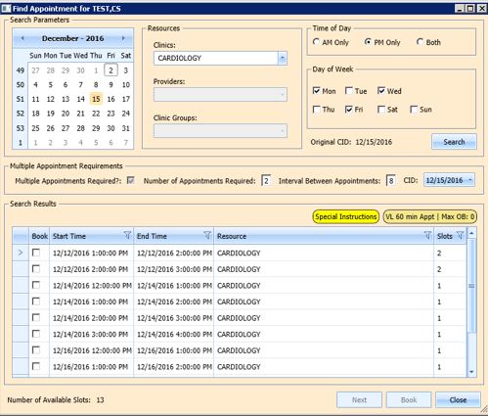

Figure : Find Appointment Dialog

The New Appointment dialog box opens. The New Appointment dialog box has one tab:

* **Appointments Tab**:
* **Patient Information Section displays** Name, DOB, SSN, SVC Connected, SC Percent, GAF (read only), and Svc Related check box**.**
* **Appointment** information section displays Start Time, Appt Type, Duration, Clinic and Notes (Appointment Start Time; Duration on for appointments to VL Clinics; and Notes are editable fields).
* **Appointment Conflicts** section displays any appointments already scheduled that conflict with the appointment being added.

1. Confirm information in the New Appointment dialog box and add any applicable text to the Notes section. Click **OK**.

The Print Letter? Dialog box displays.

1. Click **OK** to Print the Patient Letter.
2. Click **Cancel** to close dialog box and not print the Patient Letter.

The Closing Request dialog box displays “This request will be closed.”

1. Click **OK**.

The First MRTC Appointment is booked. The CID date in the Find Appointment dialog box changes to the next appointment date in the series. The MRTC Booking Status dialog box displays appointments as they are booked. An arrow points to date in MRTC Series that is being booked and automatically updates as appointments are completed.

The following information displays in the MRTC Booking Status dialog box:

* CID Date—Calculated by first booked appointment date and Interval Requested.
* Appointment Date—the date selected when booking appointments.
* Resource—the Clinic name where the appointment was booked.

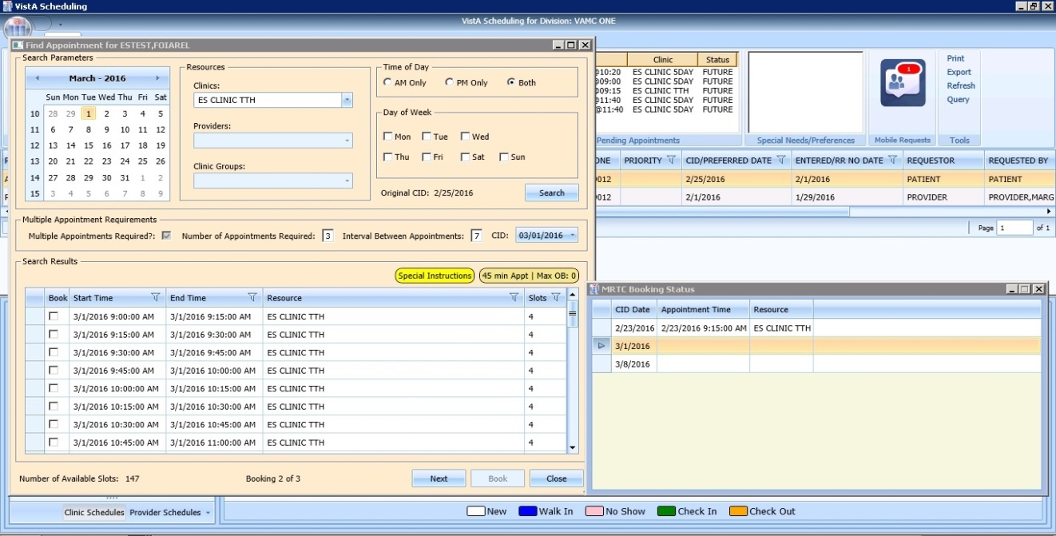

Figure : Find Appointment Dialog and MRTC Booking Status Dialog

**To book a second MRTC appointment:**

1. Select a time slot for the second MRTC appointment in the series.
2. Click **Book**.

The New Appointment dialog box displays.

1. Confirm information in the New Appointment dialog box. Add any applicable text to the Notes section, and then click **OK**.

The Print Letter? Dialog box displays.

1. Click **OK** to Print the Patient letter.

Click **Cancel** to close dialog and not print the Patient Letter.

The Closing Request dialog box displays a message “This request will be closed.”

1. Click **OK**.

The Second MRTC Appointment is booked. The CID date in the Find Appointment dialog box changes to the next appointment date in the series. The Appointment date is added in the MRTC Booking Status dialog box for the second appointment and the arrow moves to the next appointment (if applicable).

Once all MRTC Appointments have been booked for the series, the Closing Request dialog displays, “The Parent MRTC Request will be closed.”

If a clinic has a future inactive date and the CID date falls + three days after the Inactivate Date, a gray label displays in the Search Results section of the Find Appointment dialog box, “There are no slots available. The selected Clinic will be deactivated on {Inactivation Date}. Select another clinic, and then click **Search** to complete the MRTC request.”

To complete adding appointments for the series, the scheduler needs to change to an appropriate clinic in the Resources section with availability and continue adding appointments for the remainder of the series requests.

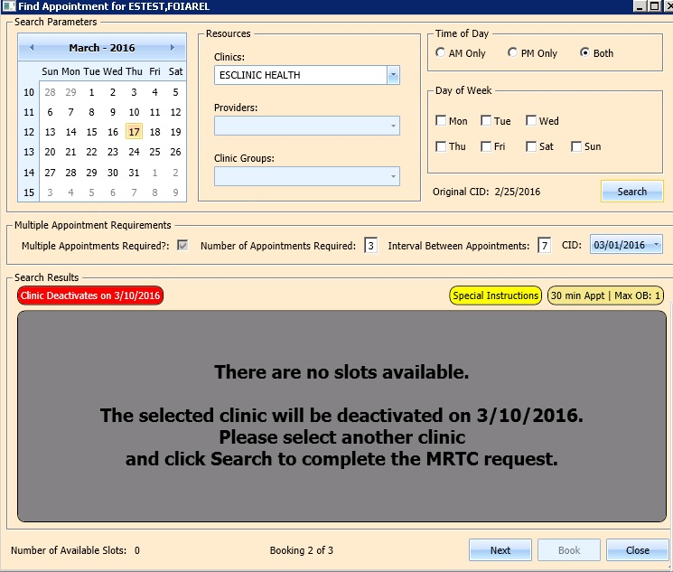

Figure 160: Future Clinic Inactivation Date

## Overbooking Appointments

Schedulers can overbook appointments based upon the following rules:

* The scheduler must have the Scheduling Overbook (SDOB) security key to overbook up to the clinic’s Maximum (Max) Overbook (OB) definition. Schedulers must have the Scheduling Master Overbook security key (SDMOB) security key to schedule beyond the clinic’s Max OB definition. Schedulers with both overbook security keys can overbook on any day that has availability defined regardless of the clinic’s Max OB definition. Schedulers cannot overbook if they are not assigned an overbooking security key.
* The Clinic must have availability defined for the day in question. If there is no availability defined, then schedulers will not be able to overbook appointments on that day regardless of the security key assigned to them.
* Appointments cannot be overbooked prior to the start of the day’s clinic availability.

### Overbooking Appointments with SDMOB Security Key

Schedulers assigned the SDMOB security key can overbook anytime outside of the clinic’s availability from the clinic’s start time to 11:59 p.m. even if the Max Overbook Limit defined for a clinic has been reached.

**To overbook an appointment with the SDMOB security key:**

1. Log into VS GUI as a Scheduler.
2. From the **Tasks** tab, in the **Search** text box, type the patient’s last name or the patient’s first initial of the last name and last four of the SSN (e.g. S1234). Click **Search**, and select the requested patient’s name. Click **Search**.
3. In the **Request Type** dialog box, select **APPT**, and then click **OK** to create a new request or click **Cancel** for the existing request.

**Note:** Refer to Section 5.1.2 Adding Appointment Request for steps on adding a new APPT Request.



Figure : Request Type

1. In the Request Management Grid select the **APPT** request.

The Clinic Schedule Grid displays the clinic’s schedule based upon the CID/Preferred date of request. For past dates, the clinic schedule opens to the default CID/Preferred date as Day 1 + six days. For the current date (or the CID/Preferred date less than three days in the future), the clinic schedule displays the current default date as Day 1 + six Days. For future dates, the clinic schedule displays -/+ three days of CID/Preferred date.

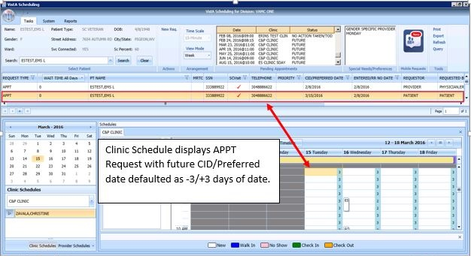

Figure : Clinic Schedule Display – APPT Request Future CID/Preferred Date

**Note:** For a newly created APPT request, the system automatically highlights the APPT request and the Clinic Schedule displays.

In the Clinic Schedule Grid, select the time slot in gray that is within the clinic’s hours, from the clinic’s start time to 11:59, or a date/time slot that has existing overbookings.

**Note:** The Clinic Max Overbook limit displays in the Clinic Day Event notes.

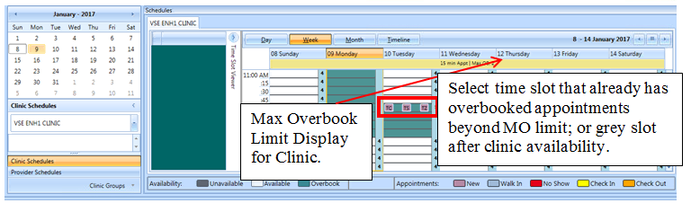

Figure : Max Overbook Limit

1. Right-click in the time slot.

The **Add Appointment** option displays.

**Note:** The **Create Walk In Appointment** option is only available for selection on the current date. It is not available for past or future CID/Preferred dates.

**Note:** Right-click options do not display if the selected time slot is for a day that has no availability defined or is prior to the clinic’s start time.

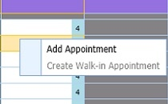

Figure : Appointment Right-click Options – Add Appointment

1. Select Add Appointment.

The Overbook message displays.

1. Click OK.

The View Appointment dialog box displays as well as the Patient Eligibility dialog box.

* **The Appointments Tab:**
* **Patient Information Section displays** Name, DOB, SSN, SVC Connected, SC Percent, GAF (read only), and Svc Related check box**.**
* **Appointment** information section displays Start Time, Appt Type, Duration, Clinic and Notes (Appointment Start Time; Duration on for appointments to VL Clinics; and Notes are editable fields).
* **Appointment Conflicts** section displays any appointments already scheduled that conflict with an appointment being added.

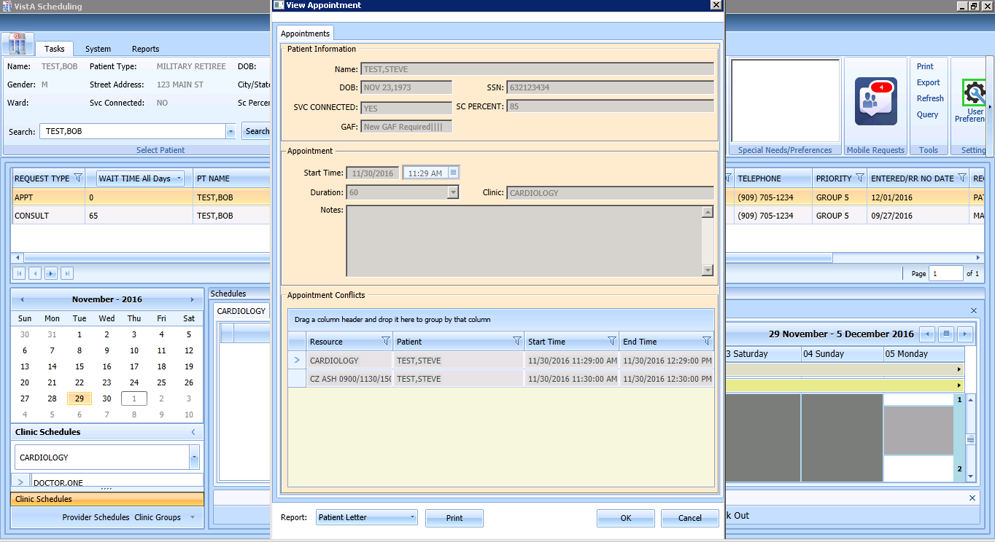

Figure : View Appointment Dialog – Appointments

1. Add any applicable Notes to the appointment. Click **OK**.

The Print Letter? Dialog displays.

1. Click **OK** to print the Letter to the patient.

Click **Cancel** to not print letter.

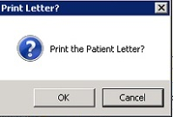

Figure : Print Letter? Dialog

The Closing Request dialog box opens.

1. Click **OK**.

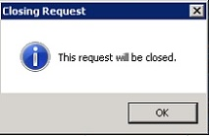

Figure : Closing Request Dialog

* The APPT Request is removed from the Patient Request Management Grid.
* The Next request for the patient is moved up and highlighted.
* The Clinic Schedule closes.
* The New appointment displays in the Pending Appointment Window on the Ribbon Bar.

1. Select an appointment from the Pending Appointment window to view it in the Clinic Schedule Grid.

* The clinic schedule opens.
* For past dates, the clinic schedule opens to the default appointment date.
* For the current date (or appointment date less than three days in future), the clinic schedule defaults to the current date.
* For future dates, the clinic schedule displays -/+ three days of the appointment date.
* The Overbook count increases in the Clinic Schedule time slot and in the Time Slot Viewer. If the appointment count has filled the time slot, hover over the window to show the slot count.

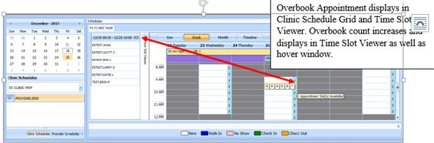

Figure : Clinic Schedule Display – Overbook Appointment

### Overbooking Appointments with SDOB Security Key

Schedulers who are assigned the SDOB security key can overbook outside of the clinic’s availability from the clinic start time to 11:59 p.m. Schedulers cannot overbook past the Max Overbook Limit defined for a clinic.

**To overbook an appointment with the SDOB security key:**

1. Log into VS GUI as a scheduler.
2. From the **Tasks** tab, in the **Search** text box, type the patient’s last name or the patient’s first initial of the last name and last four of the SSN (e.g. S1234). Click **Search**, and then select the requested patient’s name. Click **Search**.
3. If creating a new request, click the **New Req** button in the Actions pane of the ribbon bar. In the **Request Type** dialog box, select **APPT** and then click **OK** to create a new request.

**Note:** Refer to Section 5.1.2 Adding Appointment Request for steps on adding new APPT Request.



Figure : Request Type

1. Select APPT request in the Request Management Grid.

The Clinic Schedule Grid displays the clinic’s schedule based upon the CID/Preferred date of request. For a past date, the clinic’s schedule opens to the default CID/Preferred date as Day 1 + six days. For a current date (or CID/Preferred date less than three days in future), the clinic’s schedule displays the current default date as Day 1 + six days. For future dates, the clinic schedule displays -/+ three days of CID/Preferred date.

**Note:** For a newly created APPT request the system automatically highlights the APPT request and the Clinic Schedule displays.

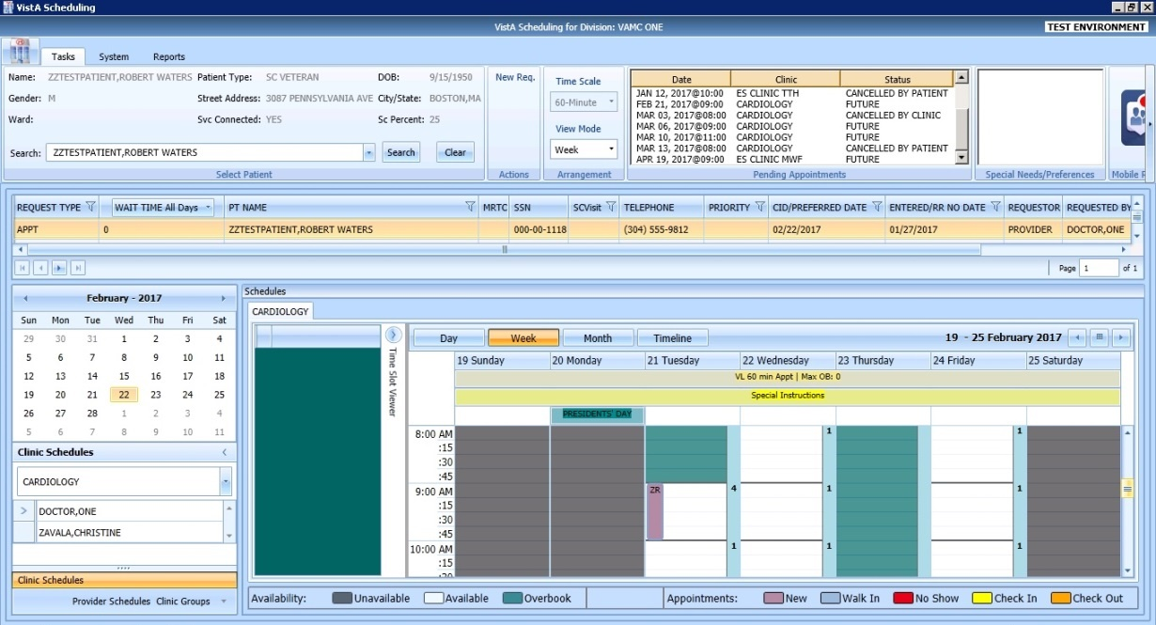

Figure : Clinic Schedule Display – APPT Request Future CID/Preferred Date

1. In the Clinic Schedule Grid, select the time slot colored in teal that is within the clinic’s hours, close of clinic hours to 11:59 p.m., or a date that does not already have existing overbooks.

**Note:** The Clinic Max Overbook limit displays in the Clinic Day Event notes.

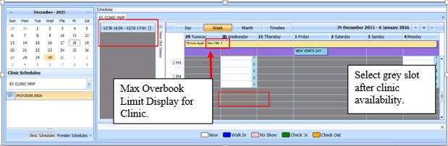

Figure : Overbook After Hours Time Slot

1. Right-click the time slot.

The Add Appointment option displays. The Create Walk In Appointment option is only available for selection on the current date. It is not available for past or future CID/Preferred dates.

**Note:** Right-click options do not display if the selected time slot is for a day that has no availability defined, is prior to the clinic’s start time, or the Max Overbook limit has been met for the day.

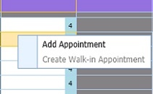

Figure : Appointment Right-click Options – Add Appointment

1. Select Add Appointment.

The Overbook message displays.

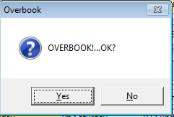

Figure : Overbook Confirmation Dialog

1. Click **OK**.

The New Appointment dialog box displays, as well as the Patient Eligibility dialog box.

* **Appointments Tab**:
* **Patient Information Section displays** Name, DOB, SSN, SVC Connected, SC Percent, GAF (read only), and Svc Related check box**.**
* **Appointment** information section displays Start Time, Appt Type, Duration, Clinic and Notes (Appointment Start Time; Duration on for appointments to VL Clinics; and Notes are editable fields).
* **Appointment Conflicts** section displays any appointments already scheduled that conflict with the appointment being added.

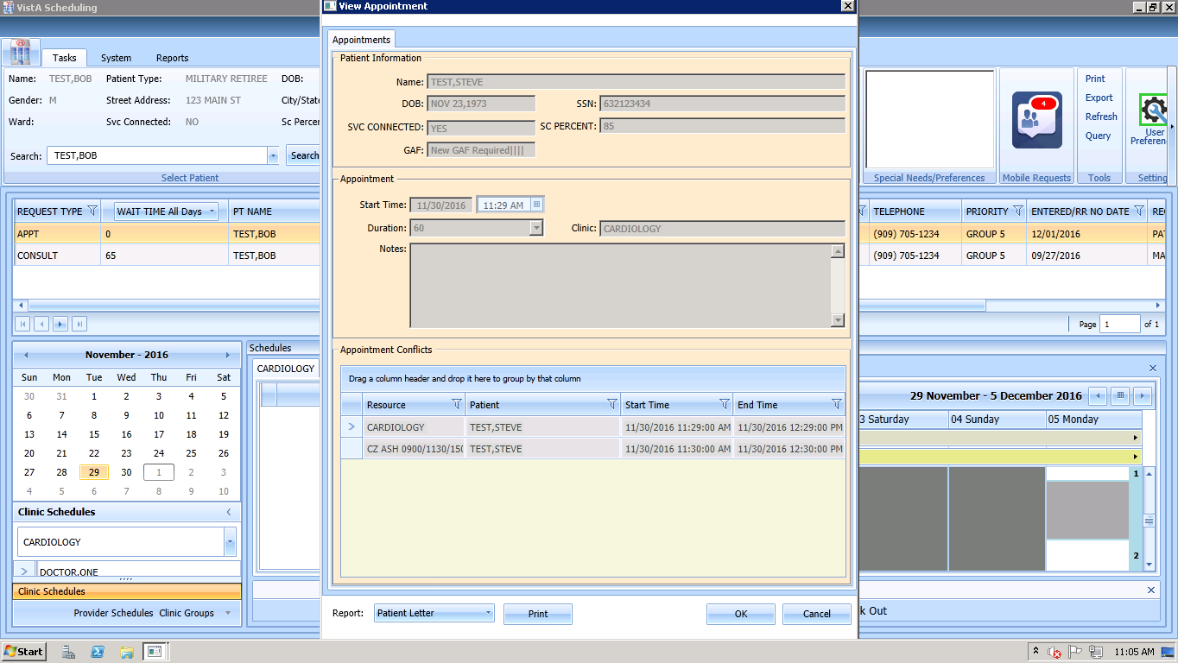

Figure : New Appointment Dialog

1. Add any applicable Notes to the appointment. Click **OK**.

The Print Letter? Dialog box displays.

1. Click **OK** to print the Patient Letter.
2. Click **Cancel** to exit the dialog box and not print the Patient Letter.

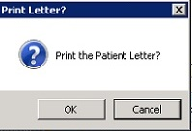

Figure : Print Letter? Dialog

The Closing Request dialog box opens.

1. Click **OK**.



Figure : Closing Request Dialog

The APPT Request is removed from the Patient Request Management Grid. The Next request for the patient is moved up and highlighted.

The Clinic Schedule closes.

The New appointment displays in the Pending Appointment window in Ribbon Bar.

1. Select an appointment from the Pending Appointment window to view it in the Clinic Schedule Grid.

The clinic schedule opens. For past dates, the clinic schedule opens to the default appointment date. For the current date (or appointment date less than three days in future), the clinic schedule displays the current default date. For future dates, the clinic schedule displays -/+ three days of appointment date.

The Overbook count increases in the clinic schedule time slot and in the Time Slot Viewer. If the appointment count has filled the time slot, hover over the window to display the slot count.

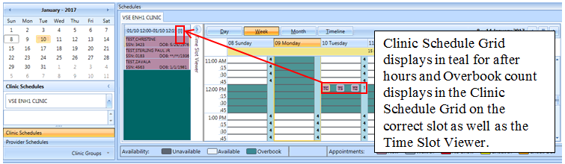

Figure : Clinic Schedule Display – Overbook Appointment After Hours

## Variable Length (VL) APPT

Scheduling appointments can typically be done in fixed length intervals based upon the clinic’s definitions. However, a clinic can be setup as a Variable Length (VL) clinic, which allows a user to schedule an appointment for an extended amount of time as needed rather than scheduling multiple appointments.

### IdentifyingaVLClinic**:**

To identify if a clinic is set up for VL scheduling:

1. Log on to VS GUI.
2. From the Clinic Schedules, type the clinic’s name (six-character minimum) or the clinic’s abbreviation (four-character minimum).

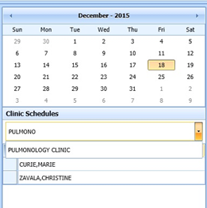

Figure : Clinic Schedules – Clinic Search

The selected clinic’s schedule displays the default, the current date as Day 1 + six days.

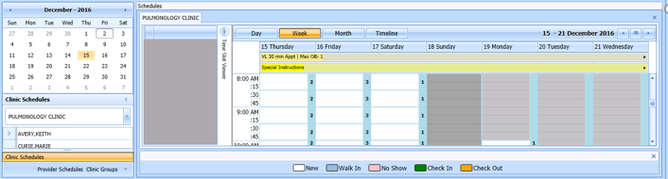

Figure : Clinic Schedule Grid

To confirm whether VL appointments can be booked at a clinic, view the All Day Event Bar in the Clinic Schedule Grid. The clinic’s defined appointment length and max overbooking limit are displayed. If the clinic is designated as a variable length clinic, the letters “VL” display before the appointment length.

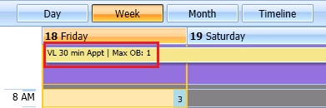

Figure : VL Indicator

### Add a VL APPT

**To add a VL APPT:**

1. In the clinic schedule, select the time slot that the APPT shall begin.
2. Highlight consecutive time slots and select **Add Appointment**

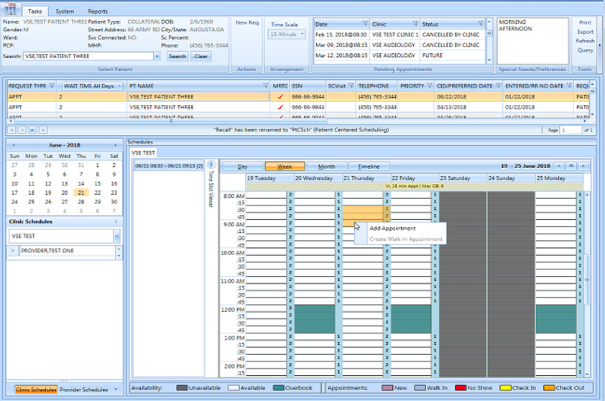

Figure : Consecutive Time Slots

1. Right-click and select **Add Appointment**.

The New Appointment dialog box displays.

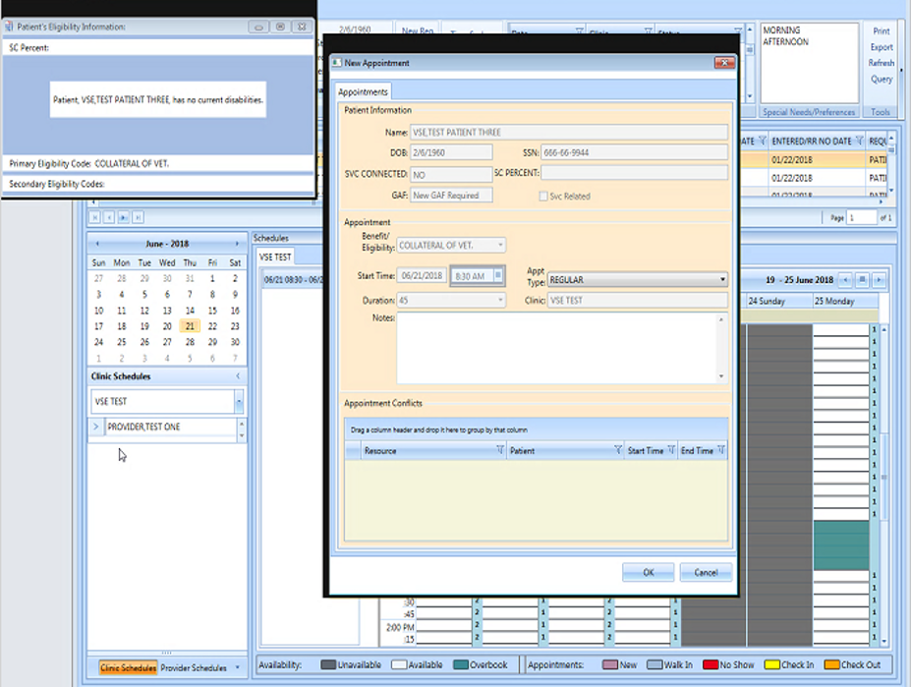

Figure : New Appointment Dialog

1. The New Appointment dialog box appears. Confirm that the appointment duration reflects the correct amount of time.
2. Click **OK**.

The Print Letter? Dialog box opens.

1. Print the letter if appropriate. Click cancel, if you do not want to print the letter.

The Closing Request dialog box displays a message “This request will be closed”.

1. Click **OK**.

The New APPT displays in the Pending Appointment window.

1. Select the APPT from the Pending Appointment window.

The Clinic Schedule displays the booked APPT spanning three time slots, which indicates a VL APPT.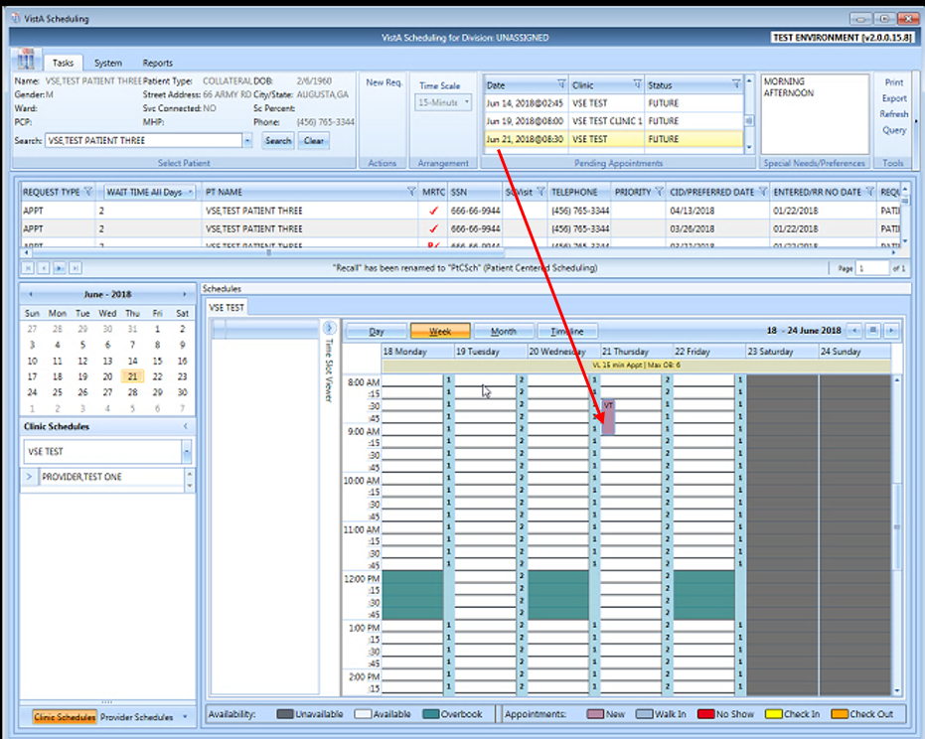

Figure : Clinic Schedule Display – Appointment Length Extended

## Compensation and Pension (C&P) APPTs

### Add a C&P APPT Request

1. Log into VS GUI.
2. From the Tasks tab, type the patient’s last name and the first name in the Search text box. Click **Search**, and then select the requested patient’s name from the list.
3. Click the **New Req** button in the Actions pane.
4. Select the APPT Request Type.
5. Complete the APPT Request dialog box.

Refer to Section 5.1.2 for instructions on completing APPT Request dialog.

1. Select the appropriate Clinic for the C&P appointment.
2. Enter the CID/Preferred Date.
3. In Appointment Type list, select C&P.
4. Click **OK**.

The APPT Request displays on the patient’s Request Management Grid.

### Add a C&P APPT for Pending 2507 Request NOT Previously Linked to Appointment

1. Log into VS GUI.
2. From the **Tasks** tab, in the **Search** text box, type the patient’s last name or the patient’s first initial of last name and last four of the SSN (e.g. S1234). Click **Search**, and then select the requested patient’s name.
3. In the Request Management Grid, select pending C&P APPT Request.
4. In the Clinic Schedule Grid, click the open time slot.
5. Right-click, and then select **Add Appointment**

**Note:** The Create Walk-In Option is available if the current day is selected in the Clinic Schedule.

The New Appointment dialog box displays.

Confirm the Appointment Type is listed as C&P. If not, select the Appointment Type from the list.

Add any applicable APPT information to the Notes section.

1. Click **OK**.

The Dialog box displays:

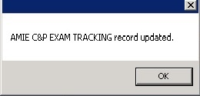

Figure : TRACKING Record Updated

**Note:** If the patient did NOT have a pending 2507 Request on file a dialog box opens:

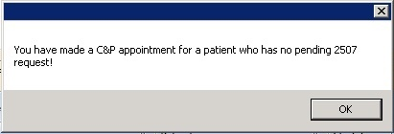

Figure : C&P Appointment for Patient with No Pending 2507 Request

1. Click **OK**.

The Print Letter? Dialog box displays.

1. Click **OK** to print the Patient Letter.

Click **Cancel** to exit the dialog box and not print the patient letter.

The Closing Request Dialog box displays a message - “This request will be closed.”

1. Click **OK**.

The New C&P APPT displays in the Pending Appointment window and the Automated Medical Information Exchange (AMIE) Tracking Link is updated.

### Add a C&P APPT for Pending 2507 Request Already Linked to APPT NOT Due to Cancellation

1. Log into VS GUI.
2. From the Tasks tab, type the patient’s last name and the first name in the Search text box. Click **Search**, and then select the patient’s name with the pending C&P APPT Request from the list.
3. In the Request Management Grid, select pending C&P APPT Request.
4. In the Clinic Schedule Grid click an open time slot.
5. Right-click on open time slot, and then select **Add Appointment.**

**Note:** The Create Walk-In Option is available if the current day is selected in the Clinic Schedule.

The New Appointment dialog box opens.

1. Confirm the Appointment Type is listed as C&P. If not, select it from the list.
2. Click **OK**.

The C&P requests dialog box displays the following information:

* Name: Veteran’s name
* Request Date: Date 2507 Request created

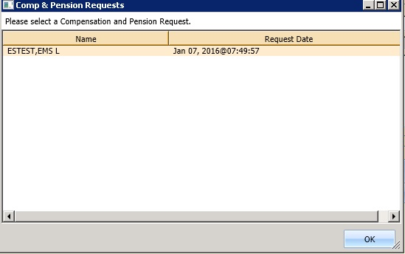

Figure : C&P Requests Dialog

1. Select the appropriate 2507 Request from the list.
2. Click **OK**.

The C&P Request dialog box displays an option to select Yes or No:

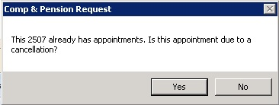

Figure : C&P Request Due to Cancellation Dialog

1. Click **No**.

A message update dialog box displays:



Figure : AMIE C&P EXAM TRACKING Record Updated

1. Click **OK**.

The Print Letter? Dialog box opens.

1. Click **OK** to print the Patient Letter.

Click **Cancel** to exit the dialog box and not print the Patient Letter.

The Closing Request dialog box displays the message: “This request will be closed.”

The New C&P Appointment displays in the Pending Appointment window, and shows the AMIE Tracking Link is updated.

### Add a C&P APPT for Pending 2507 Request due to Clinic Cancellation

1. Log into VS GUI.
2. From the **Tasks** tab, in the **Search** text box, type the patient’s last name or the patient’s first initial of the last name and last four of the SSN (e.g. S1234). Click **Search**, and then select the requested patient’s name. Click **Search**.
3. In the Request Management Grid, select pending C&P APPT Request.
4. In the Clinic Schedule Grid, click the open time slot.
5. Right-click the time slot, and then select Add Appointment.

**Note:** The Create Walk-In Option is available if the current day is selected in the Clinic Schedule.

The New Appointment dialog box opens.

Confirm the Appointment Type is listed as C&P. If not, select the Appointment Type from the list.

1. Click **OK**.

The C&P Requests dialog box displays the following information:

* Name: Veteran’s name
* Request Date: Date 2507 Request created



Figure : C&P Requests Dialog

1. Select the appropriate 2507 Request from the list.
2. Click **OK**.

The C&P Request displays the option to select Yes or No:



Figure : C&P Request Due to Cancellation Dialog

1. Click **Yes**.

The C&P APPT Links dialog box displays the following information:

* Initial Appointment Date
* Clock Stop Appointment Date
* Current Appointment Date
* Clinic Name

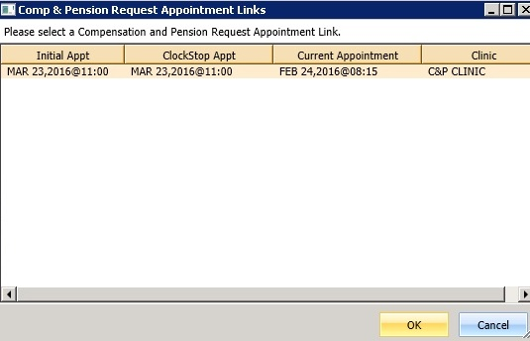

Figure : C&P Request APPT Links Dialog

1. Click **OK**.

**Note:** If the scheduler clicks **Cancel**, the following dialog box opens:

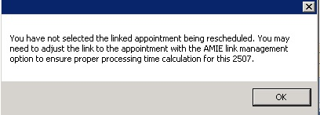

Figure : C&P APPT Links Due to Veteran Cancellation or No Show

The C&P APPT Links dialog box displays a message with the option to select Yes or No:

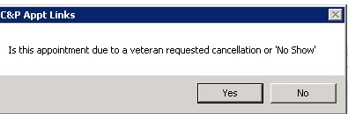

Figure : C&P APPT Links Due to Cancellation Dialog

1. Click **No**.

A Dialog box displays a message about the C&P appointment.

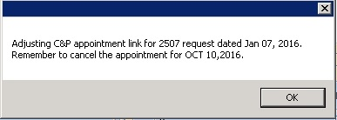

Figure : C&P APPT Links Adjustment Dialog

1. Click **OK**.

The Print Letter? Dialog opens.

1. Click **OK** to print the Patient Letter.

Click **Cancel** to exit the dialog box and not print the Patient Letter.

The Closing Request dialog box displays a message: “This request will be closed.”

The New C&P APPT displays in the Pending Appointment window and shows the AMIE Tracking Link is updated.

**Note:** The previous appointment linked to the 2507 Request must be manually dispositioned.

### Add C&P APPT for Pending 2507 Request due to Veteran Cancellation/No Show

1. Log into VS GUI.
2. From the **Tasks** tab, in the **Search** text box, type the patient’s last name or the patient’s first initial of the last name and last four of the SSN (e.g. S1234). Click **Search**, and then select the requested patient’s name. Click **Search**.
3. In the Request Management Grid, select pending C&P APPT Request.
4. In the Clinic Schedule Grid, click an open time slot.
5. Right-click the time slot, and then select **Add Appointment**.

**Note**: The Create Walk-In Option is available if the current day is selected in the Clinic Schedule.

The New Appointment dialog box opens.

1. Confirm the Appointment Type is listed as C&P. If not, select the Appointment Type from the list, and then click OK.

The C&P Requests dialog box displays the following information:

* Name: Veteran name
* Request Date: Date 2507 Request created

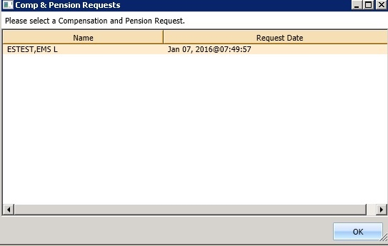

Figure : C&P Requests Dialog

1. Select the appropriate 2507 Request from the list.
2. Click **OK**.

The C&P Request dialog box displays information about the appointment and the option to select Yes or No:



Figure : C&P Request Due to Cancellation Dialog

1. Click **Yes**.

The Comp & Pension Appointment Links dialog box displays the following information:

* Initial Appointment Date
* Clock Stop Appointment Date
* Current Appointment Date
* Clinic Name



Figure : C&P Request APPT Links Dialog

1. Click **OK**.

**Note:** If the scheduler clicks **Cancel** instead of OK, the following message displays:



Figure : C&P Canceled APPT Links Dialog Warning

The C&P Appt Links dialog box displays the option to select Yes or No:



Figure : C&P APPT Links Due to Veteran Cancellation or No Show

1. Click **Yes**.

A message update dialog box displays:



Figure : AMIE C&P EXAM TRACKING Record Updated

1. Click **OK**.

The Print Letter? Dialog box displays.

1. Click **OK** to print the Patient Letter.

Click **Cancel** to exit the dialog box and not print the Patient Letter.

The Closing Request dialog box displays a message: “This request will be closed.”

The New C&P APPT displays in the Pending Appointment window and Shows the AMIE Tracking Link is updated.

**Note:** The previous appointment linked to the 2507 Request must be manually dispositioned.

### Disposition APPT Linked to Pending 2507 Request

1. Log into VS GUI.
2. From the **Tasks** tab, in the **Search** text box, type the patient’s last name or the patient’s first initial of the last name and last four of the SSN (e.g. S1234). Click **Search**, and then select the requested patient’s name. Click **Search**.
3. In the Pending Appointment window, select the pending C&P APPT linked to the pending 2507 Request.
4. In the Clinic Schedule Grid, click the appointment.
5. Right-click the appointment and the following options are available to select:

* Edit Appointment
* View Appointment
* Cancel Appointment

1. Select Cancel Appointment.

The Cancel Appointment dialog box displays. See Section 0 for detailed instructions on completing the Cancel Appointment dialog.

1. Select Appointment Cancelled By.
2. Select Reason for Cancellation.

Edit CID/Preferred Date if applicable.

1. Enter Remarks.
2. Click **OK**.

A Dialog box displays an update message:

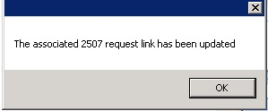

Figure : C&P Cancel APPT Associated 2507 Request Updated

**Note:** If the C&P APPT was NOT linked to the 2507 request, the following message displays in dialog box:

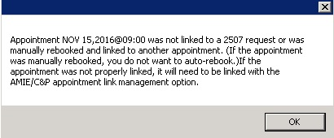

Figure : C&P Cancel APPT NOT Linked to Pending 2507 Request

1. Click **OK**.

The APPT status is updated in the Pending Appointment window. The APPT is removed from the Clinic Schedule and the AMIE Link is updated.

## VA Online Scheduling (formerly VAR)

**Note:** Note: VA Online Scheduling requests will NOT be processed in VS GUI at this time due to a number of enhancements that will be added at a later date. The SDECZREQUEST key is held in reserve until that time. If a user has the key on their VistA account now, it will give them an error each time they log in as the service cannot connect to the mobile request service.

VA Online Scheduling requests will eventually interface with VS GUI requests, including:

* Schedule an appointment requested in VA Online Scheduling through the VS GUI interface, fulfilling that request..
* View appointment requests within the GUI.
* Communicate or message the Veteran from within the GUI up to a limit of four times.
* Close out requests from within the GUI.

# Clinics

## Tasks Tab

### Viewing Clinic Schedule Availability

The VS GUI displays a consistent color visual indicator for a clinic’s workable hours including bookable holidays, non-workable hours including non-bookable holiday, clinic cancellation, and no availability as follows:

Table : Clinic Schedule Availability

|  |  |
| --- | --- |
| Appointment Availability Type | Color |
| Available Slots/Hours of Operation | White |
| Unavailable/ Non-workable hours during day with availability defined (i.e. clinic lunch breaks). | Teal |
| Cancelled Availability for Clinic—Partial and All Day Cancellation. | Teal + hash mark (\\) |
| Holiday but bookable | White |
| Holiday but NOT bookable | Gray |
| No availability defined for day (i.e. Saturday or Sunday). | Gray |
| No availability defined for the clinic | Gray |

**To search for a clinic and view the clinic schedule:**

1. From the **Tasks** tab, on the Clinic Schedules, enter a partial name of a clinic (six character minimum).

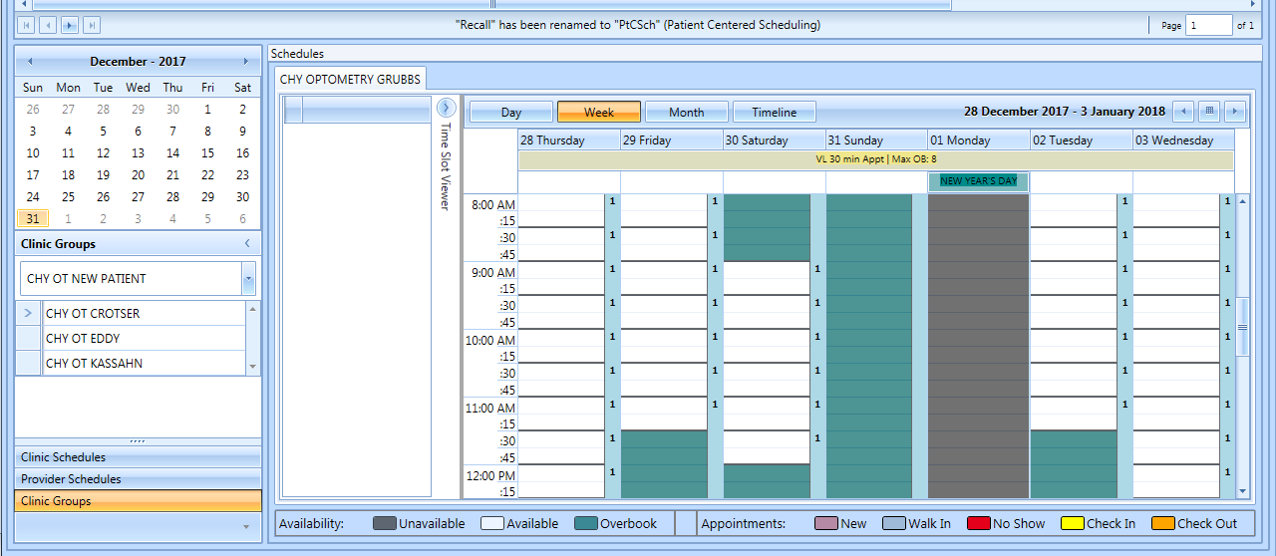

Figure : Clinic Schedules Search

1. Select the desired clinic from the returned list.

The selected clinic schedule displays.

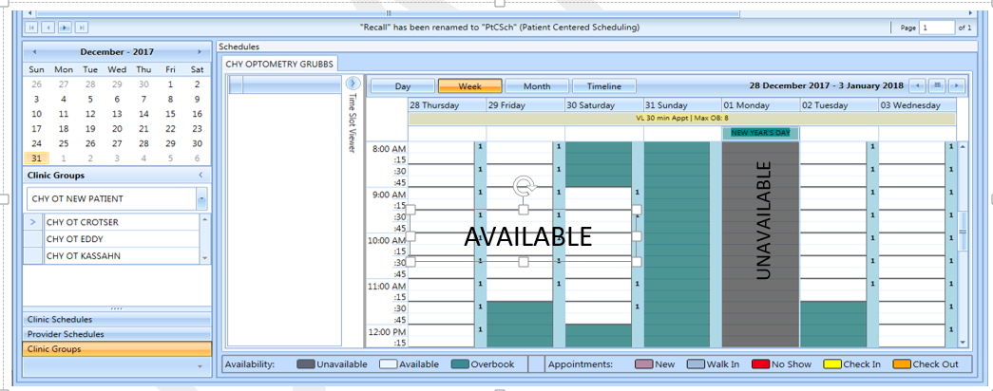

Figure : Clinic Schedules Display – Available and Unavailable

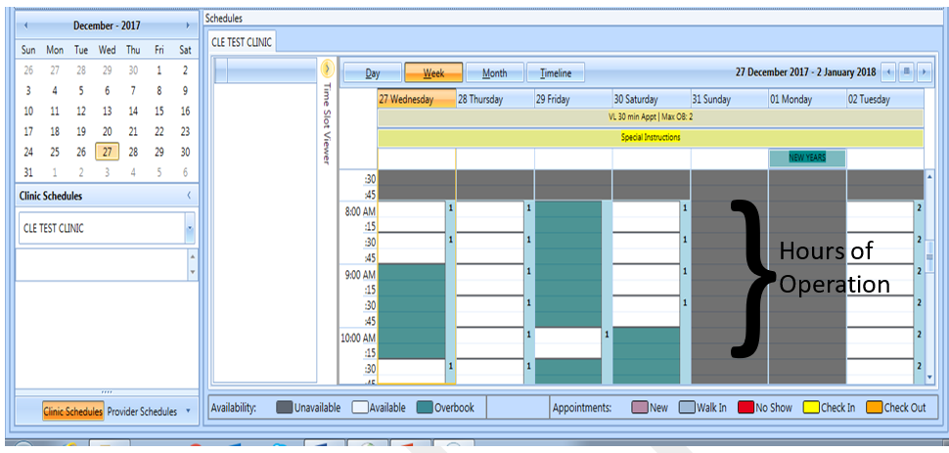

Figure : Clinic Schedules Display – Hours of Operation

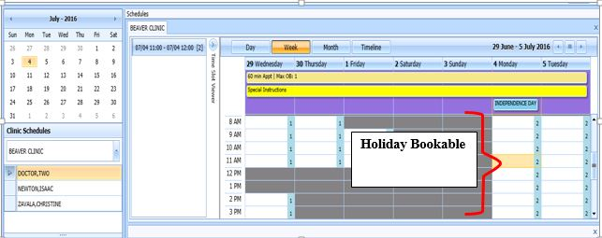

Figure : Clinic Schedules Display – Holiday Bookable



Figure : Clinic Schedules Display – Holiday Unbookable

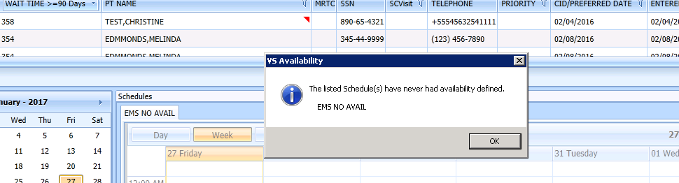

Figure : Clinic Schedule Display – No Availability Defined

### Viewing Clinic’s Availability Cancellation

The Clinic Schedule displays full or partial day cancellation in gray + \\ over the cancelled time slots.

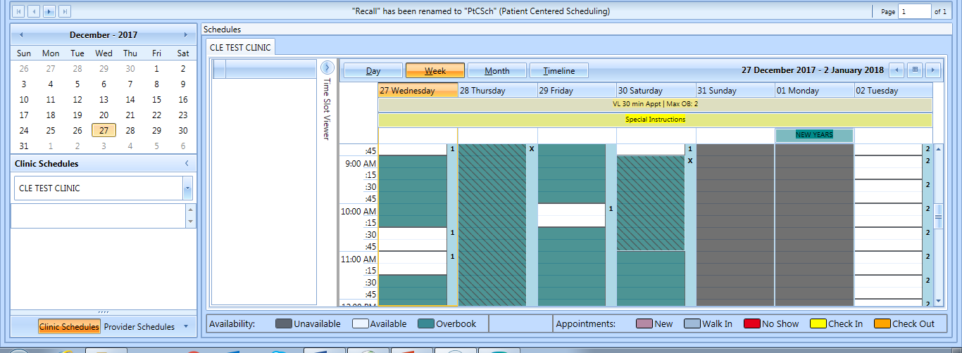

Figure : Clinic Schedule Display – Whole and Partial Day Cancel Availability

### Viewing the Clinic’s Length of APPT and Max OB

A label in the All Day Event Bar displays the Length of APP and Max OB values defined for the selected clinic.

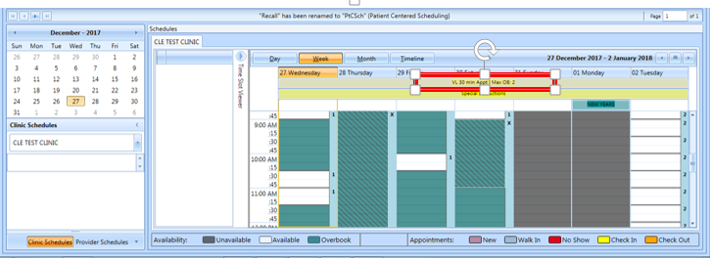

Figure : APPT Length and Max OB Allowed

### Viewing the Clinic’s VL Indicator

For clinics defined as Variable Length, a flag “VL” displays before the Length of Appointment information in the All Day Event Bar in the Clinic Schedule Grid.

**Note:** Refer to Section 6.5.2 on How to Add VL APPT.

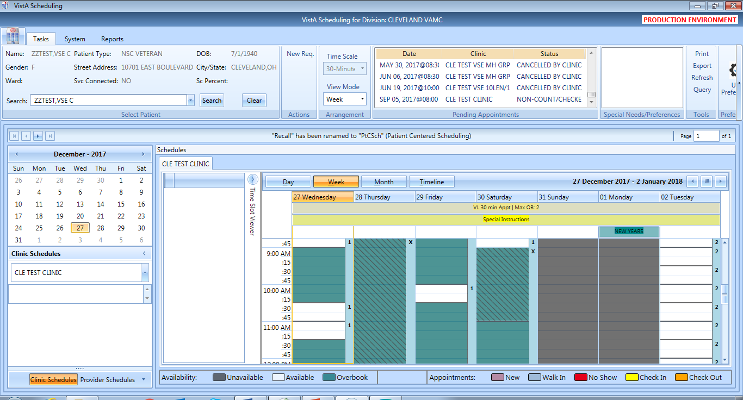

Figure : VL Indicator

### Viewing the Clinic’s Special Instructions

**To display a clinic’s special instructions:**

1. From the **Tasks** tab, on the Clinic Schedules, enter a partial name of a clinic (six characters minimum).
2. Select the desired clinic from the returned list.

The selected clinic schedule displays and the Special Instruction Indicator displays in the All Day Event Bar in the Clinic Schedule.

1. Click the **Special Instructions** indicator to display the Special Instructions.



Figure : Special Instructions Indicator

### Viewing Clinic’s Available Slots

The Time Slot Count for availability displays as follows:

* 0-9 and j-z –denote available slots where j=10,k=11…z=26.
* Upper Case Letters A-W denote overbooks, with A being the first slot to be overbooked and B being the second for that same time, etc.
* Special characters *,$,!,@,# denote overbooks or appointments that fall outside of a clinic’s regular hours.

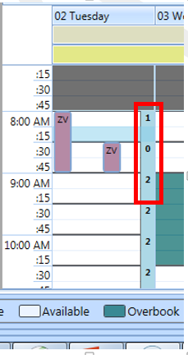

Figure : Time Slot Count

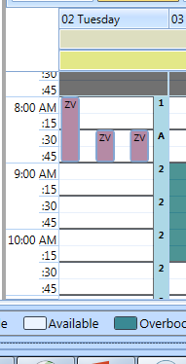

Figure : Overbook Time Slot Count

### The Time Slot Viewer

The Time Slot Viewer displays to the left of the Clinic Schedule Grid. It displays APPT information per selected time slot. For APPTs booked in the time slot, the full patient’s name displays in a list in the order they were added to the time slot.

1. From the **Tasks** Tab, on the Clinic Schedules, enter a partial name of a clinic (six-character minimum).
2. Select the desired clinic from the returned list.

The selected clinic schedule displays.

**Note:** Time Slot Viewer can be expanded or minimized in Clinic Schedule Grid.

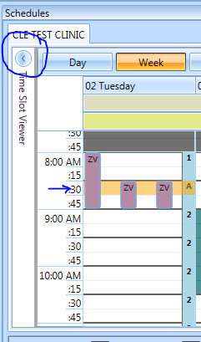

Figure : Minimized Time Slot Viewer

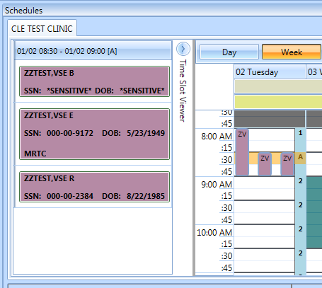

Figure : Expanded Time Slot Viewer

When you select a time slot from the Clinic Schedule it populates the Time Slot Viewer with the following information:

* Date/Time of the Time Slot.
* Available slot count left for the time slot.
* A list of patient names in the order they were booked, for any APPTs scheduled in the time slot.

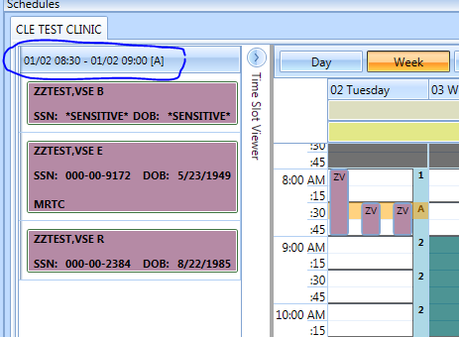

Figure : Time Slot Viewer Displays Slot Details

For booked APPTs, right-click to extend action options that are available from Time Slot Viewer, the same as in the Clinic Schedule Grid.

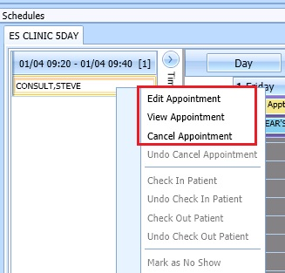

Figure : Time Slot Viewer Right-click–Edit, View, Cancel

The Check In Patient command from the Time Slot Viewer is the same as from the Clinic Schedule Grid.

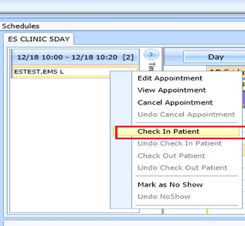

Figure : Time Slot Viewer – Check In Patient

The Check Out Patient command from the Time Slot Viewer is the same as from the Clinic Schedule Grid.

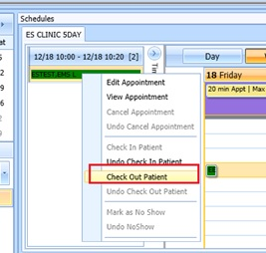

Figure : Time Slot Viewer – Check Out Patient

The Mark as No Show command from the Time Slot Viewer is the same as from the Clinic Schedule Grid.

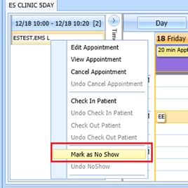

Figure : Time Slot Viewer – Mark as No Show

### Viewing Provider Availability

**To search for a provider and view the provider’s schedule.**

1. From the Tasks tab, under the Request grid calendar, select **Provider Schedules**.

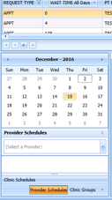

Figure : Provider Schedules

1. Enter a partial name of a provider (three characters minimum). Select the desired provider from the returned list.

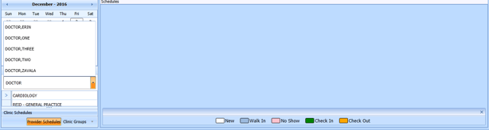

Figure : Provider Schedules Selection List

The selected provider schedule displays.

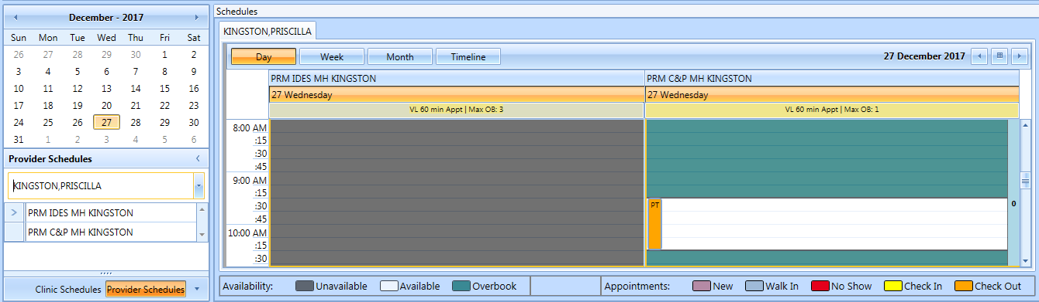

Figure : Provider Schedule Display

The provider’s availability displays across all clinics. If the provider has only one clinic, that clinic’s schedule and availability appear.



Figure : Provider Schedules Booked APPTs

Available APPT slots display as white space, which a scheduler can select to add an APPT.

The APPTs display with the name of the patient in a specific Clinic Schedule time slot.

Time slots in the Clinic Schedule that appear dimmed indicate they are not available therefore, schedulers are unable to add APPTs for those specific slots.

**Note:** Refer to Section 6 for APPT Management instructions on how to Add, Check-In, Checkout, and Cancel APPTs.

### Viewing Clinic Group Availability

**To search for a clinic group and view the clinic group’s schedule:**

1. On the Tasks tab, point to the calendar of the Request grid, and then select **Clinic Groups**.

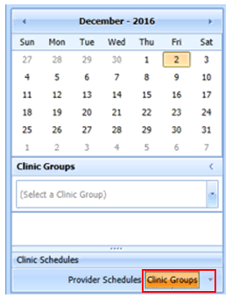

Figure : Clinic Groups

1. Enter a partial name of a clinic group (six-character minimum).
2. Select the desired Clinic Group from the returned list.

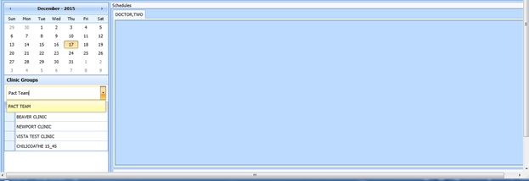

Figure : Clinic Groups Search Result List

The selected clinic group schedule(s) displays, starting with today’s date in the Day view.

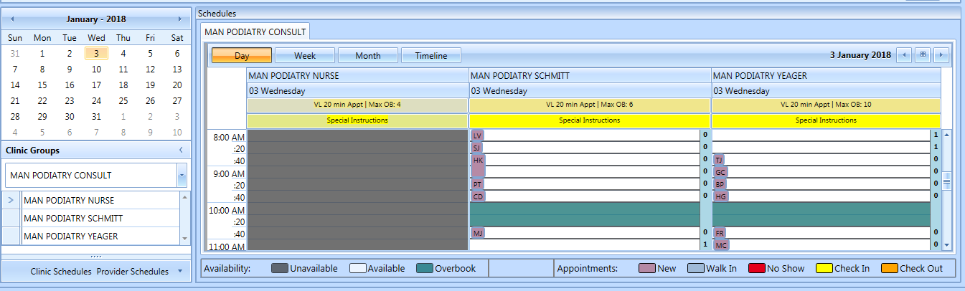

Figure : Clinic Groups Schedule Display

**Note:** Refer to Section 6 for the APPTs Management instructions on how to Add, Check-In, Checkout, and Cancel APPTs.

## System Tab

The **System** tab requires the SDECZMGR security key to access the tab.

### Viewing Clinic Availability Information

Clinic availability cannot be modified from the VS GUI.

**To quickly search for clinic availability:**

1. From the System tab, click Availability in the Resource Schedules section.
2. In the **Availability Selection** dialog box, type the desired clinic’s name.
3. Select the desired clinic and click **OK**.

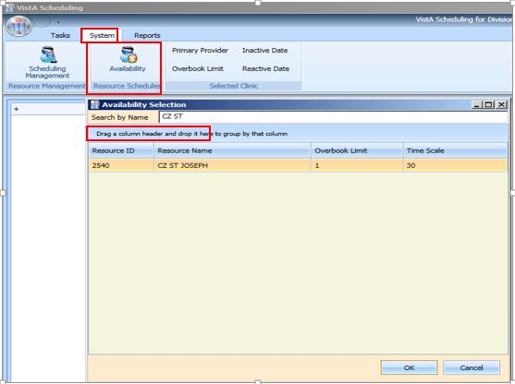

Figure : Clinic Availability Search

* The Schedule displays for the selected clinic. Primary Provider, Overbook Limit, Inactive Date, and Reactive Date, as applicable, also display in the **Selected Clinic** section.
* The **Schedule** also displays the number of APPTs per slot and the number of slots total per APPT length (in minutes and total number of bookable minutes).
* The **Schedule** uses the same visual coloration as the **Clinic Schedule** for workable hours, non-workable hours, and no availability.

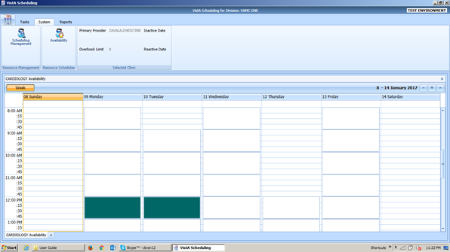

Figure : Clinic Availability

### Adding and Removing Privileged Users

#### Add A Privileged User

**To add a privileged user to a prohibited clinic:**

1. On the System tab, click **Scheduling Management**.
2. In the **Prohibited Clinic** search box, type a partial or full name of the clinic (minimum six characters).
3. Click **Find**.

A list of prohibited clinics displays.

1. Select the appropriate prohibited clinic.

A list of privileged users for the selected clinic displays.

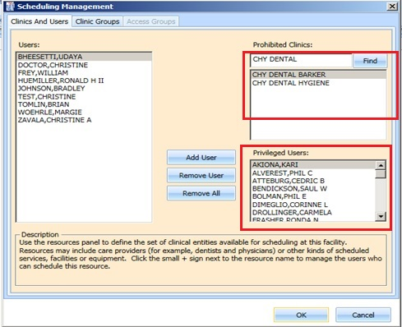

Figure : Clinics and Users

1. Select a user from the Users pane on the left side of the open window, and then click **Add User**.

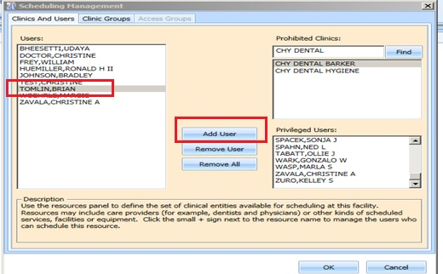

Figure : Add Privileged User

1. Click **OK** to add the user to the list of Privileged Users.
2. Please note: Only users with the VistA key SDECZMENU will show in the user list.

#### Remove Privileged User

**To remove a privileged user from a prohibited clinic:**

1. On the System tab, click **Scheduling Management**.
2. In the **Prohibited Clinic** search box, type a partial or full name of the clinic (minimum six characters).
3. Click **Find**.

A list of prohibited clinics displays.

1. Select the appropriate prohibited clinic.

A list of privileged users for the selected clinic displays.

1. Select a user from the **Privileged User** list for the selected prohibited clinic, and then click **Remove User.**

If all privileged users need to be removed, click **Remove All.**

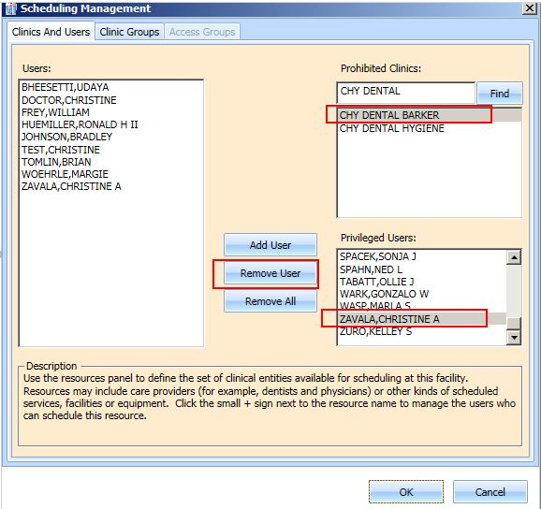

Figure : Remove Privileged User

### Creating Clinic Groups

**To create a Clinic Group:**

1. On the System tab, click **Scheduling Management**.
2. Select the **Clinic Groups** tab.
3. Click New Group.
4. Enter a name in the **Clinic Group Name** text box.

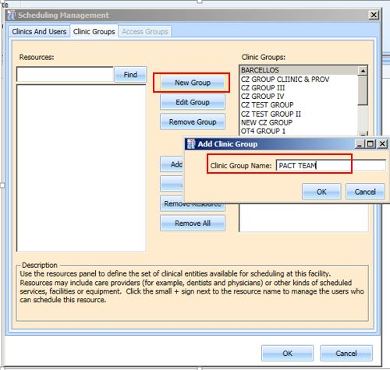

Figure : Create New Clinic Group

1. Click **OK**.
2. Select the newly added **Clinic Group**.
3. Enter a partial name search for a **Resource**,and then click **Find.**

A resource can be a clinic or a provider that is active with an active person class.

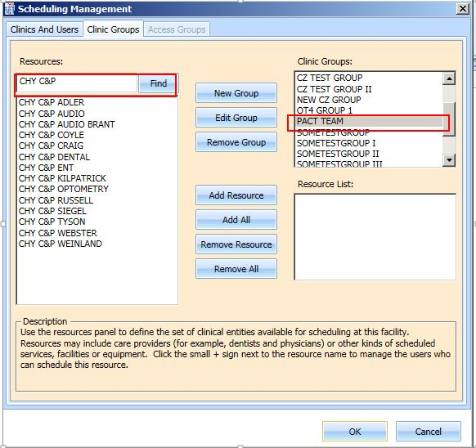

Figure : Find Resource

1. Select the appropriate resource to add to the Clinic Group, and then click **Add Resource**.

If all of the resources listed from the search need to be added, click **Add All**.

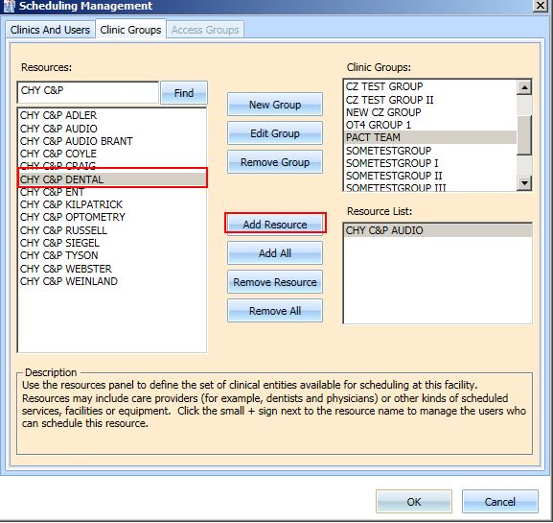

Figure : Add Resource to Clinic Group

1. Click **OK** to add the clinic group to the list.

### Removing a Resource from a Clinic Group

**To remove a resource from a Clinic Group:**

1. On the System tab, click **Scheduling Management**.
2. Select the **Clinic Groups** tab.
3. Select a clinic group to be edited from the **Clinic Groups** list.

Resources defined for the Clinic Group are displayed in the **Resource List** box.

1. Select a resource to remove, and then click **Remove Resource**.

If all resources need to be removed, click **Remove All**.

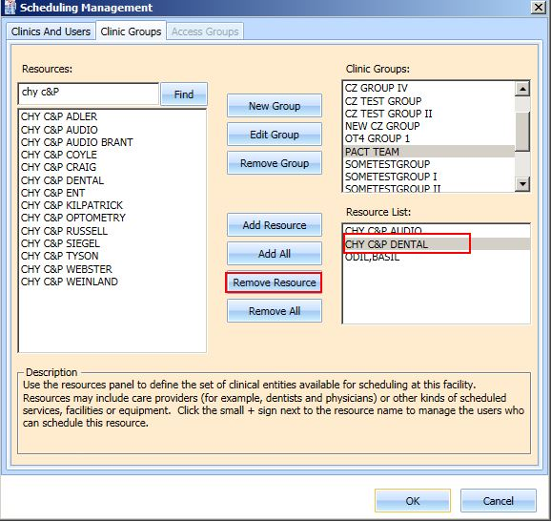

Figure : Remove Resource from Clinic Group

# Reports

The **Reports** tab allows you to view and print various reports. The Reports tab requires the SDECZMGR manager security key to access the tab. The following selections and reports are available:

* Audit Activity
* Clinics

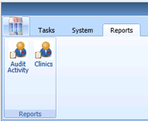

Figure : Reports Tab Selections

## The Audit Activity Report

### Generating an Audit Activity Report for an Individual Scheduler

**To view Audit Activity for an individual scheduler:**

1. From the **Reports** tab, select **Audit Activity**.

The Audit Activity dialog displays.

1. Select the individual s**cheduler’s** name from the list.
2. Select **Start** **Date** and **End** **Date**. You can type the date or select it from the calendar.

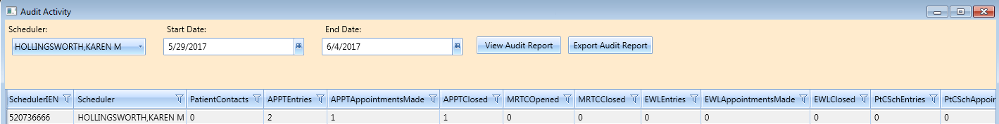

Figure : Audit Activity Report – Individual Scheduler

The following columns display data for the selected scheduler, based upon the time frame specified:

* SchedulerIEN (New Person File)
* SchedulerName
* PatientContacts
* APPTEntries
* APPTAppointmentsMade
* APPTClosed
* EWLEntries
* EWLAppointmentsMade
* EWLClosed
* Patient-Centered SchedulingAppointmentsMade
* ConsultAppointmentsMade
* AppointmentsCancelled
* TotalActions

1. Click **Close** to exit the Audit Activity report dialog box.

### Generating an Audit Activity Report for All Schedulers

1. From the Reports tab select **Audit Activity**.

The Audit Activity dialog displays.

1. From the **Scheduler** list select **All**.
2. Enter the **Start Date** and the **End Date** for the audit report.
3. Click View Audit Report.

The following columns display data for All Schedulers based upon the time frame specified:

* SchedulerIEN (Internal Entry Number – New Person File)
* SchedulerName
* PatientContacts
* APPTEntries
* APPTAppointmentsMade
* APPTClosed
* EWLEntries
* EWLAppointmentsMade
* EWLClosed
* Patient-Centered SchedulingAppointmentsMade
* ConsultAppointmentsMade
* AppointmentsCancelled
* TotalActions

Note: APPT columns include actions on RTC requests.

1. Click **Close** to exit the Audit Activity report dialog box.

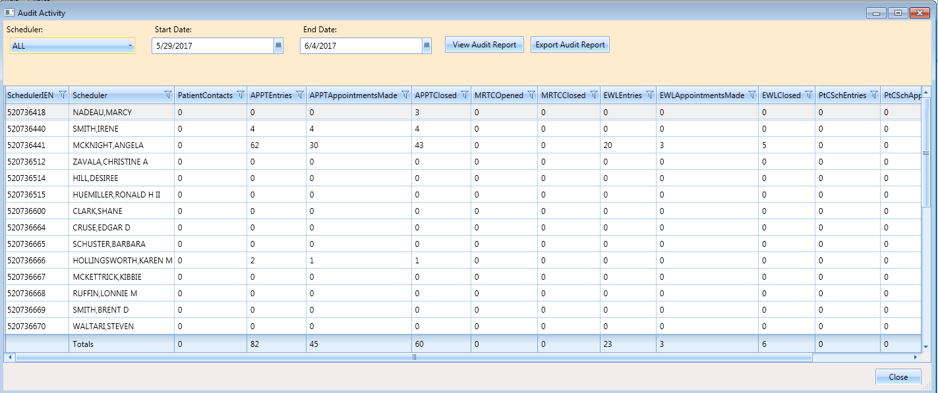

Figure : Audit Activity Report – All Schedulers

### Working with Audit Activity Report Data

#### Sorting by Column Header

1. Log into VS GUI.
2. Select the **Reports** tab.
3. Select **Audit Activity** from the Reports section.

The Audit Activity dialog box displays for all schedulers defined in the New Person file (#200).

The following data displays on the screen for the selected scheduler:

* SchedulerIEN (New Person File)
* SchedulerName
* PatientContacts
* APPTEntries
* APPTAppointmentsMade
* APPTClosed
* EWLEntries
* EWLAppointmentsMade
* EWLClosed
* Patient-Centered SchedulingAppointmentsMade
* ConsultAppointmentsMade
* AppointmentsCancelled
* TotalActions

1. Select the applicable column header to change the sort order for the report by data specified in a different column.

* To sort data in the specified column in ascending order, click the column header.
* To sort data in the specified column in descending order, click the column header a second time.

1. Click **Close** to exit the Audit Activity Report dialog box.

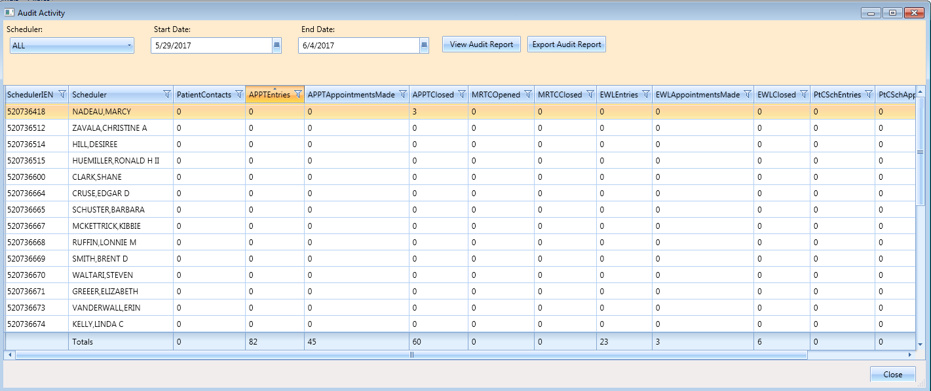

Figure : Audit Activity Sort – Ascending

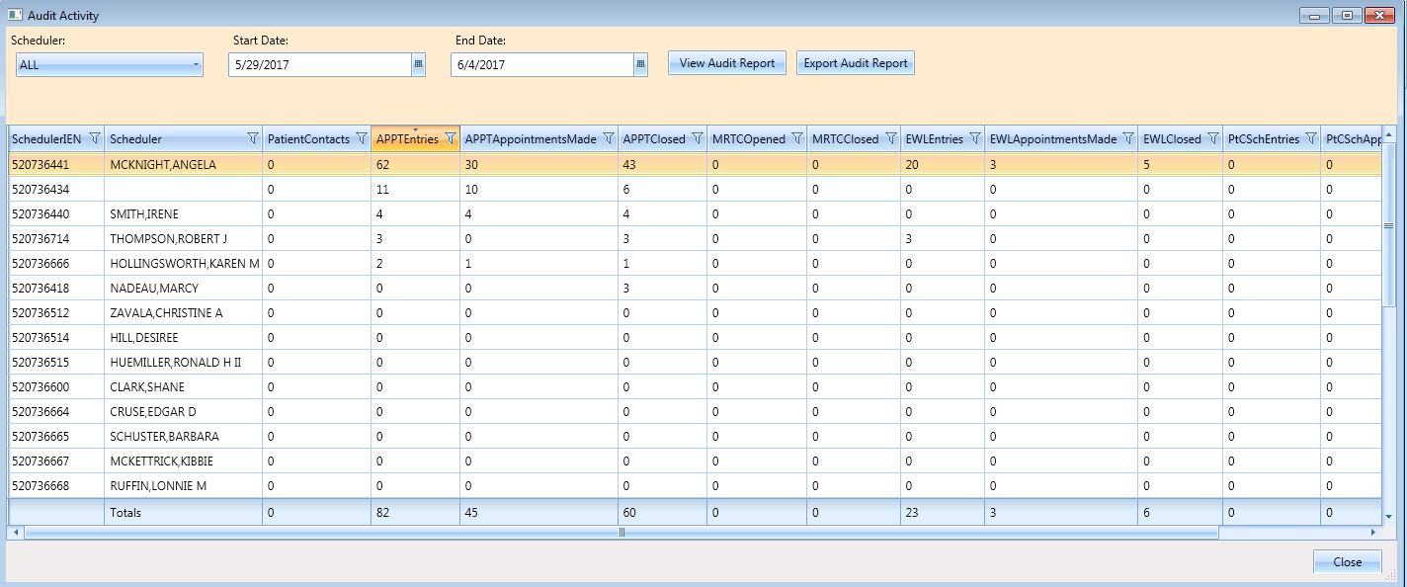

Figure : Audit Activity Sort – Descending

#### Filtering by Column Data

1. Select a filter option from each column header to filter data in the Audit Activity report.

**Note**: All schedulers who have greater than or equal to 10 APPT Appointments Made in the selected date range.

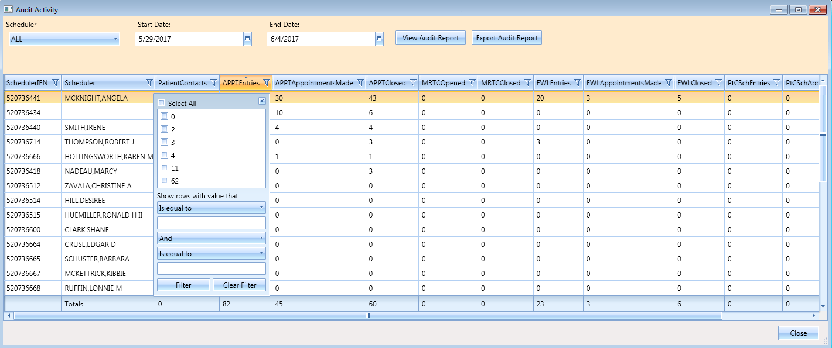

Figure : Audit Activity Report – Filtered

Multiple filters can be selected to refine results (i.e., All schedulers who have greater than or equal to 10 APPT Entries but less than or equal to 30 APPT Closed for the selected date range).

Selected filters are highlighted in column headers.

To remove filters, select the filter option in a column header, and then click **Clear Filter**.

1. Click **Close** to exit the Audit Activity report dialog box.

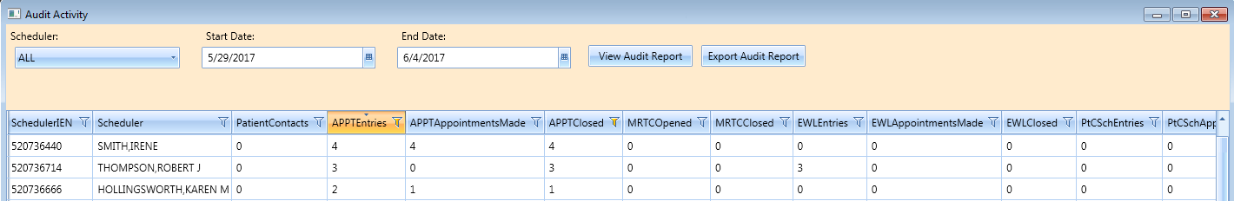

Figure : Audit Activity Report – Multiple Filters

### Export an Audit Activity Report for Individual or All Schedulers

The data displayed on the screen can be exported to an Excel spreadsheet.

1. To export the audit report, click **Export Audit Report**.

The Save As dialog box opens.

1. Select the location to save the report file.

The default File name is “Audit Report”. You can edit if necessary.

Confirm the “Save As Type” is Excel.

1. Click **Save**.

The Report is generated. It contains data displayed on the screen in the Audit Activity dialog box and it is saved to the location specified in the Save As dialog box.

1. Click **Close** to exit the Audit Activity report dialog box.

## Clinics Report

The Clinic Report is accessed from the **Reports** tab by selecting **Clinics** from the Reports section. The report displays clinic activity for all clinics, defined in the Hospital Location file as the default.

### Clinic Activity Report – Individual Clinic

The Clinic Report can be limited to individual clinics.

1. Log into VS GUI.
2. Select **Reports** tab.
3. From the Reports section, click **Clinics**.
4. In the Clinic Activity dialog box, enter the clinic’s name (six-character minimum) that is defined in the Hospital Location file.
5. Click **Search**.

The following data displays on the screen for the selected clinic:

* Clinic name
* Division
* Stop Code
* Service
* CreateDT
* InactiveDT
* ReactiveDT
* AppType
* DefaultProv
* AdditionalProv
* ApptLength
* Variable
* MaxDays

1. Click the **Clear** button to remove the search criteria and return to the Clinic Activity report for all clinics.
2. Click **Exit** to close the Clinic Activity Report dialog box.

### Working with the Clinic Activity Report

#### Sorting by Column Headers

1. Log into VS GUI.
2. Select the **Reports** tab.
3. Select **Clinics** from the Reports section.

The Clinic Activity dialog box displays for all clinics defined in the Hospital Location file (File #44).

The following data displays on the screen for the selected clinic:

* Clinic name
* Division
* Stop Code
* Service
* CreateDT
* InactiveDT
* ReactiveDT
* AppType
* DefaultProv
* AdditionalProv
* ApptLength
* Variable
* MaxDays

**Note:** The sort defaults in alphabetical order by the Clinic’s name.

1. To change the sort order for the report by data specified in a different column, select the applicable column header.
2. Click once on the column header to sorts the data in ascending order.
3. Click a second time on the column header to sort the data in descending order.
4. Click **Exit** to close the Clinic Activity Report dialog box.

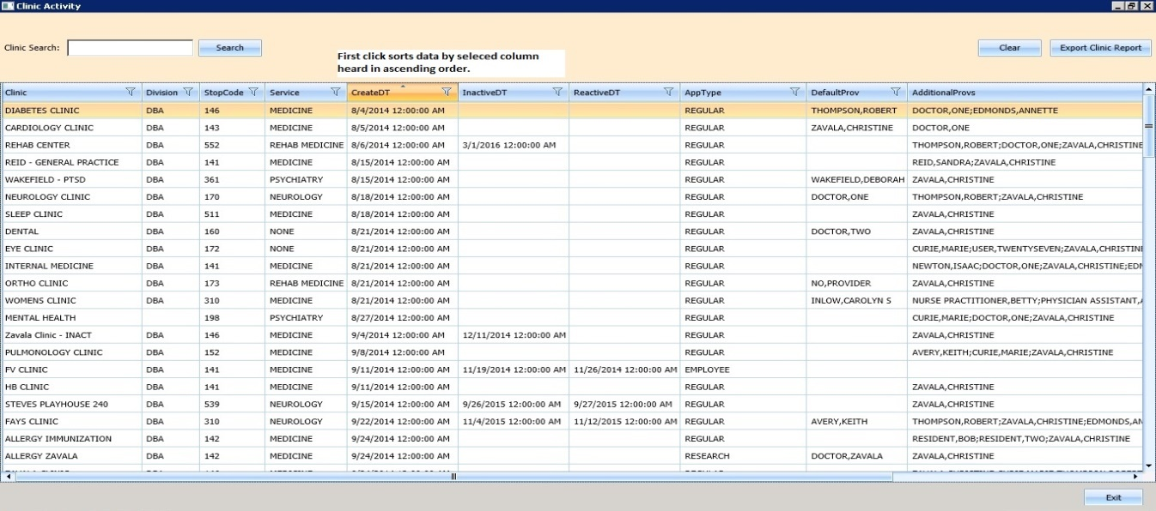

Figure : Clinic Activity Report Sort – Ascending Order

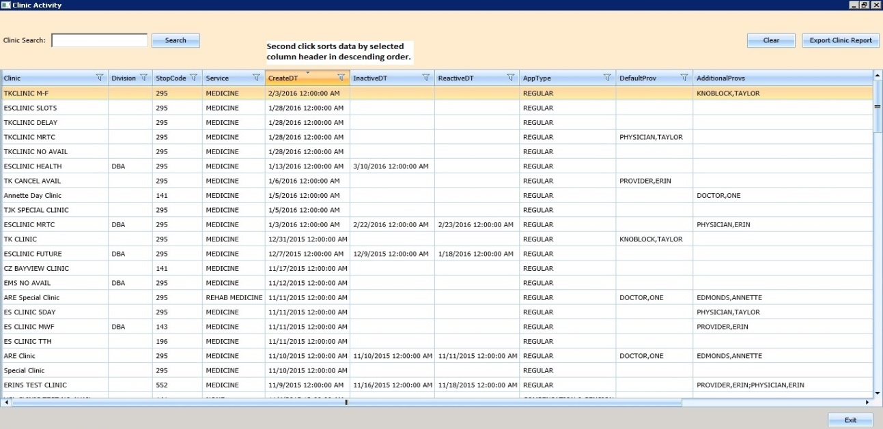

Figure : Clinic Activity Report Sort – Descending Order

#### Filtering Data by Column

Data in the Clinic’s Activity report can be filtered as follows:

1. Select the filter option in each column header (e.g., Clinic Activity data can be filtered by all Clinics with a defined Service of Rehab Medicine).

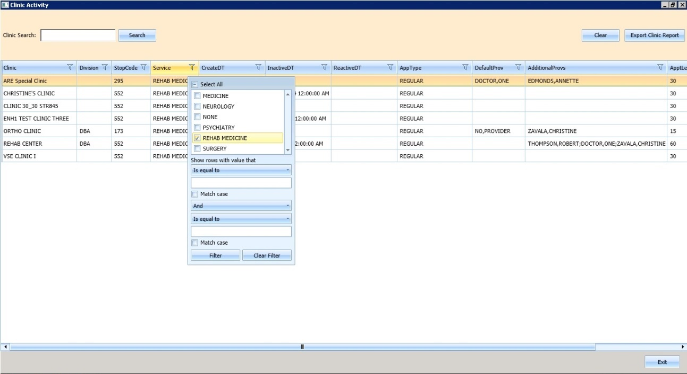

Figure : Clinic Activity Report – Filtered

Multiple filters can be selected to refine results (e.g., Clinic Activity data can be filtered by all Clinics with a defined Service of Rehab Medicine that also have no DefaultProv defined).

Selected filters are highlighted in column headers.

**To remove filters:**

1. Select a filter option in the column header, and then click **Clear Filter**.
2. Click **Exit** to close the Clinic Activity report dialog box.

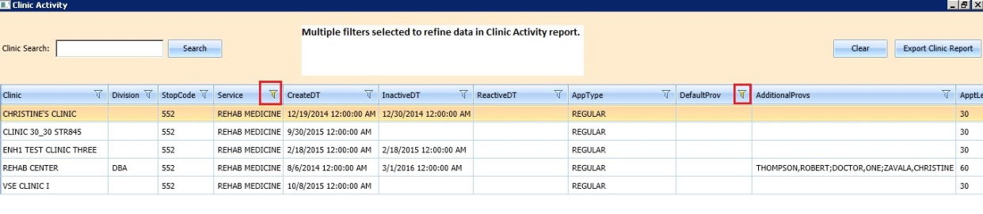

Figure : Clinic Activity Report – Multiple Filters

### Exporting a Clinic Report

**To export a Clinic Report:**

1. From the **Reports** tab, in the **Reports** section, select **Clinics.**

The **Clinic Activity** dialog box opens, displaying the report.

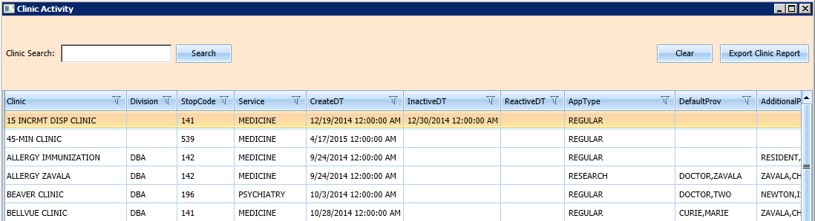

Figure : Clinic Activity

If applicable, search for a specific clinic in the Clinic Search field. Click **Search**. If no specific clinic is used, ensure the full list is downloaded by scrolling down on the right several times until the last clinic on the list is the same when scroll to the bottom.

1. Click Export Clinic Report.

A Save **As** dialog box opens.

1. Select the location to save the report.

Confirm the file name. The default is “Clinic Report”.

Confirm the Save as Type is Excel.

1. Click **Save**.

Data displayed on the screen is exported to the file and saved to the specified location with the defined name.

1. Click **Exit** to close the Clinic Activity report dialog box.

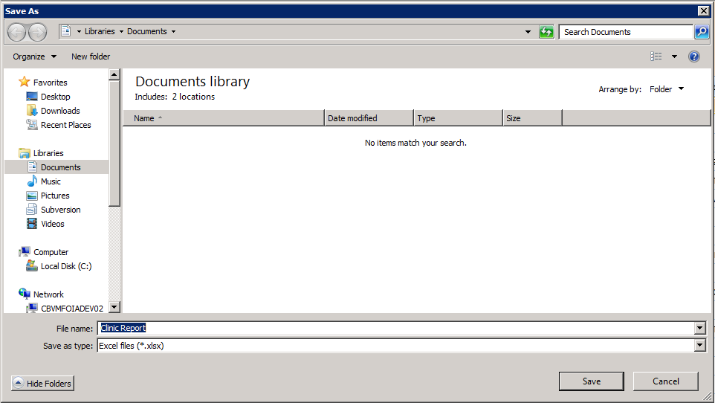

Figure : Save As

# Trash Queue Cleanup

**WARNING: ONLY USE THIS OPTION IF DIRECTED BY HEALTH PRODUCT SUPPORT ADMIN TEAM. PLACE A TICKET IF YOUR SITE THINKS THIS MAY BE NEEDED.**

During initial set-up of VS GUI, administrators who need to identify and purge unresolved requests, a task can be run to identify open appointment requests or duplicate appointment requests, close them, and produce a report for administrators. This excludes VAR requests which are called Veteran or Mobile requests, all stored in the SDEC APPT REQUEST file.

## Compile List of Re-Opened REQUEST Records that Can Be Closed

During initial set-up of VS GUI, the following dialog allows the user to find open appointment requests or duplicate appointment requests to produce a report for administrators to review/review verify.

The SDEC Initial Cleanup Utility will allow the Closing of Re-Opened SDEC APPT REQUEST records, which have resulted from a cancellation in VistA of a corresponding SDEC APPOINTMENT.

1. Log on to the VistA Legacy System.
2. Select VS GUI Initial Cleanup Utility [SDEC INITIAL CLEANUP UTILITY]
3. Select Compile List of Re-Opened REQUEST records that can be closed

**To Compile a List of Re-Opened REQUEST records that can be closed:**

1. Enter a list of Clinics (one by one) to EXCLUDE from Compilation.
2. Enter the Clinic to Exclude.
3. Press Enter to not exclude any Clinic.

A dialog box displays “You did not choose any Clinics to Exclude”.

Are you sure you want to run Cleanup for all clinics? Yes or No?

1. Click Yes to continue.
2. Click No to abort.
3. Select one of the following to print the results:

* VistA Print Device
* Spooler
* VistA Email
* Screen with capture

1. Review the list to ensure these are all extraneous open requests that should be auto-closed.

**To Compile for all Clinics excluding the following:**



Select Option: SDEC INITIAL CLEANUP UTILITY VS GUI Initial Cleanup Utility

The following Utility will allow the Closing of Re-Opened SDEC APPT REQUEST

records which have resulted from a Cancellation in VistA of a corresponding

SDEC APPOINTMENT.

* 1. Select one of the following Compile List of Re-Opened REQUEST records that can be Closed

2 Commit Records to Be Closed from Compiled List

What Would You like to Do?: **1 Compile List of Re-Opened REQUEST records that can be Closed**

Please enter in, one by one, a list of Clinics to EXCLUDE from Compilation.

Enter CLINIC to EXCLUDE: <Hit **Enter** to not exclude any Clinics>

You did not choose any Clinics to Exclude.

Are you sure you want to run cleanup for ALL clinics? (Y OR N):? NO// YES

Compiling for all Clinics excluding the following:

DEVICE: HOME// HOME (CRT)

(You may enter a device that prints to a file, a printer, email message, or you may print on the screen.)

*** Open SDEC APPT REQUESTs List run Jan 09, 2017@02:48:47 ***

LAST 4 APPT REQ IEN

CLINIC PATIENT SSN APPT IEN CID DA==

VSE ENH1 CLINIC FAULCON,GONZALO J 2916 1747 ; 1985 12/27/2016

VSE ENH1 CLINIC TEST,STERLING PAUL JR 0183 1752 ; 1988 12/27/2016

## Commit Records to Be Closed from Compiled List

During initial set up of VS GUI, to commit Records to Be Closed from the Compiled List created via SDEC INITIAL CLEANUP UTILITY:

1. Log on to the VistA Legacy System.
2. Select VS GUI Initial Cleanup Utility [SDEC INITIAL CLEANUP UTILITY]
3. Select Commit Records to Be Closed from Compiled List

A dialog box displays “What Would You like to Do?”

**To Commit Records to Be Closed from the Compiled List:**

1. Open SDEC APPT REQUEST Compilation Lists to choose from:

The batch list displays records.

1. Enter the Batch # previously reviewed above. There may be several batches in the list from past compile jobs.

A message displays “Committing Open records for Batch # to Closed…. Done”

After the task is completed, the Current Status changes to “Closed” and the Disposition fields in the SDEC APPT REQUEST file are set accordingly.

**To verify the record has been closed:**

1. Go to VA FileMan
2. Inquire to view the SDEC APPT REQUEST File (#409.85)

View the following fields:

* CURRENT STATUS
* DATE DISPOSITIONED
* DISPOSITIONED BY
* DISPOSITION
* DISPOSITION CLOSED BY CLEANUP

Select Option: SDEC INITIAL CLEANUP UTILITY VS GUI Initial Cleanup Utility

The following Utility will allow the Closing of Re-Opened SDEC APPT REQUEST

records which have resulted from a Cancellation in VistA of a corresponding

SDEC APPOINTMENT.

* 1. Select one of the following Compile List of Re-Opened REQUEST records that can be Closed

2 Commit Records to Be Closed from Compiled List

What Would You like to Do?: **2 Commit Records to Be Closed from Compiled List**

Open SDEC APPT REQUEST Compilation Lists to Choose From:

Batch # Run User Start Date Finish Da==

1 STUCK,ERIN Dec 14, 2016@07:41:56 Dec 14, 2016@07:41:56

2 KRON,CAROLYN S Dec 16, 2016@23:54:52 Dec 16, 2016@23:54:53

3 KRON,CAROLYN S Dec 22, 2016@11:47:18 Dec 22, 2016@11:47:19

4 KRON,CAROLYN S Jan 09, 2017@02:34:05 Jan 09, 2017@02:34:05

5 KRON,CAROLYN S Jan 09, 2017@02:48:47 Jan 09, 2017@02:48:47

Enter Batch #:**5**

Committing Open records for Batch # 5 to Closed...Done

Once the task completes, the CURRENT STATUS is changed to “CLOSED” and the DISPOSITION fields in the SDEC APPT REQUEST file are set accordingly.

To verify the record has been closed, go to VA FileMan and Inquire to view the SDEC APPT REQUEST File (#409.85). View the following fields:

* CURRENT STATUS
* DATE DISPOSITIONED
* DISPOSITIONED BY
* DISPOSITION
* DISPOSITION CLOSED BY CLEANUP

#### Systems Manager

1. Navigate to Fileman Record INQUIRY [RTZ INQ-FM-INQUIRY], either through the programmer prompts or through the site’s local fileman prompts.
2. Select Inquire to File Entries [DIINQUIRE]
3. Inquire to File Entries

Output from What File: SDEC APPT REQUEST//

1. Select SDEC APPT REQUEST PATIENT:
2. Press Return

To see more

To exit

OR

Choose a number from the list

Select Systems Manager Menu Option: fm VA FileMan

VA FileMan Version 22.0

Enter or Edit File Entries

Print File Entries

Search File Entries

Modify File Attributes

Inquire to File Entries

Utility Functions ...

Data Dictionary Utilities ...

Transfer Entries

Other Options ...

Select VA FileMan Option: inquire to File Entries

OUTPUT FROM WHAT FILE: SDEC APPT REQUEST//

Select SDEC APPT REQUEST PATIENT: TEST,STERLING PAUL JR

* 1. TEST,STERLING PAUL JR

2 TEST,STERLING PAUL JR

3 TEST,STERLING PAUL JR

4 TEST,STERLING PAUL JR

* 1. TEST,STERLING PAUL JR

Press <RETURN> to see more‘,’’^’ to exit this list, OR

CHOOSE 1-5:

Press <RETURN> to see more‘,’’^’ to exit this list, OR

CHOOSE 10-15:

16 TEST,STERLING PAUL JR

17 TEST,STERLING PAUL JR

18 TEST,STERLING PAUL JR

19 TEST,STERLING PAUL JR

20 TEST,STERLING PAUL JR

Press <RETURN> to see more‘,’’^’ to exit this list, OR

CHOOSE 1-20: 16 TEST,STERLING PAUL JR

ANOTHER ONE:

STANDARD CAPTIONED OUTPUT? Yes// (Yes)

Include COMPUTED fields: (N/Y/R/B): NO// b BOTH Computed Fields and Record Num

ber (IEN)

DISPLAY AUDIT TRAIL? No// y YES

NUMBER: 1752 PATIENT: TEST,STERLING PAUL JR

CREATE DATE: DEC 23, 2016 INSTITUTION: CHEYENNE VAMC

REQUEST TYPE: APPOINTMENT

REQ APPOINTMENT TYPE: REGULAR

Created on Dec 23, 2016@14:37:43 by User #520736464 (SDECRPC Option)

PATIENT STATUS: NEW

Created on Dec 23, 2016@14:37:43 by User #520736464 (SDECRPC Option)

REQ SPECIFIC CLINIC: VSE ENH1 CLINIC

Created on Dec 23, 2016@14:37:43 by User #520736464 (SDECRPC Option)

ORIGINATING USER: KRON,CAROLYN S PRIORITY: FUTURE

REQUESTED BY: PATIENT

Created on Dec 23, 2016@14:37:43 by User #520736464 (SDECRPC Option)

CID/PREFERRED DATE OF APPT: DEC 27, 2016

Created on Dec 23, 2016@14:37:43 by User #520736464 (SDECRPC Option)

**CURRENT STATUS: CLOSED**

**Changed from “OPEN” on Jan 09, 2017@02:49:09 by User #520736464**

**(SDEC INITIAL CLEANUP UTILITY Option)**

Changed from “CLOSED” on Dec 23, 2016@14:47:01 by User #520736464

(SDCANCEL Option)

Changed from “OPEN” on Dec 23, 2016@14:38:10 by User #520736464

(SDECRPC Option)

Enter RETURN to continue ‘r’’^’ to exit:

Created on Dec 23, 2016@14:37:43 by User #520736464 (SDECRPC Option)

COMMENTS: TEST

Created on Dec 23, 2016@14:37:43 by User #520736464 (SDECRPC Option)

ENROLLMENT PRIORITY: GROUP 8 MULTIPLE APPOINTMENT RTC: NO

DATE/TIME ENTERED: DEC 23, 2016@13:37

DATE EDITED: DEC 23, 2016@14:37 EDITED BY: KRON,CAROLYN S

REQ SPECIFIC CLINIC: VSE ENH1 CLINIC

**DATE DISPOSITIONED: JAN 09, 2017 DISPOSITIONED BY: KRON,CAROLYN S**

**DISPOSITION: ENTERED IN ERROR DISPOSITION CLOSED BY CLEANUP: YES**

SERVICE CONNECTED PERCENTAGE: 0 SERVICE CONNECTED PRIORITY: NO

## View Unresolved APPT Requests Reopened by the SDCANCEL Option

A user who has access to the VS GUI Requests Reopened by Cancel Availability [SDEC REQ REOPENED BY SDCANCEL] can view unresolved appointment requests. This is helpful after clinic availability has been canceled on a day with a lot of patients scheduled. If the user runs this report, it is a guide to which patients still have an open request sitting in VS GUI ready to be rescheduled.

**To view unresolved appointment requests:**

1. Go to the **Outputs** option under the Scheduling Manager’s Menu.
2. Select VS GUI Requests Reopened by Cancel Availability [SDEC REQ REOPENED BY SDCANCEL].
3. Select CLINIC:

Follow the steps shown below.

Select Scheduling Manager’s Menu Option: outputs

AQK Encounter Activity Report

AQK2 ACRP Stop Code Report

CAAR Clinic Appointment Availability Report

Appointment List

Appointment Management Report

Cancelled Clinic Report

Clinic Assignment Listing

Clinic List (Day of Week)

Clinic Next Available Appt. Monitoring Report

Clinic Profile

Display Clinic Availability Report

Enrollments > X Days

File Room List

Future Appointments for Inpatients

Inpatient Appointment List

Management Report for Ambulatory Procedures

No-Show Report

Patient Profile MAS

PCMM Main Menu ...

Print Scheduling Letters

Provider/Diagnosis Report

Radiology Pull List

Routing Slips

Visit Rpt by Transmitted OPT Encounter

VS GUI Requests Reopened by Cancel Availability

Workload Report

Select Outputs Option: **a**

2 VSE ENH1 CLINIC ONE ZAVALA,CHRISTINE A

3 VSE ENH1 CLINIC TWO

CHOOSE 1-3: **1 VSE ENH1 CLINIC**

Select CLINIC:

DEVICE: HOME// HOME (CRT)

VS GUI Requests Re-Opened by Cancel Availability (SDCANCEL) Option

for clinics: VSE ENH1 CLINIC

PATIENT SSN TELEPHONE CID/PREF DATE

TEST,CHRISTINE 000-12-1234 (555)123-1234 JAN 12,2017

# VistA Scheduling 508 Compliance

The following section outlines the process for executing the VistA Scheduling Application functionality using the keyboard. Many keyboard shortcuts have been added for ease of use. A consolidated list of all keyboard shortcuts is provided in Section 13.

## The Tasks Tab

**Ctrl + T** is the keyboard shortcut to navigate to the **Tasks Tab**.

### The Ribbon Bar

1. Log on to VS GUI as a scheduler.

The Search field is highlighted and the cursor is blinking.

1. Press the **Tab** key to advance through the Ribbon Bar.
2. Beginning at the **Patient Search** field, move from left to right.

If the controls in each section listed below are enabled, when you press the tab key each one will be highlighted accordingly:

* Patient Search Field
* Search Button
* Clear Button
* Actions
* Arrangement
* Pending Appointments
* Special Needs/Preferences
* Mobile Requests
* Tools
* Print
  + Export
  + Refresh
  + Query

After leaving the **Tools** section, you will be redirected to the **Patient Search** field.

Table : Keyboard Shortcuts for Ribbon Bar Components

|  |  |
| --- | --- |
| Ribbon Bar Component | Keyboard Shortcut |
| Patient Search Field | ALT + S |
| Action | ALT + A |
| Arrangement | ALT + G |
| Pending Appointment Window | ALT + P |
| Special Needs/Preferences | ALT + N |
| Mobile Requests | ALT + M |
| Tools | ALT + T |

### Request Type Dialog

Using the Tab key**:**

1. From the **Actions Pane**, with the **New Req.** highlighted, press **Enter**.

The **Request Type** dialog box displays.

Focus is **OK**.

1. Press the Tab key to move to **CLEAR**.
2. Press the Tab key to move to **APPT Request Type**.
3. Press the Tab key to move to PATIENT-CENTERED SCHEDULING Request Type.
4. To select a **Request Type**, press the tab key to highlight, and then press the **Space Bar** key to select.
5. Press the Tab key to move to **OK**, and then press **Enter**.

**Note:** The arrow keys can also be used to navigate to the Request Type dialog box.

Table : Keyboard Shortcuts for Request Type

|  |  |
| --- | --- |
| Component | Keyboard Shortcut |
| OK | ALT + O |
| Clear | ALT + C |

### Appointment Request

**Using the Tab key**:

The **Appointment** Request **Dialog** opens with **OK** highlighted.

Use the Tab key to move to **CLEAR** and the **Svc Related** check box.

1. Press the **Space Bar** to select.

Use the Tab key to move to **Clinic** (default) and **Service/Specialty**.

1. Press the **Space Bar** to select.
2. Press the Tab key to move to the **Clinic** field, and then enter the **Clinic Name** (four-character minimum).
3. Press the Tab key to move to the **CID/Preferred Date** field, and once highlighted press **Enter** to display **Calendar** control.
4. Use the up arrow and the down arrow to navigate the dates in the calendar, and then press **Enter** to select the date.
5. Press the Tab key to move to **Appointment Type**, and then use the arrow keys to select **Appointment Type**.
6. Press the Tab key to move to the **Requested By** field, and then use the arrow keys to select **Requested By**.
7. Press the Tab key to move to the **Provider** field (if applicable), and then enter the **Provider** name (three-character minimum).
8. Press the Tab key to move to the **Multiple Appointments Required** check box, and then press the **Space Bar** to select.
9. Press the Tab key to move to the **Number of Appointments Required** field, and then use the arrow keys to select the number of appointments required.
10. Press the Tab key to move to the **Interval Between Appointments** field, and then use the arrow keys to select the number of days between appointments.
11. Press the Tab key to move to the **Comments** field, and then enter your text.
12. Press the Tab key to move to **OK**, and then press Enter to select and create the APPT Request and exit the dialog box.

Table : Keyboard shortcuts for the Appointment Request

|  |  |
| --- | --- |
| Component | Keyboard shortcut |
| OK | ALT + O |
| Clear | ALT + C |

**Query**

The **Query Dialog** box opens with the **Patient** field highlighted.

1. Enter the patient’s **Last Name**, **First Name** or thelast initial and last four of the SSN.
2. Press the Tab key to move to **Find**, and then press **Enter**.

Use the **Down Arrow** to highlight names in the **Patient** list.

1. Press the **Enter** key to select patients from the list to include in the query.
2. Press the Tab key to move to the **Patients** column.

Use the **Down Arrow** to highlight the names listed.

1. To remove names from the selection press **Enter**.

Use the Tab key to move to the **Request Type Filter**.

1. Press **Enter** to open the **Request Types** dialog box.

Use the arrow keys to navigate to the **Request Type** selection grid.

1. Press the **Space Bar** to select the highlighted **Request Type**.

Use the Tab key to move to **OK** to confirm the selection.

Use the Tab key to **Cancel** the selection and exit the dialog box.

**The Clinic/Service Filter**

Use the Tab key to move to the **Clinic/Service Filter**.

1. Press **Enter** to open the **Clinics** dialog box.
2. Enter the **Clinic/Service** name in the blank field (four-character minimum).

Use the Tab key to move to **Find** and the **Select All** check box.

1. Press the Space Bar to **Select All**.

Use the Tab key to move to **Clinics** or **Services**.

**Clinics** is the default.

1. Press the Space Bar to select the **Services** button.

Use the arrow keys to navigate up and down the **Clinics/Service Grid**.

Use the **Space Bar** to select/deselect from the list.

1. Press the Tab key to move to **OK,** and then press **Enter** to confirm the selections for the query.

OR use the Tab key to **Cancel**

1. Press **Enter** to quit the selection and exit the dialog box.

**The Priority Group Filter**

1. Press the Tab key to move to the **Priority Group Filter** and then press **Enter** to display the **Priority Group** dialog box.

Use the Tab key to move to the **Select All** check box.

1. Press the **Space Bar** to select (if applicable).
2. Press the Tab key to move to the **Priority Group** grid.

Use the up or down arrow to navigate up and down the list.

Use the **Space Bar** to select/deselect the **Priority Group** options.

1. Press the Tab key to move to **OK,** and then press **Enter** to confirm the selections for the query.

OR use the Tab key to **Cancel**

1. Press **Enter** to quit the selection and exit the dialog box.

**Wait Time**

1. Press the Tab key to move to the following:

* Wait Time list.
* **SC Visit?** List
* **Connected?** list

Use the arrow keys to navigate the options for the query selections.

1. Press the Tab key to move to the **Origination Date** field/**CID/Preferred Date** field.
2. Enter the date for the query selection as applicable.
3. Press the Tab key to move to the **Urgency** field (Applicable to Consult Requests only)/**Change Sort** field.

Use the arrow keys to navigate to the list for query selection.

1. Press the Tab key to move to the **Clear** button, and then press **Enter**.

The **Clear Filter** dialog box displays.

1. Press the Tab key to move to **OK,** and then press **Enter** to clear the **Request Query** dialog box of all filter selections and start the query selection process again.
2. Press the Tab key to move to **Cancel** and then press **Enter** to **Cancel Clear** Filter selection and exit the dialog box.

**Note:** Selecting **Cancel** will keep the current **Request Query** filter selections for the query.

1. Press the Tab key to move to the **Submit** button, and then press **Enter**.

The Request Query Confirmation dialog box opens.

1. Press the Tab key to move to **OK**, and then press **Enter**.

The query results display in the **Request Management Grid**.

**To Cancel the action:**

1. Press the Tab key to **Cancel**.
2. Press the **Enter** key to abort the query results and return to the **Request Query** dialog box.
3. Press the Tab key to move to **Close**, and then press **Enter** to close the **Request Query** dialog box.

## Systems Tab

To access the **Systems Tab**, press **CTRL+Y**.

### ****Systems Tab Ribbon Bar****

1. Press the Tab key to move to Scheduling Management.
2. Press **Enter** to display the **Scheduling Management** dialog box.
3. Press the Tab key to move to **Availability**, and then press **Enter** to open the **Availability Selection** dialog box.

Table : Keyboard Shortcuts for the Systems Tab Ribbon Bar

| Ribbon Bar Component | Keyboard Shortcut |
| --- | --- |
| Systems Tab | CTRL + Y |
| Scheduling Management | ALT + M |
| Availability | ALT + H |
| Selected Clinic | ALT + L |

### Scheduling Management

#### Clinics and Users Tab

The **Scheduling Management Dialog** box opens on the **Clinics** and **Users** tab with the **OK** button highlighted. Focus is on **OK** button.

1. Press the Tab key to move to the **Users Selection List**.

Use the **Down** **Arrow** to highlight the **First Name** in the **Users List**.

1. Press **Enter** to select the **User Name**, and then press the Tab key to move to the **Prohibited Clinic** field.
2. Enter the **Clinic Name**.
3. Press the Tab key to move to the **Find b**utton, and then press **Enter**.

The Prohibited Clinic List is displayed.

Use the arrow keys to navigate up and down the list.

1. Press the Tab key to move to the **Privileged Users List** for users who are assigned to the selected clinic.

Use the Tab key to move to the **Add User** button, the **Remove User** button or the **Remove All** button.

Table : Keyboard Shortcuts for Scheduling Management

| Component | Keyboard Shortcut |
| --- | --- |
| Add User | ALT + A |
| Remove User | ALT + R |
| Remove All | ALT + E |
| Find | ALT + F |
| OK | ALT + O |
| Cancel | ALT + C |

#### Clinic Groups Tab

When the user accesses the Clinic Group tab, the OK button is highlighted.

1. Press the Tab key to move to Resources.
2. Enter the Clinic Schedule Resource criteria

* User name, Clinic Name, Clinic Group

1. Press the Tab key to move to the Find button, and then press Enter.

Use the down arrow to highlight the first name in the Resource List.

1. Press the Tab key to move to the following:

* New Group
* Edit Group
* Remove Group
* Clinic Groups List
* Add Resource
* Add All
* Remove Resource
* Remove All

Table : Keyboard Shortcuts for the Clinic Groups Tab

| Component | Keyboard Shortcut |
| --- | --- |
| New Group | ALT + N |
| Edit Group | ALT + E |
| Remove Group | ALT + R |
| Add Resource | ALT + S |
| Add All | ALT + L |
| Remove Resource | ALT + D |
| Remove All | ALT + X |
| OK | ALT + O |
| Cancel | ALT + C |

### Availability Selection

The **Availability Selection Dialog** box opens with the **OK** button highlighted.

1. Press the Tab key to move to the **Cancel** button.
2. Press the Tab key to move to the **Search by** Name field.
3. Enter the **Clinic Name** (four-character minimum).
4. Press the Tab key to move to the Resource **List Grid**.

Use the arrow keys to navigate up and down the **Resource List**.

1. Press **Enter** to select the highlighted **Resource**.

The Select Clinic Availability displays.

Table : Keyboard Shortcuts for the Availability Selection

| Component | Keyboard Shortcut |
| --- | --- |
| Search Field | ALT + S |
| First Row of Results Grid | ALT + G |
| OK | ALT + O |
| Cancel | ALT + C |

## The Reports Tab

To access the **Reports Tab** press **CTRL+R**.

### Reports Tab Ribbon Bar

1. Press the Tab key to move to Audit Activity.
2. Press the Tab key to move to **Clinics**.
3. Press the Tab key to move to Management Reports.

Table : Keyboard Shortcuts for the Reports Tab Ribbon Bar

| Ribbon Bar Component | Keyboard Shortcut |
| --- | --- |
| Reports Tab | Ctrl + R |
| Reports | Alt + R |

### Audit Activity

The **Audit Activity** dialog box opens with the Close button highlighted.

1. Press the Tab key to move to the **Scheduler** list.

The default is **All**.

Use the **Down** **Arrow** to select a user’s name (listed in alphabetical order).

1. Enter the user’s name (last name, first name) to go directly to the specific user.
2. Press the Tab key to move to the **Start** **Date** field, and then press **Enter** to select the **Calendar**.

Use the arrow keys to select the date.

1. Press the Tab key to move to the **End Date** field, and then press **Enter** to select the **Calendar**.

Use the arrow keys to select the date.

1. Press the Tab key to move to the View Audit Report, and then press **Enter** to display the **Audit Report in Grid**.
2. Press the Tab key to move to the Export Audit Report, and then press **Enter** to open the **Save As** dialog box.

**Note:** Only data displayed on the screen will appear in the exported **Audit Report**.

You can use the Tab key to navigate the **Audit Report Grid**.

Table : Keyboard Shortcuts for Audit Activity

| Component | Keyboard Shortcut |
| --- | --- |
| Scheduler drop down | ALT + S |
| Audit Report | ALT + V |
| Export Report | ALT + E |
| Close | ALT + C |

### Clinic Activity

The **Clinic Activity** dialog box opens with the **Exit** button highlighted.

1. Press the Tab key to move to the **Clinic Search** field, and then enter the **Clinic Name** (six-character minimum).
2. Press the Tab key to move to the **Search** button, and then press **Enter**.
3. Press the Tab key to move to the Clinic Results Grid.

Use the Tab key to navigate through the Clinic Results Grid including the Column Headers and Filters.

Table Keyboard Shortcuts for Clinic Activity

| Component | Keyboard Shortcut |
| --- | --- |
| Search Button | ALT + S |
| Clear | ALT + C |
| Export | ALT + E |
| Exit | ALT + X |

# Troubleshooting

Contact the Enterprise Service Desk (ESD), formally the National Service Desk (NSD), and open a ticket for any VS GUI related issues. At the time of publishing, the phone number is 855-673-HELP (4357).

VSE Pulse page resources and training aids:

* Frequently Asked Questions/Known Issues document: [https://vaww.vha.vaco.portal.va.gov/sites/DUSHOM/10NA/ACAO/VSE_Adopt_Implementation/Lists/VSEKnownIssues/AllItems.aspx](https://www.vapulse.net/docs/DOC-107042)
* Scheduler: [https://www.vapulse.va.gov/community/vista-scheduling-enhancements-vse](https://www.vapulse.net/community/vista-scheduling-enhancements-vse)
* Super User: [https://www.vapulse.va.gov/groups/vse-superusers](https://www.vapulse.net/groups/vse-super-users)
* National Return to Clinic Order Implementation: [https://www.vapulse.va.gov/groups/return-to-clinic-rtc](https://www.vapulse.net/groups/return-to-clinic-rtc)

## **Changing User ID and Password**

Contact your supervisor or System Administrator for User ID or Password changes.

## Special Instructions for Error Correction

Some potential warning messages are listed here.

Table : Warning Messages

| Reason for Message | Message | Action | Result |
| --- | --- | --- | --- |
| Sensitive Information Warning | Warning displays to the user:  ***WARNING***  ***RESTRICTED RECORD*** | Click **OK** | User is able to log into the Security Log Audit Trail |
| Warning for similar names and SSN | Similar Names dialog displays  System lit patients with similar name and same last four digits of SS# | Click **OK** | User is able to continue |
| Accessing deceased patient’s record | This patient died on <Date of Death>  Do you wish to continue? | Click **OK** | User is able to perform action such as Disposition, Cancel Appointments |
| Accessing own record at selection | Security regulations prohibit computer access to your own medical record. | Click **OK** | User is unable to perform any activity/actions |

# Acronyms and Abbreviations

| Term | Description |
| --- | --- |
| Access Block | A color-coded representation of the amount of time allotted for a specific Access Type (or appointment). |
| Access Groups | Categories of Access Types. Assigning Access Types to Access Groups makes it easier to schedule and search for certain types of appointments. |
| Access Types | The variety of different appointment types available in the Legacy VistA Scheduling package. Each type of appointment, such as routine physical, dental, walk-in, or other specific appointment type is an Access Type. |
| AMIE | Automated Medical Information Exchange |
| API | Application Program Interface |
| APPT | Appointment: A scheduled or unscheduled meeting between patient and healthcare professional.; an appointment can include several encounters with providers or clinics for tests, procedures, etc. |
| CID | Clinically Indicated Date |
| Clinic | A medical center location where patients receive care by a doctor or authorized provider. |
| CPRS | Computerized Patient Record System |
| Enh | Enhancement |
| EWL | Electronic Wait List |
| GUI | Graphical User Interface |
| MUMPS | Massachusetts General Hospital Utility Multi-Programming System |
| MRTC | Multiple Return To Clinic |
| NSR | New Service Request |
| OI&T | Office of Information and Technology |
| OOS | Occasion of Service |
| OT3 | Optional Task #3 |
| OT4 | Optional Task #4 |
| OVAC | Office For Veterans Access to Care |
| PACT | Patient-Aligned Care Teams |
| PII | Personally Identifiable Information |
| PIMS | Patient Information Management System |
| POC | Point of Contact |
| PRF | Patient Record Flag |
| Provider | A doctor or other authorized provider in the medical center who provides patient care. |
| PT | Patient |
| PWS | Performance Work Statement |
| RM Grid | Request Management Grid |
| RTC | Return to Clinic |
| SDMOB | Scheduling Master Overbook |
| SDOB | Scheduling Overbook |
| Slot | Number of appointments per defined appointment length that have been previously set up in VistA Scheduling. For example, if “Slots = 4” and the clinic (resource) appointment length is 30 minutes, then there are four available appointments for every 30 minutes. |
| SSN | Social Security Number |
| T4 | Transformation Twenty-One Total Technology |
| TAC | Technology Acquisition Center |
| TCP/IP | Transmission Control Protocol/Internet Protocol |
| VA | Department of Veterans Affairs |
| VAR | Veteran Appointment Request |
| VCL | Veterans Crisis Line |
| VHA | Veterans Health Administration |
| VistA | Veterans Health Information Systems and Technology Architecture |
| VL | Variable Length |
| VS | VistA Scheduling |
| VSE | VistA Scheduling Enhancements |

# Keyboard Shortcuts Quick List

Patient demographic information can be displayed and edited at any point in the process by entering **CTRL + P** to open the Patient Info screen.

Ribbon Bar Components

|  |  |
| --- | --- |
| Ribbon Bar Component | Keyboard Shortcut |
| Patient Search Field | ALT + S |
| Action | ALT + A |
| Arrangement | ALT + G |
| Pending Appointment Window | ALT + P |
| Special Needs/Preferences | ALT + N |
| Mobile Requests | ALT + M |
| Tools | ALT + T |

Request Type

|  |  |
| --- | --- |
| Component | Keyboard Shortcut |
| OK | ALT + O |
| Clear | ALT + C |

Appointment Request

|  |  |
| --- | --- |
| Component | Keyboard Shortcut |
| OK | ALT + O |
| Clear | ALT + C |

Systems Tab Ribbon Bar

| Ribbon Bar Component | Keyboard Shortcut |
| --- | --- |
| Systems Tab | CTRL + Y |
| Scheduling Management | ALT + M |
| Availability | ALT + H |
| Selected Clinic | ALT + L |

Scheduling Management

| Component | Keyboard Shortcut |
| --- | --- |
| Add User | ALT + A |
| Remove User | ALT + R |
| Remove All | ALT + E |
| Find | ALT + F |
| OK | ALT + O |
| Cancel | ALT + C |

Clinic Groups Tab

| Component | Keyboard Shortcut |
| --- | --- |
| New Group | ALT + N |
| Edit Group | ALT + E |
| Remove Group | ALT + R |
| Add Resource | ALT + S |
| Add All | ALT + L |
| Remove Resource | ALT + D |
| Remove All | ALT + X |
| OK | ALT + O |
| Cancel | ALT + C |

Availability Selection

| Component | Keyboard Shortcut |
| --- | --- |
| Search Field | ALT + S |
| First Row of Results Grid | ALT + G |
| OK | ALT + O |
| Cancel | ALT + C |

Reports Tab Ribbon Bar

| Ribbon Bar Component | Keyboard Shortcut |
| --- | --- |
| Reports Tab | CTRL + R |
| Reports | ALT + R |

Audit Activity

| Component | Keyboard Shortcut |
| --- | --- |
| Scheduler list | ALT + S |
| Audit Report | ALT + V |
| Export Report | ALT + E |
| Close | ALT + C |

Clinic Activity

| Component | Keyboard Shortcut |
| --- | --- |
| Search Button | ALT + S |
| Clear | ALT + C |
| Export | ALT + E |
| Exit | ALT + X |

Addendum

1. Addendum for Patch SD*5.3*723 Site Instructions
   1. Information

It is crucial to install SD*5.3*723, Fix for Appointments with No Resource, **immediately** after the installation of SD*5.3*722, Large Background Job Fix.

Site personnel should be aware that encounters may be created if there are schedulers in the VistA Scheduling (VS) Graphical User Interface (GUI) during the patch installation of SD*5.3*722 and prior to installation of SD*5.3*723. Encounter ‘Action Required’ Reports should be reviewed for old encounters including past Fiscal Year data. Questions can be brought to the Office of Veterans Access to Care (OVAC) Friday Office Hours call. The call information has been updated within this document in the Assistance section.

Be advised that with the installation of SD*5.3*722 and SD*5.3*723, staff may see cancelled appointments in the Pending Appointments Box in the VS GUI that were not previously visible.

* Prior to this patch, when an appointment was scheduled for the same date and time as a previously cancelled appointment the cancelled appointment would no longer be visible in VS GUI or VistA.
* With the installation of these patches, if the new appointment is made for a different clinic but the same, date and time as the previously cancelled appointment, the cancelled appointment and the active appointment will both be visible in the VS GUI but only the current appointment will be visible in VistA. When viewing the cancelled appointment in VS GUI via Expand Entry the comments for the cancelled appointment along with other appointment identifiers may be over-written with the new appointment data. This is a known issue with cancelled appointments and will be addressed in future releases.
* If the cancelled appointment is made for the same clinic and the same date and time, the cancelled appointment will not be visible in either VS GUI or VistA.

Staff may also notice some mismatched appointment statuses (checked-in, checked-out, etc.) when comparing the VS GUI Calendar Grid and the Pending Appointment Box. This is a known issue and will be addressed in an upcoming release. The mismatch status occurs for appointments that were created in a clinic without a matching SDEC Resource Type which created an appointment with a missing appointment SDEC Resource pointer. This caused an error in loading appointments in the VS GUI from the pending appointment list and would not display in the calendar grid. The work around was to take action on the broken appointments in VistA (check-in, check-out, etc.). The status change was not reflected in VS GUI due to the missing appointment resource pointer. The installation of SD*5.3*723 and correcting the appointments as outlined in this document caused the mismatch of status. This impacts past appointments that were manipulated in VistA and will not impact present and future appointments as long as the broken appointments are corrected per the instructions provided in this document before using VistA as a work around. Mismatching may also occur when a patient is checked-in via VetLink as the Pending Appointments Box may experience a delay in displaying the checked-in status.

* 1. Known Defects and Anomalies

An existing anomaly in the **SDEC** **APPOINTMENT File (#409.84)** was brought to light when patches SD*5.3*722 and SD*5.3*723 were installed. The Pending Appointments List in the VSE GUI is now populated using data from the VSE **SDEC APPOINTMENT File (#409.84)** instead of data from the **PATIENT File (#2)**.

* + 1. Impact

When the **SDCANCEL** option is used to cancel clinic availability for all or part of a day, data in the appointment is updated in the **HOSPITAL LOCATION File (#44)** and in the **PATIENT File (#2)**, but not in the VSE **SDEC** **APPOINTMENT File (#409.84)**.

Therefore, when a set of appointments for a clinic has been cancelled using **SDCANCEL** option, the Pending Appointments List will show an incorrect appointment status of "Future Appointment" or “No Action Taken,” even though the appointment has been cancelled and the clinic is closed.

* + 1. Workaround

When a patient calls to schedule a new appointment, if the appointment in the Pending Appointments list displays "Future Appointment" or “No Action Taken,” the scheduler must also check the Calendar View to ensure the appointment is still valid.

If the Calendar shows the day is blocked off, the appointment will still be visible on the schedule for the blocked off day. Cancelling the appointment from the Calendar will correctly cancel the appointment in VSE.

Follow these steps in this order so that appointments will not be improperly displayed:

1. Manually cancel each individual appointment using VS GUI or VistA as Cancelled by Clinic.

2. Use the Cancel Clinic Availability option **[SDCANCEL]** to cancel the day, marking the day as unavailable to schedule.

NOTE: Do Not Use Cancel Clinic Availability **[SDCANCEL]** first. This will automatically mark the appointments as cancelled in the **HOSPITAL LOCATION File (#44)** but not in the **SDEC** **APPOINTMENT File (#409.84)**.

* 1. Overview
     1. Problem

Some of the appointments created after the installation of VistA Scheduling Graphical User Interface (VS GUI) do not have a clinic location with a matching resource. This can result in files becoming out of sync and potentially displaying the appointment and/or slot incorrectly. This is often referred to as a “ghost appointment” or “single slot issue”. Additionally, if active clinic locations without a matching resource are not corrected, the clinic location can continue to produce bad appointments in some situations. Not every site has active clinic locations producing bad appointments, but most have at least a few.

* + 1. Solution

Patch SD*5.3*723, Fix for Appointments with No Resource, provides four (4) options the site can utilize to identify active clinics that do not have a matching resource, an option to edit the resource for a clinic, an option to create a resource for a clinic, and a utility that will identify and correct appointments with exact matches only.

These menu options have been added to the **Scheduling Manager’s Menu [SDMGR]** in the **Supervisor Menu [SDSUP]**.

1. CLINICS WITHOUT MATCHING RESOURCE LIST **[SDEC MISSING RESOURCE]**
2. EDIT RESOURCE **[SDEC RESOURCE EDIT]**
3. CREATE A RESOURCE **[SDEC RESOURCE CREATE]**
4. AUTOMATICALLY FIX APPOINTMENTS WITH NO RESOURCE **[SDEC NO RES APPT AUTO FIX]**

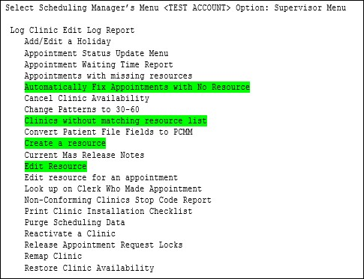

Figure : Scheduling Manager's Menu [SDMGR] \ Supervisor Menu [SDSUP]

The options in Patch SD*5.3*723 will fix many of the existing ghost appointments. Sites should use the instructions below to fix as many of the appointments that it can. A future Patch, SD*5.3*731, VSE – Fix Issues Identified in SD*5.3*723, will allow the site to fix additional existing ghost appointments. It is recommended sites should wait on manual correction of remaining ghost appointments until after the installation of patch SD*5.3*731.

* + 1. Access Requirement

Site identified personnel will need access to the **SCHEDULING MANAGER’S MENU [SDMGR]** to access the new VistA options. In most cases, the individual will also need to request **READ**, **WRITE** and **LAYGO** access to the **SDEC RESOURCE File (#409.831)** from Office of Information Technology (OIT) due to the site running Kernel Part 3 security set up.

* + 1. Assistance

The VSE Program Office will dedicate Friday Office Hours Calls for the four (4) Fridays after the patch is installed to assist sites with help running these options and/or to answer questions. Adobe/VA Nationwide Teleconferencing System (VANTS) information below.

VSE Office Hours (as of 10/01/2019)

Wednesdays and Fridays 1-2PM ET

Adobe Link: <https://va-eerc-ees.adobeconnect.com/vseoh/>

VANTS: 1-800-767-1750 Access Code: 00737#

If you have questions, cannot attend a Friday session, or need more information, please email the VSE Program Office at [VHAVSEProgramOffice@va.gov](mailto:VHAVSEProgramOffice@va.gov).

1. Identify Clinic without Matching Resource List
2. This option is completed in legacy VistA to determine if any clinic within the **HOSPITAL LOCATION File (#44)** is missing or has a mismatched resource in the **SDEC RESOURCE File (#409.831)**. If any are found, the site can fix it using Correct Clinic Resource Issues instructions provided below.

The output of this report should be a text file (logging, spooler, etc.) Do not print the output to paper. Instructions to output the report to a text file is provided in Appendix A.

1. Navigate to report, **CLINICS WITHOUT MATCHING RESOURCE LIST [SDEC MISSING RESOURCE]**.

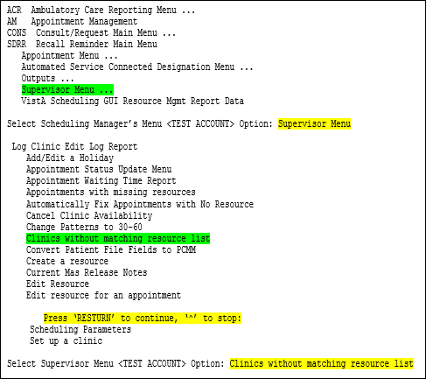

Figure : CLINICS WITHOUT MATCHING RESOURCE LIST Menu Option

1. **Sort by: NAME//** Press **RETURN**
2. **Start with NAME: FIRST//** Press **RETURN**
3. When the prompt **DEVICE**: displays, user will need to print to the screen for logging (or spooler, if available). This can be completed per the user’s normal method to capture extended report results. Appendix A provides instructions on starting/stopping logging.
4. **DEVICE:** 0;80;999

* Zero (0) tells VistA print to screen.
* 80 indicates the number of columns
* 999 indicates how many rows in each page before the user is prompted to press **RETURN**.

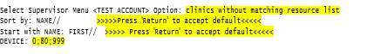

Figure : CLINICS WITHOUT MATCHING RESOURCE LIST Report Prompts

1. Continue pressing **RETURN** until the report is complete.
2. Open and scan the text file from the location you saved to make sure it contains the full report results. The clinics will be listed in alphabetical order.

REMINDER: Reset the logging file to a new text file before initiating logging again. If the same file name is kept as the target, the next time logging is started, the system will either add to the file, or overwrite the current file. Appendix A provides instructions on starting/stopping logging.

1. Reviewing/Analyzing Report Results

The goal of this section is to determine if any active clinics from the report output require correction. If an active clinic with this problem is not fixed, appointments created in VistA by schedulers using a problem clinic location may create a corrupt (ghost) appointment in the system.

* 1. Report Results

The output file for the **CLINICS WITHOUT MATCHING RESOURCE LIST** displays three columns of information:

* **LOCATION NAME** – This is the Clinic Name in the **HOSPITAL LOCATION File (#44)**.
* **RESOURCE NAME** – This is the Resource Name in the **SDEC RESOURCE** **File (#409.831)** for the VistA Scheduling Graphical User Interface (VS GUI).
* **DIFF?** – This column will display as blank, N/A, or three (3) asterisks (***).
  + Blank – indicates there is no issue between the clinic **LOCATION NAME** and **RESOURCE NAME**. User intervention is not required.

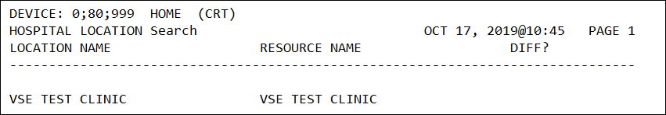

Figure : Sample Output with Blank DIFF? Column

* + N/A – A non-clinic resource is listed in the **RESOURCE NAME** column. User intervention is not required.

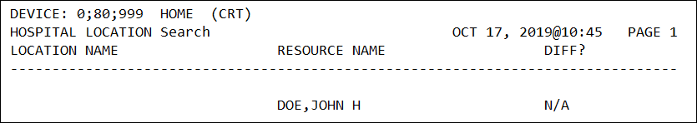

Figure : Sample Output with N/A listed in the DIFF? Column

* + Three (3) asterisks (***) - indicates there may be an issue with the **SDEC RESOURCE**. User intervention **IS** required.
    - Example 1: **LOCATION NAME** column does not match the **RESOURCE NAME** column. Site will need to use **Edit Resource [SDEC RESOURCE EDIT]** to correct the **SDEC RESOURCE** **File (#409.831)**.

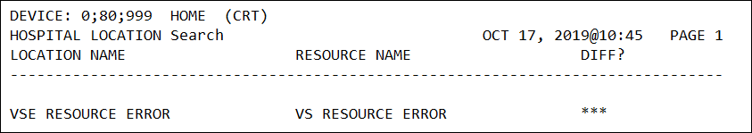

Figure : Sample Output with Mismatched Resource with Three (3) Asterisks (***) in the DIFF? Column

* Example 2: **RESOURCE NAME** column is blank indicating the SDEC RESOURCE is missing. Site will need to use **Create a Resource [SDEC RESOURCE CREATE]** to correct the **SDEC RESOURCE File (#409.831)**.

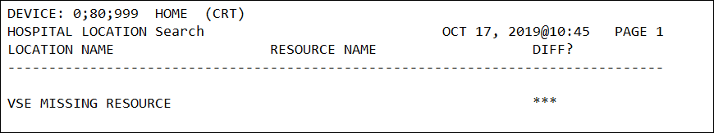

Figure : Sample Output with a Missing Resource with Three (3) Asterisks (***) in the DIFF? Column

The main concern is with **ACTIVE** clinics with three (3) asterisks (***) in the **DIFF?** column. Inactive clinics with three (3) asterisks (**\*\*\***) will be fixed by the system if they are reactivated in the future.

Search the file for active clinics that need correction.

1. Starting with the cursor at the top of the output report file, use the **Find** feature to search for the three (3) asterisks (***) in the **DIFF?** column.

NOTE:The user can use **Ctrl + F** keyboard shortcut to display the Find dialog box or select Edit from the drop-down menu and select Find.

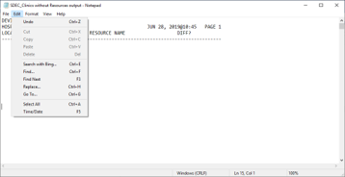

Figure : How to Search Using Find

1. Enter three (3) asterisks (**\*\*\*)** in the prompt box **Find what:** and select **Find Next**.

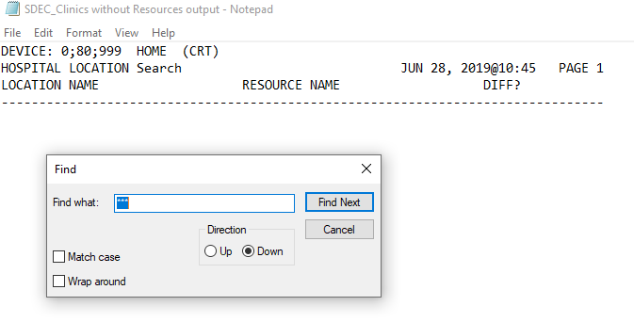

Figure : Find Dialog Box

1. Collect the names of any active clinics that have three (3) asterisks (***) in the **DIFF?** column and proceed to Correct Clinic Resource Issues to fix the clinic resource.
2. Some sites may not have any active clinics with issues and can proceed to Identify and Fix Existing Appointments with Resource Problems to fix corrupted appointments.
3. Correct Clinic Resource Issues
   1. Edit Resource

The **EDIT RESOURCE [SDEC RESOURCE EDIT]** menu option allows the site to correct any active clinic with a mismatch between the **Location Name** and **Resource Name** identified in the **CLINIC WITHOUT MATCHING RESOURCE LIST** output. The output will display **Location Name**, **Resource Name**, and three (3) asterisks (***) listed in the **DIFF?** column.

NOTE: The Location Name and Resource Name must match exactly to include case, spelling, and leading or trailing spaces.

1. Navigate to the **SUPERVISOR MENU [SDSUP]** and enter the following prompt responses listed in the following steps. Reference mismatched **LOCATION NAME** and **RESOURCE NAME** identified in Figure 256: Sample Output with Mismatched Resource with Three (3) Asterisks (***) in the DIFF? Column.
2. **Select SDEC RESOURCE**: RESOURCE NAME identified in the **CLINICS WITHOUT MATCHING RESOURCE LIST** report from Identify Clinic without Matching Resource List.
3. **RESOURCE:** NAME OF CLINIC
4. **RESOURCE TYPE:** CLINIC// H.NAME OF CLINIC

…OK? YES//

NOTE: **RESOUCE TYPE** must match a **LOCATION NAME** in the **HOSPITAL LOCATION File (#44).** Do not add a new **HOSPITAL LOCATION**. Please see Figure 261 for example of entering the **RESOURCE TYPE** incorrectly.

1. **HOSPITAL LOCATION:** NAME OF CLINIC
2. The resource has been successfully added when you are returned to the prompt **Select SDEC RESOURCE**.

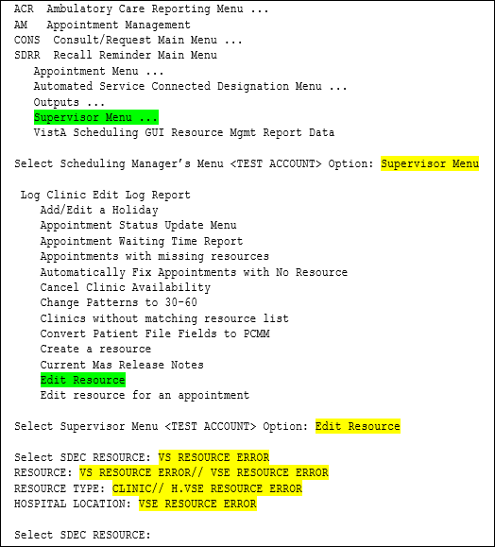

Figure : EDIT RESOURCE Menu Option and Prompt Responses

If the **RESOURCE TYPE** entered does not match a **LOCATION NAME** in the **HOSPITAL LOCATION File (#44)**, the system will ask:

* Are you adding ‘**RESOURCE TYPE ENTERED**’ as a new **HOSPITAL LOCATION**?

The answer is NO and is the default answer. **DO NOT** add a new **HOSPITAL LOCATION**.

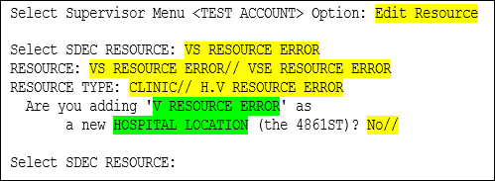

Figure : RESOURCE TYPE Entered Incorrectly

* 1. Create a Resource

The **CREATE A RESOURCE [SDEC RESOURCE CREATE]** menu option allows the site to correct any active clinic missing a resource in the **SDEC RESOURCE File (#409.831)** identified in the **CLINIC WITHOUT MATCHING RESOURCE LIST** output with a blank **Resource Name** and three (3) asterisks (***) listed in the **DIFF?** column. Reference missing **RESOURCE NAME** in Figure 257: Sample Output with a Missing Resource with Three (3) Asterisks (***) in the DIFF? Column.

1. Navigate to **CREATE RESOURCE [SDEC RESOURCE CREATE]** option in the **SUPERVISOR MENU [SDSUP]** and enter the prompt responses listed in the following steps.
2. **Select SDEC RESOURCE**: NAME OF CLINIC

NOTE: These must match exactly to include case sensitivity, spelling, and trailing or leading spaces.

1. **Are you adding ‘name of clinic’ as a new SDEC RESOURCE:** NO//Y

NOTE: The default for this prompt is NO. If the clinic already has a resource, you will not get this prompt.

1. **RESOURCE TYPE:** H.NAME OF CLINIC
2. **DATE/TIME ENTERED:** NOW
3. **ENTERED BY USER:** your name
4. **HOSPITAL LOCATION:** NAME OF CLINIC
5. The resource has been successfully added when you are returned to the prompt **Select SDEC RESOURCE**.

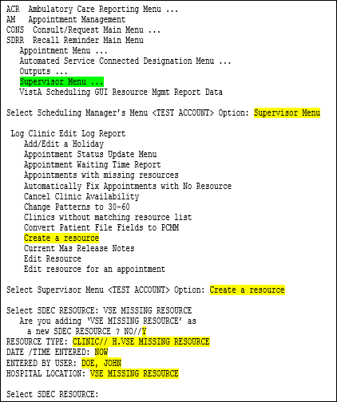

Figure : CREATE A RESOURCE Menu Option and Prompt Responses

* 1. Check Corrections Made to the SDEC RESOURCE File

After making corrections to the **SDEC RESOURCE File (#409.831)** through either the **Edit Resource** or **Create a Resource** options, re-run the CLINIC WITHOUT MATCHING RESOURCE LISTto verify the clinic corrected is now displaying a blank under the **DIFF?** column versus the three (3) asterisks (***). If the clinic is still displaying the three (3) asterisks (***) in the **DIFF?** column, verify the **LOCATION NAME** and **RESOURCE NAME** match exactly. If they are an exact match but are still displaying three (3) asterisks (***) in the **DIFF?** column, proceed to Check for Inactive Clinics because corrections cannot be made for inactive clinics using these options.

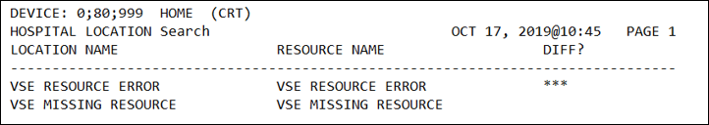

Figure : Checking SDEC RESOURCE File (#409.831) Corrections

NOTE: Figure above is the output result of re-running the **CLINIC WITHOUT MATCHING RESOURCE LIST** report after corrections have been made.

The **VSE RESOURCE ERROR** clinic listed in Figure 263: Checking SDEC RESOURCE File (#409.831) Corrections initially had a mismatched name between the **HOSPITAL LOCATION** and **RESOURCE NAME** (see Figure 256). Although, they now match, the report is still displaying three (3) asterisks under the **DIFF?** column indicating something is still wrong with this clinic’s resource. Site should proceed to **Error! Reference source not found.** to verify if this clinic is active or inactive.

The **VSE MISSING RESOURCE** clinic listed in Figure 263: Checking SDEC RESOURCE File (#409.831) Corrections was initially missing the resource name (see Figure 257) and the **SDEC RESOURCE File (#409.831)** was corrected. The report is now displaying the resource name and a blank under the **DIFF?** column indicating the clinic resource is now fixed.

* 1. Check for Inactive Clinics

Inactive clinics with three (3) asterisks (**\*\*\***) will be fixed by the system if they are reactivated in the future and do not require user intervention at this time.

Clinics with ZZ in the name are typically inactive, but you may come across an inactive clinic without a ZZ. These are typically found if a clinic will not drop off the **CLINIC WITHOUT MATCHING RESOURCE LIST** after it is corrected.

The option **CLINIC PROFILE [SDCLINIC]** found in the **SCHEDULING MANAGER’S MENU [SDMGR]** Option **OUTPUTS** **[SDOUTPUT]** can be used to check whether a clinic is inactive.

1. Navigate to the **Scheduling Manager’s Menu [SDMGR]**
2. **Select Scheduling Manager’s Menu Option:** Outputs
3. **Select Outputs Option:** Clinic Profile
4. **Select division:** ALL// press **RETURN**
5. **Select clinic:** ALL// VSE

NOTE: Default response ALL is provided. If user would like to narrow down the clinic to select, enter a portion of the clinic name which is case sensitive and then press RETURN. The example provided is to check the VSE RESOURCE ERROR clinic from Figure 263, so VSE was used to narrow down the clinic choices.

1. VSE MISSING RESOURCE
2. VSE RESOURCE ERROR
3. **CHOOSE:** 2
4. **Select another clinic**: press RETURN
5. **DEVICE**: HOME// press RETURN

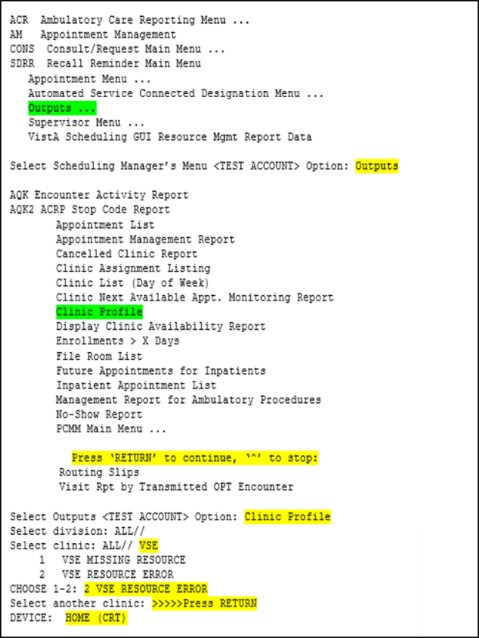

Figure : Clinic Profile Menu and Prompts

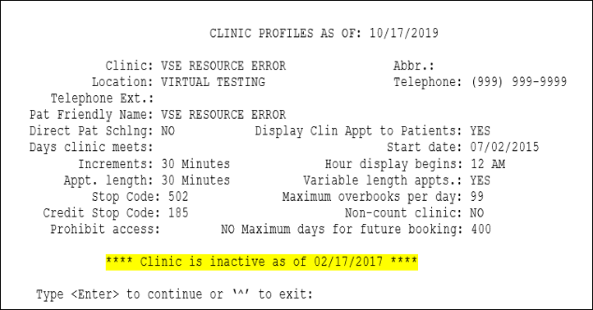

Figure : Clinic Profile for Inactive Clinic

**NOTE:** Figure above is a screenshot of an INACTIVE clinic which displays the message ***Clinic is inactive as of (DATE)*** at the bottom of the clinic profile.

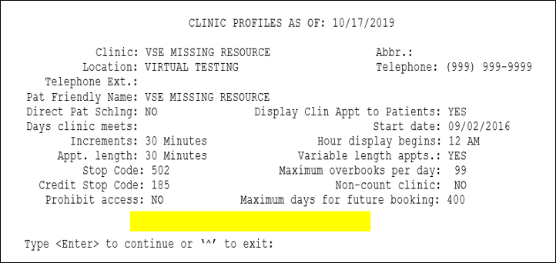

Figure : Clinic Profile of Active Clinic

NOTE: Figure above is an example of a clinic that is **ACTIVE** and does not contain a message at the bottom of the profile.

1. If the clinic is inactive, but does not have ZZ in the name, contact your lead/supervisor or clinic profile staff to determine if the clinic name should be edited. These clinics will not drop off the report no matter how many times you edit the **SDEC RESOURCE File (#409.831)**.

If the clinic is active and will not drop off the report after you complete the corrections contact your lead/supervisor, clinic profile staff, or Program Application Specialist (PAS) as appropriate, and use the Friday Office Hours or email the program office. Please refer to the Assistance section for contact information.

1. Identify and Fix Existing Appointments with Resource Problems

Sites should run option **AUTOMATICALLY FIX APPOINTMENTS WITH NO RESOURCES** **[SDEC NO RES APPT AUTO FIX],** which will check for existing appointments with resource issues and will automatically fix any appointment that is an exact match by looking in the **PATIENT File (#2)**. This option will not require user interaction to make the corrections.

The check will also display appointments that may potentially require the site to fix manually. It cannot be predicted what percentage of appointments will be fixed; however, with the installation of patch SD*5.3*731, sites can run the option again and allow the enhanced utility to clean up additional appointments decreasing the number that require a manual fix.

The utility needs to be run once for the facility; however, if the option is run multiple times (intentionally or otherwise), it will not hurt the system.

This option will need to be completed for any future appointments as well as those made from the time the facility implemented the VS GUI. For most facilities, running the check back to 1 January 2016 will suffice. If the facility was an Initial Operating Capability (IOC) facility, the check may require going back to 1 January 2014.

This step will need to be conducted before or after business hours as it requires the system to query substantial appointment records and could potentially be resource intensive, especially at larger sites. The duration to complete this process is unknown, and it is advised to break this step down into multiple runs to have the system process blocks of appointments at a time and prevent tying up system resources. As an example, a large site could run the check for the following dates in this order: T+1, T+60, T+120, T+390, T-1, T-60, T-120, 1OCT2019, 1JUN2019, 1JAN2019, 1JUN2018, 1JAN2018, etc.

* 1. Automatically Fix Appointments with No Resources

1. Navigate to the **SUPERVISOR MENU [SDSUP]** and enter the following for the prompts.
2. **Select Supervisor Menu Option:**  AUTOMATICALLY FIX APPOINTMENTS WITH NO RESOURCES
3. Pause here before entering a date and turn on logging to capture the results in a file. Do not print the report to a printer. Instructions on logging are available in Appendix A.
4. **DATE:** 1OCT2019

NOTE: At this **DATE** prompt, consider doing this in batches as described above. All appointments from the date entered and into the future will be checked and fixed.

1. The utility returns user to the **SUPERVISOR MENU** when it completes.

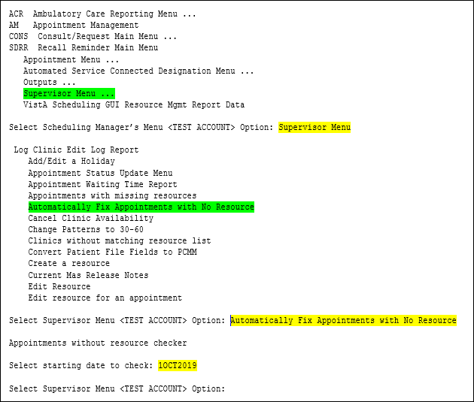

Figure : Automatically Fix Appointments with No Resources

* 1. Reviewing/Analyzing Appointments without Resources Results

The results from the **Automatically Fix Appointments with No Resource** [**sdec no res appt auto fix**] check will display any appointment the system fixed and those that it could not fix. The site is not required to make manual corrections for appointments until after patch SD*5.3*731 is installed and the enhanced version of this utility resolves any additional appointments automatically that it can. If any appointments are found after the installation of patch SD*5.3*731 enhanced version of the utility is run, the site will be required to make the corrections manually and guidance will be provided with the patch installation.

The output report from the **Automatically Fix Appointments with No Resource** [**sdec no res appt auto fix**] check will display each appointment date, time, patient name, clinic, and reason the appointment could not be automatically corrected. It will also display two fields called **Date appointment made** and **Appointment made by**. The response desired in both of those fields is either **same in both** or **3 of 3**. If it does not contain this result, then the appointment will need to be corrected manually, or ignored. The report also provides a totals section at the end of the report that provides a summary of the appointments it fixed and those that it could not and the list of clinics for those appointments.

NOTE: Appointments listed as **Cancelled in PATIENT File (#2)** but NOT in **APPOINTMENT File (#409.84)** do not require a correction.

1. Open the file created during the **Automatically Fix Appointments with No Resource** checker from the previous section.
2. Review results.

* **Example 1:** This appointment has been automatically corrected by the utility and reflects the comment **…updated**.

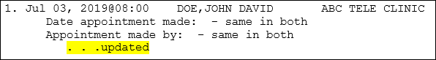

Figure : Appointment with SDEC RESOURCE Issue Automatically Corrected

* **Example 2:** This is a past appointment that has been cancelled and does not need to be corrected.

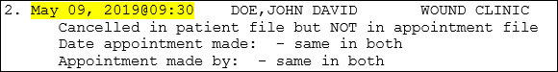

Figure : Past Patient Appointment - No Correction Required

* **Example 3:** This is a future appointment for the patient and the **Date appointment made** field reports a discrepancy between the **APPOINTMENT File (#409.84)** and the **PATIENT File (#2).** In order to fix this appointment, it will need to be **Cancelled by Clinic** and rescheduled in the VS GUI using the same Patient Indicated Date (PID).

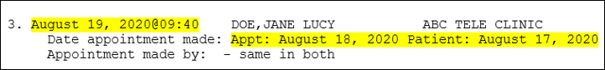

Figure : Future Patient Appointment - Must be Corrected

1. This Summary is listed at the end of the **Automatically Fix Appointments with No Resource** report. It contains the summary of the number of appointments found for a clinic that was missing a resource in the **SDEC RESOURCE File (#409.831)**, number of appointments fixed, and number of appointments the utility failed to match and could not correct.

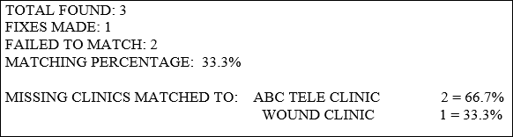

Figure : Summary of Appointments Checked and Results

1. Ongoing Data Check Expectations

The options introduced in this patch should not be an ongoing cleanup effort.

* Once a clinic or appointment is fixed, it should stay fixed.
* New clinics should reliably create a resource as part of normal operations.
* Reactivated clinics will create a resource if they do not have one.

1. Addendum for Patch SD*5.3*731 Site Instructions
   1. Known Defect and Work Around

It was discovered that the calendar grid in VistA Scheduling Graphical User (VS GUI) will not automatically load when VA Online Scheduling (VAOS) appointments are selected in the pending appointments list. The work around to get the appointment to display on the calendar grid is to search for the clinic in the clinic search bar at the bottom left of the GUI window and then navigate the calendar grid to the date of the scheduled appointment.

* 1. Overview

Patch SD*5.3*731 enhances the appointment fixing routine used by options Manually Fix Appointments with No Resource **[SDEC NO RES APPT FIX]** and the Automatically Fix Appointments with No Resource **[SDEC NO RES APPT AUTO FIX]** that were introduced in patch SD*5.3*723, Fix for Appointments with No Resource. It also modifies the SDEC EP WAIT LIST Remote Procedure Call (RPC) code to strip time from the Clinically Indicated Date (CID) if it is present. This modification allows schedulers to cancel VA Online Scheduling (VAOS) appointments from the VistA Scheduling Enhancements (VSE) calendar without error.

Previously in Patch SD*5.3*723, the correcting routine would not repair the **SDEC** **APPOINTMENT File (#409.84)** where the current state (active or cancelled) was different from the appointment in the **PATIENT File (#2)**.

The new version can flag an **SDEC** **APPOINTMENT File (#409.84)** entry as cancelled and will copy the corresponding cancellation data into it from the **PATIENT File (#2)** entry. It can also change an **SDEC APPOINTMENT File (#409.84)** entry from cancelled to active and will remove the cancellation data. The enhanced version also compares appointments in the **patient** **File** **(#2)** and **HOSPITAL LOCATION File (#44)** to ensure consistency between them so that VSE and VistA Scheduling can function properly.

Patch SD*5.3*731 also adds a new option Appointments with no resource report **[SDEC NO RES APPT REPORT]**. This report option uses the same criteria as the Automatically Fix Appointments with No Resource **[SDEC NO RES APPT AUTO FIX]** option without making any changes. This can be used to review the discrepancies between the **patient** **File** **(#2)**, **hospital location** **File** **(#44)** and the **SDEC** **APPOINTMENT File (#409.84)**.

* 1. Site Instructions

After the installation of Patch SD*5.3*731, sites should use the following options to finish cleaning up any remaining ghost appointments.

1. **Automatically Fix Appointments with No Resource [SDEC NO RES APPT AUTO FIX]** enhanced version from Patch SD*5.3*731 but will follow the same steps as provided in the Addendum for Patch SD*5.3*723. See Section E.1. Automatically Fix Appointments with No Resources.
2. Identify remaining appointments with resource issues using one of the provided reports:
   1. **Appointments with Missing Resources [SDEC NULL RESOURCE]** from Patch SD*5.3*723. Instructions to use this option are provided with the Patch SD*5.3*731 addendum below.
   2. **Appointments with no resource report [SDEC NO RES APPT REPORT]** from Patch SD*5.3*731.
3. Fix remaining appointments with resource issues using the following options.
   1. **Manually Fix Appointments with No Resource [SDEC NO RES APPT FIX]** from Patch SD*5.3*723. Instructions to use this option are provided with the Patch SD*5.3*731 addendum below.
   2. **Edit resource for an appointment [SDEC APPOINTMENT EDIT]** from Patch SD*5.3*723. Instructions to use this option are provided with the Patch SD*5.3*731 addendum below.
   3. Automatically Fix Appointments with Resource Problems

Sites should run option Automatically Fix Appointments with No Resource **[SDEC NO RES APPT AUTO FIX]** which has been enhanced in Patch SD*5.3*731. This option will check for existing appointments with resource issues and automatically fix any appointment that is an exact match by looking in the **PATIENT File (#2)**. This option will not require user interaction to make the corrections.

Steps to run this option are included in the SD*5.3*723 Addendum in Section E.1. Automatically Fix Appointments with No Resources.

* 1. Identify Remaining Appointments with Resource Problems

After running the enhanced version of the Automatically Fix Appointments with No Resource **[SDEC NO RES APPT AUTO FIX]**, sites should use one of the following reports to identify remaining appointments with resource issues. Instructions to run the reports are provided below with sample output. Sites can choose either option.

* + 1. Appointments with Missing Resources Option

Appointments with missing resources **[SDEC NULL RESOURCE]** is a report option included in Patch SD*5.3*723. This report should be logged to a file. Instructions on logging are available in Appendix A. The report will provide a list of appointments that have a resource issue that needs to be resolved.

1. Navigate to the **Supervisor Menu [SDSUP]** and enter the following for the prompts.
2. **Select Supervisor Menu Option:**  Appointments with missing resources
3. Pause here before entering a date and turn on logging to capture the results in a file. Do not print the report to a printer. Instructions on logging are available in Appendix A.
4. **Sort by: STARTTIME//** >>>>Press ‘Return’ to accept default<<<<<
5. **Start with STARTTIME: FIRST//** >>>>>Enter start time such as t-30<<<<<

NOTE: Site should focus on present and future appointments but can run the report for past appointments from the time VS GUI was implemented at the site. It is not necessary to correct past appointments that still have a resource issue and the site can choose to ignore these appointments.

1. **Go to STARTTIME: LAST//** >>>>>Press ‘Return’ to accept default<<<<<
2. DEVICE: 0;80;99

* Zero (0) tells VistA print to screen.
* 80 indicates the number of columns
* 99 indicates how many rows in each page before the user is prompted to press **RETURN**.

1. The utility returns user to the **Supervisor Menu** when it completes.

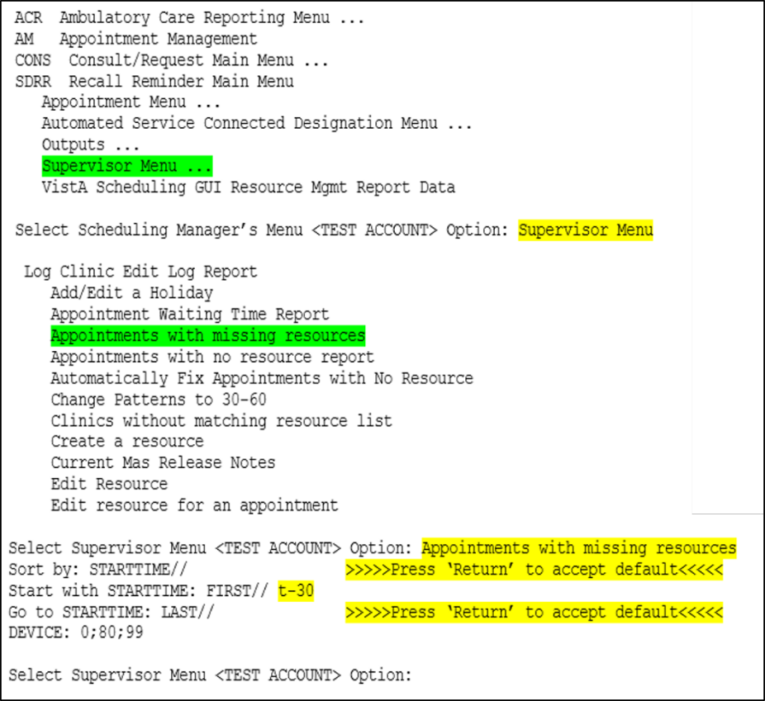

Figure : Appointments with Missing Resources Prompts

The report output displays the Internal Entry Number (IEN) of the appointment, the appointment start time, patient name, clinic location, and number of data points in agreement between the **PATIENT File (#2)** and the **SDEC APPOINTMENT File (#409.84)**. The three data points for a patient’s appointment are: Date, Status, and Made By. A response of ‘3 of 3 data points agree’ indicates that all fields match, and the appointment can be fixed automatically or manually. If a response of less than 3 of 3 is provided, then the appointment needs to be reviewed and corrected.

An example of all three data points not matching can be found in Figure 270: Future Patient Appointment - Must be Corrected. In this example, the appointment dates did not match between the **PATIENT File (#2)** and the **SDEC APPOINTMENT File (#409.84)** and to correct it, the appointment had to be cancelled by clinic and rescheduled using the VS GUI and the same Patient Indicated Date (PID).

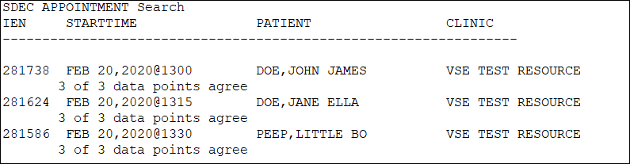

Figure : Appointments with Missing Resources Sample Output

* + 1. Appointments with No Resource Report Option

Appointments with no resource report **[SDEC NO RES APPT REPORT]** is a new report option provided in Patch SD*5.3*731 which identifies appointments with no resource and may require correction. This report uses the same criteria as the Automatically Fix Appointments with No Resource [SDEC NO RES APPT AUTO FIX] option without automatically fixing the appointments. This option allows the site to review the discrepancies between the **PATIENT File (#2)**, **HOSPITAL LOCATION File (#44)**, and the **SDEC APPOINTMENT File (#409.84)**. The report will display the appointment date and time, the IEN in parenthesis, the patient name, clinic location, and the results of comparing the data points in columns labeled **SOURCE**, **STATUS**, **DATE MADE**, and **MADE BY**.

1. Navigate to the **Supervisor Menu [SDSUP]** and enter the following for the prompts.
2. **Select Supervisor Menu Option:**  Appointments with no resource report
3. Pause here before entering a date and turn on logging to capture the results in a file. Do not print the report to a printer. Instructions on logging are available in Appendix A.
4. DEVICE: HOME// 0;80;99

* Zero (0) tells VistA print to screen.
* 80 indicates the number of columns
* 99 indicates how many rows in each page before the user is prompted to press **RETURN**.

1. The option displays the following messages before the next prompt.

* Appointments without resources checker
* Select starting date to check

1. **DATE**: >>>>>Enter Date such as t-30, or 1NOV2019<<<<<

NOTE: Site should focus on present and future appointments but can run the report for past appointments from the time VS GUI was implemented at the site. It is not necessary to correct past appointments that still have a resource issue and the site can choose to ignore these appointments.

1. The utility returns user to the **Supervisor Menu** when it completes.

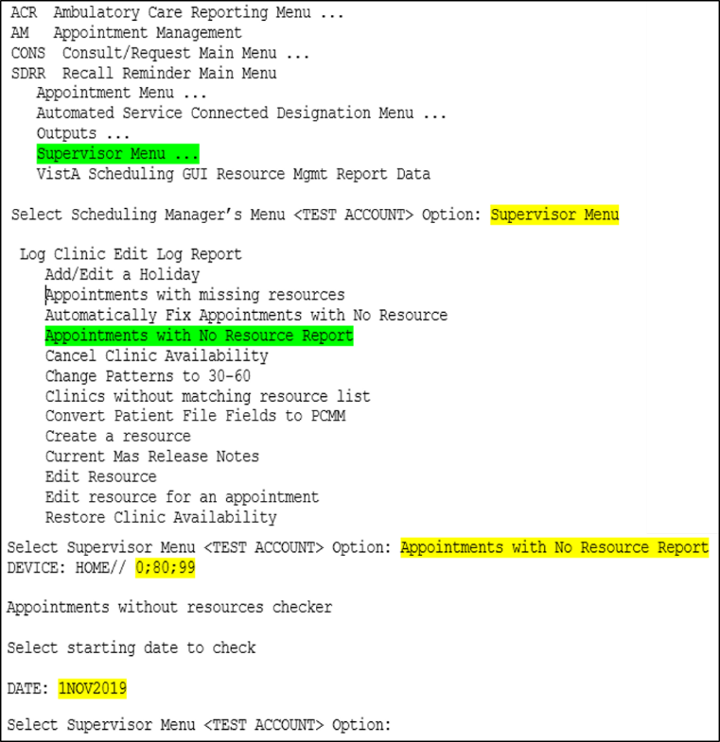

Figure : Appointments with No Resource Report

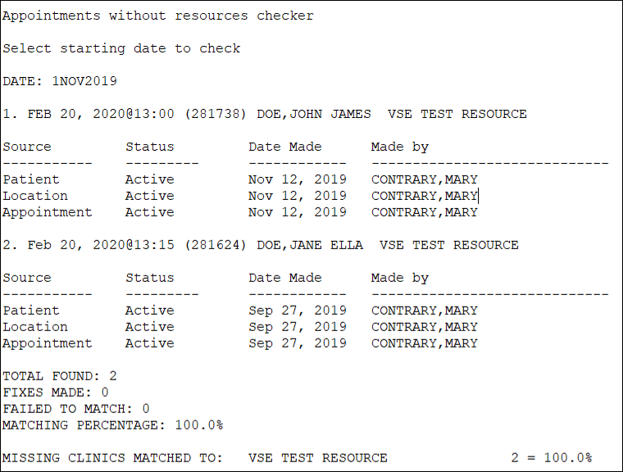

Figure : Appointments with No Resource Report Output

* 1. Manually Fix Appointments with Resource Issues

After running one of the report options above for a list of appointments with resource issues, the site should manually fix appointments that are remaining. The focus should be on present and future appointments. The past appointments can be ignored. There are two options available to fix the remaining appointments, Manually Fix Appointments with No Resource **[SDEC NO RES APPT FIX]** and Edit resource for an appointment **[SDEC APPOINTMENT EDIT]**. The sites should use the manual fix initially as it provides a list of appointments from the date user selects into the future and information on whether there is an exact match between the **PATIENT File (#2)**, **HOSPITAL LOCATION File (#44)**, and **SDEC APPOINTMENT File (#409.84)**, and the option to correct the resource issue or bypass the appointment. If an appointment does not have an exact match, the site should bypass the appointment and review the appointment further prior to fixing the resource issue. If an appointment is bypassed, the site can use the Edit resource for an appointment **[SDEC APPOINTMENT EDIT]** to go straight to the individual appointment or can choose to run the manual fix option again.

* + 1. Manually Fix Appointments with No Resource

Manually Fix Appointments with No Resource **[SDEC NO RES APPT FIX]** is an option included with Patch SD*5.3*723 that lists appointments with null resources, determines if there is a likely match by looking into the **PATIENT File (#2)** and then prompts the user to fix the appointment or bypass it.

1. Navigate to the **Supervisor Menu [SDSUP]** and enter the following for the prompts.
2. **Select Supervisor Menu Option**: Manually Fix Appointments with No Resource
3. The option displays the following messages before the next prompt.

* Appointments without resources checker
* Select starting date to check

1. **DATE**: >>>>>Enter a date format such as t-30 or date such as 1NOV2019<<<<<

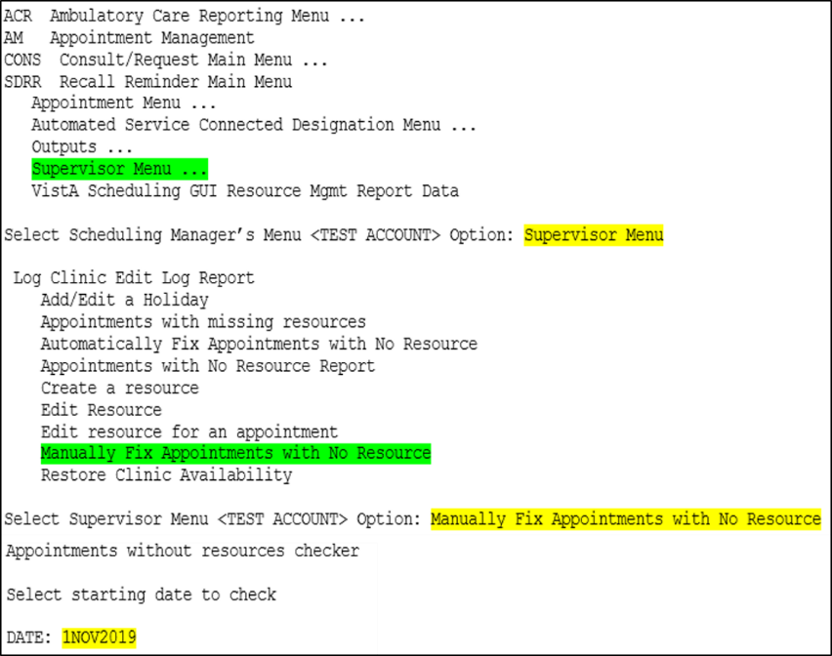

Figure : Manually Fix Appointments with No Resource Menu Option and Prompts

The option will run the resource checker and provide onscreen the list of appointments that can be reviewed and fixed, or bypassed.

1. After the appointment information listed onscreen the option provides a prompt stating:

**Make ‘Name of Clinic’ the resource for this appointment?** NO// >>>>>No is the default response which would skip this appointment. If the correction is desired, user should enter Y to make the correction<<<<<

Based on the user response of Yes or No, the option will display whether the appointment was updated or skipped.

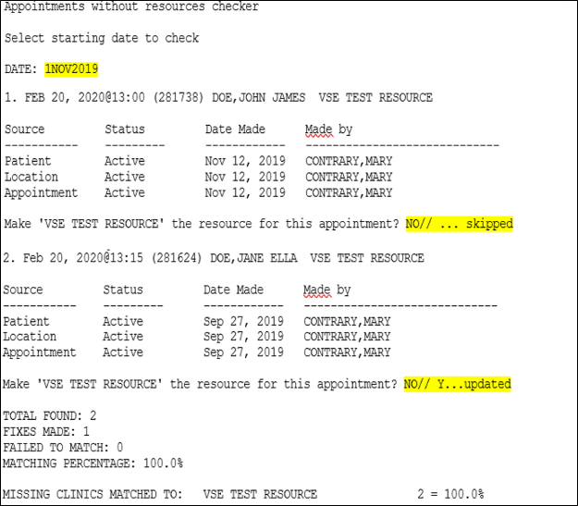

Figure : Manually Fix Appointments with No Resource Onscreen Results and Prompts

Once the option has completed the list of appointments based on the date criteria entered above, it will provide a summary of the total appointments found with a resource issue, the number of fixed appointments, the number of appointments failed to match, the matching percentage, and the break-down of appointments per clinic identified.

* + 1. Edit Appointment Resource

If an appointment was skipped in the manual fix, the site can use the Edit resource for an appointment **[SDEC APPOINTMENT EDIT]** option and the IEN of the appointment identified in one of the reports above to go directly to the appointment and fix the SDEC Resource.

1. Navigate to the **Supervisor Menu [SDSUP]** and enter the following for the prompts.
2. **Select Supervisor Menu Option:** Edit resource for an appointment
3. **Select SDEC APPOINTMENT STARTTIME:** `IEN of Appointment

NOTE: Use the backtick which is located on the tilde key directly under the Escape key on the keyboard plus the IEN of the appointment found on one of the reports and this will open the exact appointment that requires the resource to be edited.

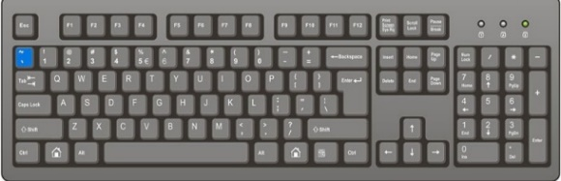

Figure : Location of Backtick on QWERTY Keyboard

1. **RESOURCE:** NAME OF CLINIC
2. Resource has been edited and returns user to the prompt **Select SDEC APPOINTMENT STARTTIME.**

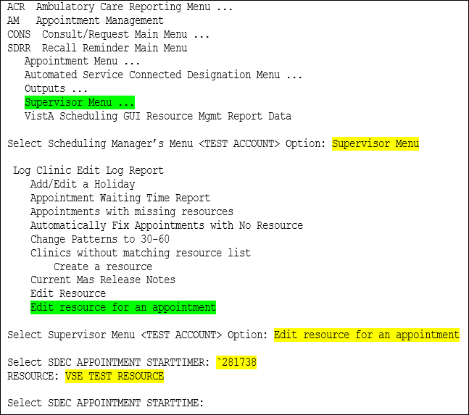

Figure : Edit resource for an appointment Prompt Responses

* 1. Check Corrections for Appointments with SDEC Resource Issues

After corrections are made to an appointment through any method of fix, automatically, manually, or directly through edit appointment resource, sites should verify corrections have been successfully made by running either the Appointments with Missing Resources Option or Appointments with No Resource Report Option. The correction has been successful if the appointments have fallen off the reports.

Appendix

1. Appendix A
   1. Send Report Results to Text File

The output of these reports should be a text file (logging, spooler, etc.). Do not print the output to paper. There are several ways to accomplish this, so please feel free to capture the results using the method that is most comfortable for you. The following steps provide one approach to sending the report results to a text file.

1. Log into VistA.
2. From the Reflections window for VistA Legacy, Select **File** drop-down
3. Select **Logging** which opens a dialog box
4. Select the **Checkbox** by **Disk**. If **Checkbox** by **Print** is the default selection, **uncheck** the box to deselect **Print**.
5. Select **Browse** to select the location to save the file.

NOTE: Suggest saving this file to the desktop for ease of locating and opening.

* In the **Save As** dialog box, enter File name representative of the option used, for example, **SDEC-Clinics_without_matching_resources** or **SDEC_Appointments_with_problem_resources_1JAN2019**.

**NOTE:** It is recommended to use a date in the file name so that logging can be captured for each date range completed.

* In the **Save as type** field, use **.txt** as the file type (usually the default).
* Click **Save**.

1. Click **OK** in the **Logging Settings** dialog box.
2. User is returned to the main Reflections window.
3. Select **File** drop-down from the Reflections window and select **Start Logging** to begin logging.
4. User is returned to the main Reflections window.

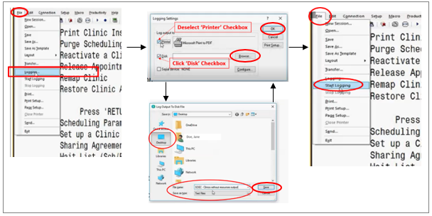

Figure : Send Report Results to Text File

1. When report has completed running in VistA, select **File** drop-down on the Reflections window and select **Stop Logging**.

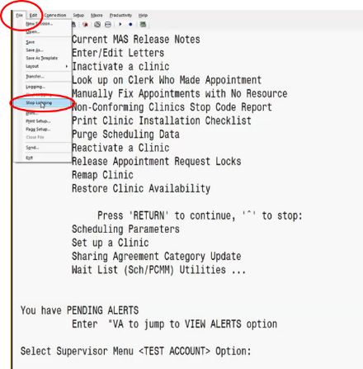

Figure : Stop Logging